Annual Report
2023
Canberra Institute of Technology

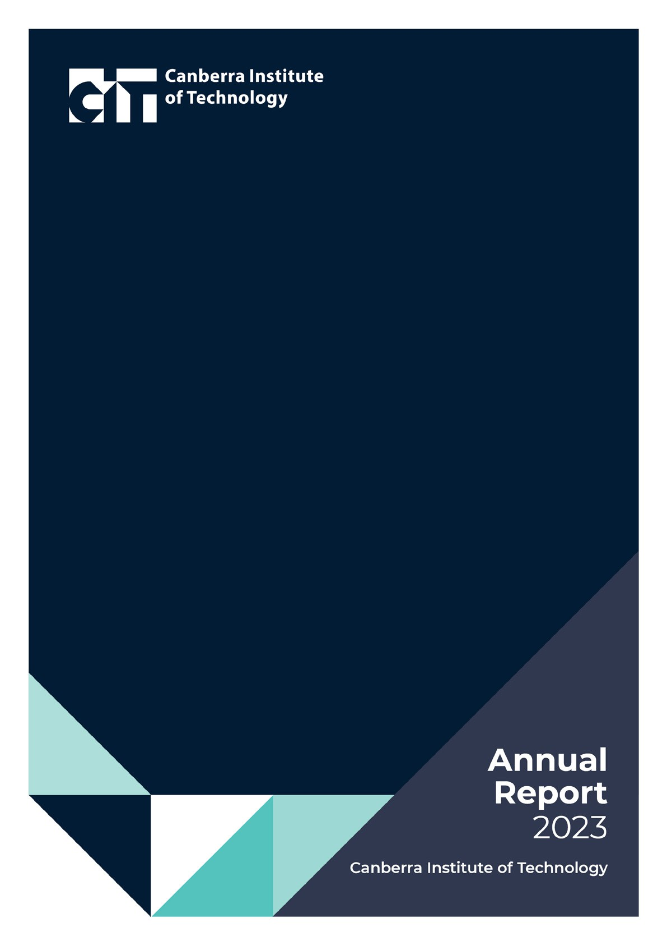

Acknowledgement of Country
Dhawura Nguna Dhawura Ngunnawal Ngunnawalwari Dhawurawari Nginggada Dindi Yindumaralidjinyin Dhawura Ngunnawal Yindumaralidjinyin
This is Ngunnawal Country.
We always respect their Elders, male and female. We always respect Ngunnawal Country.
CIT acknowledges the cultural host nation of the ACT, the Ngunnawal people as Canberra’s first inhabitants and Traditional Custodians of the ACT and Region. We recognise the special relationship and connection to Country that the Ngunnawal people have with this area since time immemorial.
Prior to non-Indigenous arrival Ngunnawal were a thriving community whose cultural practices were and still are core to their physical and spiritual wellbeing. We acknowledge the historical dispossession of the Ngunnawal people and recognise the long lasting, profound and ongoing impact to their health and
well-being that invasion has had on their livelihoods, cultural practices and families as well as the continuation of their laws/lore.
CIT respectfully acknowledges the significant contribution of the Ngunnawal people to the life of Canberra.
We also acknowledge other Aboriginal and Torres Strait Islander peoples that have made this place their home.

Canberra Institute of Technology Annual Report 2023
© ACT Government 2024

ISSN 1322-5456
This work is copyright. Apart from any use permitted under the Copyright Act 1968,
no part may be reproduced by any process without written permission from the Manager, Publications and Communications, Corporate Services Bureau, ACT Government,
GPO Box 158, Canberra ACT 2601.
RTO: 0101 CRICOS: 00001K

CONTENTS

CONTENTS 3
LIST OF FIGURES 4

PART A: | TRANSMITTAL CERTIFICATE | 7
 | FROM THE CIT BOARD CHAIR | 8
 | FROM THE CIT CHIEF EXECUTIVE OFFICER | 9
PART B: | ORGANISATION OVERVIEW AND PERFORMANCE | 11
 | B1: ORGANISATIONAL OVERVIEW | 12
 | B2: PERFORMANCE ANALYSIS | 24
 | AWARD WINNING EDUCATION AND TRAINING | 28
 | 2023 STRATEGIC PERFORMANCE HIGHLIGHTS | 30
 | CAMPUS RENEWAL | 34
 | INDUSTRY SKILLS NEEDS | 37
 | CIT SOLUTIONS | 47
 | B3: SCRUTINY | 49
 | B4: RISK MANAGEMENT | 51
 | B5: INTERNAL AUDIT | 52
 | B6: FRAUD PREVENTION | 54
 | B7: FREEDOM OF INFORMATION | 55
 | B8: COMMUNITY ENGAGEMENT AND COMMUNITY SUPPORT | 57
 | B9: ABORIGINAL AND TORRES STRAIT ISLANDER REPORTING | 61
 | B10: WORK HEALTH AND SAFETY | 64
 | B11: HUMAN RESOURCES MANAGEMENT | 68
 | B12: ECOLOGICALLY SUSTAINABLE DEVELOPMENT | 77
PART C: | FINANCIAL MANAGEMENT REPORTING | 81
 | C1: MANAGEMENT DISCUSSION AND ANALYSIS | 82
 | C2: FINANCIAL STATEMENTS | 87
 | C3: CAPITAL WORKS | 143
 | C4: ASSET MANAGEMENT | 145
 | C5: GOVERNMENT CONTRACTING | 147
 | C6: STATEMENT OF PERFORMANCE | 149
 | ACRONYMS AND ABBREVIATIONS | 154
 | COMPLIANCE INDEX 2023 | 155
 | CONTACT OFFICER | 156

LIST OF FIGURES

Figure 1: | Board Member Meeting Attendances 2023 | 17
Figure 2: | CIT Operational Governance Framework | 21
Figure 3: | Performance of CIT graduates against other Australian TAFE graduates 2023 | 25
Figure 4: | NCVER Student Outcome Survey 2023 Graduate Outcomes 2019 – 2023 | 26
Figure 5: | Employer Response Rate by Year 2020 - 2023 | 27
Figure 6: | Employer satisfaction with CIT Training 2013 to 2023 | 23
Figure 7: | Number of Fee-Free TAFE Enrolments by Priority Group 2023 | 32
Figure 8: | CIT Woden Campus Project - key training and diversity targets | 35
Figure 9: | Audit and Risk Committee Members Meetings Attended 2023 | 52
Figure 10: | Open Access Information - Section 96 (3) (a) (i), (ii) and (iii) | 55
Figure 11: | FOI Applications received and decision type - Section 96 (3) (a) (iv), (vii), (viii) and (ix) | 55
Figure 12: | FOI processing timeframes - Section 96 (3) (v) and (vi); Section 96 (3) (d) | 56
Figure 13: | Amendment to personal information - Section 96 (a) (x) and Section 96 (3) (e) | 56
Figure 14: | Reviews – Section 96 (3) (b); Section 96 (3) (c) | 56
Figure 15: | Fees - Section 96 (3) (f) | 56
Figure 16: | Funding for CIT Fee Assistance 2023 | 59
Figure 17: | Reduce the Incidence Rate of Claims resulting in one or more weeks off work by at least 30% | 65
Figure 18: | Reduce the Incident Rate of Claims resulting in one or more weeks off work by at least 30% | 66
Figure 19: | Target 2 – Reduce the incidence rate of claims for MSD over time 2013-14 to 2022-23 | 66
Figure 20: | Reduce the incidence rate of claims for MSD over time (Trend) | 67
Figure 21: | FTE and Headcount by Division | 70
Figure 22: | FTE and Headcount by College/Division | 71
Figure 23: | Headcount by Division and College (%) | 71
Figure 24: | FTE and Headcount by Gender and % of Workforce | 72
Figure 25: | Headcount by Gender 2021 to 2023 | 72
Figure 26: | Headcount by Gender (%) | 72
Figure 27: | Headcount by Employment Category and Gender | 73
Figure 28: | Headcount by Classification Group and Gender | 73
Figure 29: | Headcount by Classification Group (%) | 73
Figure 30: | Headcount by Diversity Group and Total % of staff | 74
Figure 31: | Headcount by Age and Gender | 74
Figure 32: | Headcount by Age and Gender (%) | 74
Figure 33: | Headcount by Age 2021 to 2023 | 74
Figure 34: | Headcount by Age (%) | 75
Figure 35: | Recruitment and Separation Rates of permanent staff for the 2023 calendar year | 75
Figure 36: | Average Length of Service | 75
Figure 37: | Gender Pay Gap | 76
Figure 38: | Sustainable development performance – current and previous calendar years | 79
Figure 39: | Revenue Breakdown by Category | 83
Figure 40: | Operating Expenses Breakdown by Category | 84
Figure 41: | Total Assets Breakdown by Category | 85
Figure 42: | Total Liabilities Breakdown by Category | 86
Figure 43: | Working Capital | 86
Figure 44: | ATSIPP Performance Measures for CIT in the calendar year 2023 | 147
Figure 45: | Whole of Government Panel arrangements Funding $ | 148

Part A
Transmittal Certificate

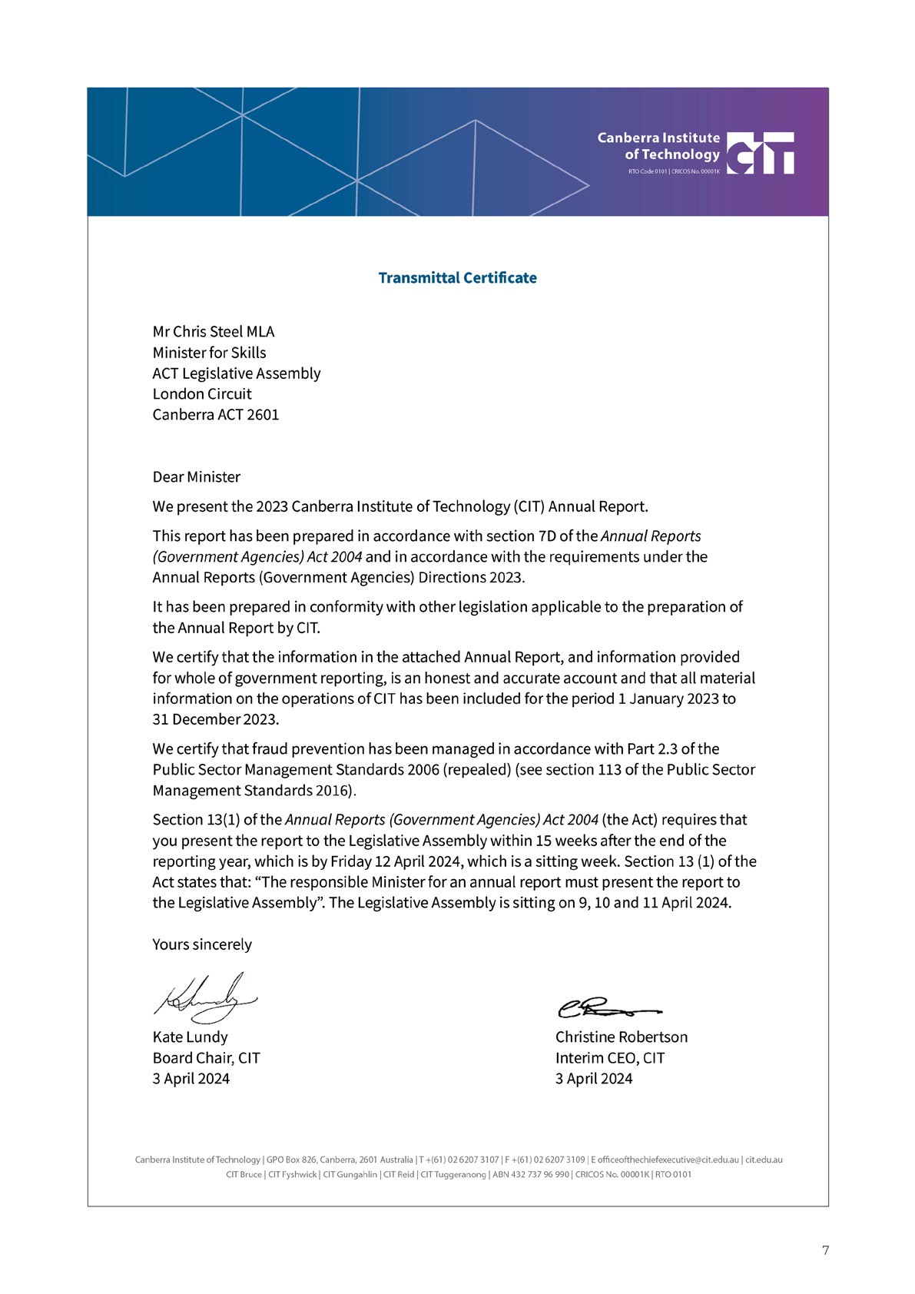

FROM THE

CIT BOARD CHAIR

Kate Lundy
CIT Board Chair

Last year brought with it many opportunities and challenges. Governments continue to grapple with the impending skills shortages and rapid diversification of emerging and future skills needs, placing the vocational and training sector at the forefront of their response.
With this shift in the national skills policy agenda, and the expiry of our current strategy at the end of 2024, the CIT Board initiated discussions with the CIT
Executive team in early November 2023 to recalibrate and reassess where CIT need to focus our efforts over the next ten years.
The CIT Board is committed to developing a new strategy that is representative of the organisation and reflective of government, industry and community wants and needs. Internal consultation with staff commenced late November and will continue into the new year, along with student and stakeholder consultation.
Last year was also a year of celebration, as CIT marked its 95th anniversary as an established education and training provider. It was an opportune time to reflect on how far we have come, and what the future of CIT looks like in the lead up to, and beyond our centenary in 2028.
We have a proud history of adaptation, rising to the economic and social needs of the government of the day, fulfilling the needs of our students, delivering skills to industry and serving our community. The creation of a 10-year strategy is ambitious, and rightly so. CIT has proven itself through our successes over the past 95 years, and 2023 was no exception.
The Prime Minister, Federal Skills Minister and ACT Chief Minister launched the National Skills
Agreement at CIT’s Electric Vehicle lab. CIT delivered Fee-Free TAFE for the first time with more than 2,530 enrolments. CIT students won four medals at
WorldSkills and won five categories at the ACT Training Awards. CIT Fee-Free TAFE students and our Interim CEO also met with the Prime Minister to share stories on the success of the Fee-Free TAFE program.
The Board continued to focus on improving governance, financial management, procurement and ensuring CIT’s policies and processes are of a high standard.
CIT successfully negotiated the General Staff Enterprise Agreement and achieved a successful vote for the new Educators Agreement. Work continued on the creation of our new Reconciliation Action Plan and the Board turned its focus to identifying opportunities for business growth.
Campus renewal and digitalisation will remain priorities for CIT in 2024, with the view to ensure welcoming, inclusive and innovative learning and teaching environments, across all of our campuses.
I would like to thank CIT Board members and the CIT Executive team for their support in 2023, and for their dedication towards the delivery of a large agenda as we continue to build and improve our foundations and drive the delivery of various critical strategic projects that underpin our future direction.
The Board recognises that our people are at the heart of our organisation, the driving force that has propelled us through 95 years of adaptation and innovation and will define our future success. The Board would like to thank all staff for their dedication to the continued delivery of quality education and training to our students.
The Board notes the uncertainty for staff as the CEO remains on leave to ensure procedural fairness while the Integrity Commission Investigation is continuing. The Board thanks Ms Robertson for continuing at CIT as Interim CEO while the CEO remains on leave.

FROM THE CIT CHIEF EXECUTIVE OFFICER

Christine Robertson Chief Executive Officer (Interim)

In 2023, CIT celebrated a significant milestone, our 95th anniversary as a quality education and training provider to the ACT and region. We took the time
to recognise and reflect on our rich history, with celebrations held across our campuses throughout the year. It became evident at these celebrations just how deeply embedded CIT is within the community and the importance of the work we do each day.
Since our creation in 1928, we have been key to the delivery of government priorities for vocational
education and training. In our infancy, as the Junior Technical and Trades School at Telopea Park, we enrolled 95 learners across eight trade areas. We now skill over 20,000 students each year. The most recent statistics show that on completion of their
training, almost 90% of our graduates were employed or in further study, almost 5% ahead of the national average.
This year we saw a significant shift in the national vocational education and training landscape as governments look to address the current, emerging, and future skills needs. The Australian Government delivered its policy framework for the vocational and higher education sectors, with the release of its White Paper on jobs and opportunities to provide “a
roadmap to position the Australian labour market for the future”. Shortly after, we saw the launch of the landmark National Skills Agreement, held at our own Hybrid and Electric Vehicle Laboratory at our Fyshwick campus.
Subsequently, the Jobs and Skills Australia inaugural Jobs and Skills Report was released, promoting
the concept of a joined-up national skills system comprising three pillars – vocational education, higher education, and migration. The report notes the need for a holistic approach to policy development and implementation and argues for a more joined-up tertiary education system. Work on the Australian
Universities Accord continued as CIT began to think about its role in the delivery of this new Australian Government skills agenda and continued its work with the ACT Government as we turned to identify opportunities under the National Skills Agreement.
Some highlights from the 2023 year include:
- CIT’s performance at WorldSkills, a competition held biennially for Australia’s best young apprentices. CIT students claimed four medals at the WorldSkills national championships in Melbourne, including a gold to 19-year-old Refrigeration and Air Conditioning apprentice Floyd Lucas-Baxter.
- Recognised as the ACT’s 2023 Large Training Provider of the Year with CIT educators, students and industry partners also receiving individual and collaborative awards.
- CIT Solutions student Emma Brown was awarded the Australian Training Award for Aboriginal and Torres Strait Island Student of the Year at the National Training Awards.
- Celebrating the first group of graduates from our partnership with Tesla, and the commencement of delivering the Essential 8 cyber-security course on behalf of the Australian Cyber Security Centre.
- Successful delivery of 2,530 training places under Tranche 1 of the Australian Government’s Fee-Free TAFE initiative.
Work continues on the establishment of our new state of the art campus in Woden, scheduled to open in 2025, and significant projects are in flight to uplift our technology infrastructure and digital capability. Our continued engagement with Jobs and Skills Councils, industry, employers, and the ACT Government focuses on delivering qualified employees to areas of critical skills shortages.

I would like to acknowledge and thank all our staff for their unwavering dedication to our students and our stakeholders.
I would also like to thank the CIT Board for their continued guidance and confidence in CIT staff, under the leadership of the Chair, Ms Kate Lundy.
This year promises to be another significant year for CIT, with many opportunities and challenges that lie ahead. Our focus continues to be on ensuring our workforce is supported to harness the opportunities and rise to the challenges, as we continue to support ACT Government priorities for social and economic growth and prosperity, and support individual students to meet their learning and career goals.

Part B
Organisational Overview and Performance

B1 ORGANISATIONAL OVERVIEW

History of CIT
On 6 June 1928, Prime Minister Stanley Bruce officially opened the ‘Telopea Park Technical Trades and Infants School’, the first iteration of the Canberra Institute of Technology (CIT) on the grounds of the Telopea Park School in Barton, ACT.
With the support of shared facilities and educators at Telopea Park School, classes began in technical trades such as fitting and machining, plumbing and sheet metal work, motor maintenance, engineering trade drawing, carpentry, joinery, dressmaking, needlework, and cookery.
Evening classes in typewriting, shorthand, business principles, English and mathematics were also made available for women seeking careers as secretaries and stenographers in the newly formed Commonwealth Public Service.
In 1928, there were a total of 80 students enrolled in the technical and commercial classes, and 60 in the evening classes. By 1936 CIT were offering formal apprenticeships and in 1939 became the Canberra Technical College.
The Second World War saw a significant growth in course offerings and enrolments as CIT became
a major provider of war-time training. CIT went on to play a major role in the Commonwealth
Reconstruction Training Scheme, and expanded non- trade offerings, such that 40% of the learners enrolled in 1951 were taking ‘hobby courses’.
From the 1950s, CIT continued to grow in enrolments and scope. In 1975, when Canberra’s population had reached 198,000, CIT became the Canberra College of Technical and Further Education, and TAFE provision in the ACT expanded with the establishment of Bruce College of TAFE in 1977, and Woden TAFE in 1980.
In anticipation of the transition to self-government in 1988, the ACT Legislative Assembly enacted the Canberra Institute of Technology Act 1987 (CIT Act), which established CIT as an ACT Government Entity,
ultimately accountable to the government of the day. The Minister may give a direction to CIT in relation to the exercise of CIT’s functions and CIT must comply. This Annual Report is written in response to Annual Reports (Government Agencies) Directions 2023 in accordance with Section 8 of the Annual Reports (Government Agencies) Act 2004.

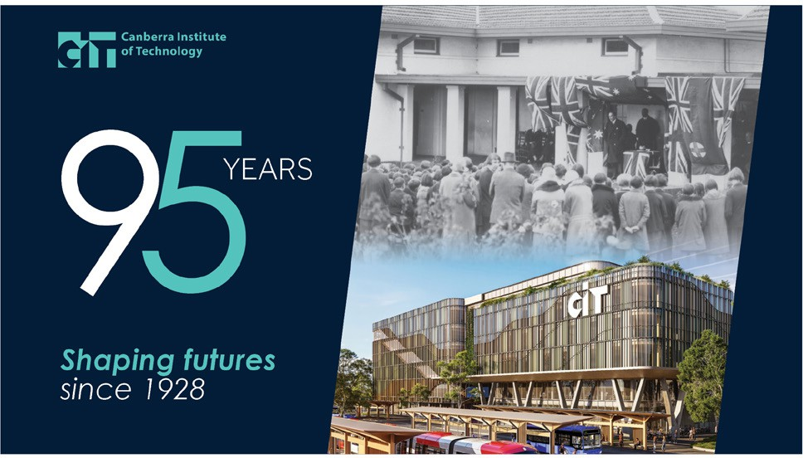

In 2014, the CIT Act was amended to replace the CIT Advisory Council with a governing board to better enable CIT “to meet the twin objectives of operating as a public provider of vocational education and training and operating with greater commercial and entrepreneurial focus in an increasingly contestable training marketplace” (Minister for Education and Training, ACT Legislative Assembly, 30 October 2014). Governance of territory authorities is regulated by the Financial Management Act 1996 (FMA) and many elements of the operation of a governing board
established under territory legislation are provided for in the FMA.
Throughout this period of expansion and diversification, CIT has remained firmly anchored to its base as the public provider of quality vocational education and training across the region and a significant contributor to the ACT skills base.
CIT and its wholly owned subsidiary CIT Solutions (CITSOL) trains approximately 20,000 students each year, with a wide range of nationally recognised courses.

Roles, Functions and Services
CIT is the premier public provider of Vocational Education and Training (VET) services in the ACT and makes an important contribution to Canberra’s social and economic wellbeing and development.
The provision of VET through CIT is central to the ACT Government’s objective to support a well trained and highly skilled workforce in a growing ACT economy.
CIT supports the ACT Government and the Minister for Skills and Training, Chris Steel MLA, to meet their
obligations for the publicly funded VET and delivery of the CIT campus re-development.
In accordance with the CIT Act, CIT has the following functions:
- Conduct an educational institution to provide excellence in study that the Board, with the Minister’s written approval, decides; or the Minister directs.
- Provide educational products and services to advance and develop knowledge and skills in the community.
- Support ACT industry and business in pursuing economic growth and sustainability for the community.
- Perform the role of public provider of vocational education and training in the ACT.
- Issue awards to people who have satisfactorily completed a course of study at the CIT and to issue honorary awards.
- Consult and cooperate to promote education and training and employment pathways for learners.
- Make suitable financial arrangements with industry and business for the purpose of CIT’s functions above.
- Exercise any other function given to it under a Territory law.

Corporate Objectives
CIT Corporate objectives in 2023, as outlined in the CIT Statement of Intent 2023-24 ACT Budget Statements
B, Chief Minister, Treasury and Economic Development Directorate (page 139), are to:
- Support the ACT Government’s Skilled to Succeed: skills and workforce agenda for the ACT, by working collaboratively with industry, customers, and government, to provide a more inclusive
responsive, flexible and future-focused skills sector to respond to future workforce needs.
- Perform the role of public provider of VET in the ACT, in accordance with its functions under the Canberra Institute of Technology Act 1987
(the Act), by providing course offerings aligned to ACT Government priorities and the ACT Skills Needs List.
- Support ACT industry and business in pursuing economic growth and sustainability for the community, by applying appropriate and contemporary learning opportunities for students to acquire the relevant skills for current and future workforce requirements.
- Serve all members of our community, as the public provider of VET in the ACT, with a dedicated focus on empowering traditionally marginalised cohorts, and prioritising Aboriginal and Torres Strait Islander cultures, to tackle systemic discrimination and contribute to the ACT Government’s commitment to Closing the Gap and the ACT Aboriginal and Torres Strait Islander Agreement 2019-2028.
These objectives are being achieved through the lens of CIT’s Strategic Compass 2025 - CIT Futures.

Strategic Compass – CIT Futures 2025

STRATEGIC COMPASS 2025

cit.edu.au/futures2025
Our Strategic Compass - CIT Futures 2025 outlines our strategic direction and the future of CIT, recognising our potential to set the benchmark in modern skills training and drive activity that will help shape the local education landscape.
At CIT, we are embracing a future rich with possibilities, a future where we are at the centre of a vibrant, constantly adapting ecosystem of students, business, and the community. CIT is an integral part of the
ACT community, and as the premier public provider of vocational education and training in the ACT, is uniquely placed to contribute to the prosperity and sustainability of Canberra’s future.
View our Strategic Compass – CIT Futures 2025 site for more information. cit.edu.au/strategic_compass/home

Looking to the Future 2023 CIT staff conference
The Looking to the Future 2023 staff conference, held on 30 January, was a chance for over 400 CIT educators, trainers, and staff to network, share knowledge and ideas with their colleagues and set the scene for the year ahead.
Interim CEO Christine Robertson highlighted the inspiring work of staff across CIT to improve procedures, teaching delivery methods, courses, and services to better support students (picture below). These improvements allowed CIT to make the best use of a range of opportunities in 2023, including the 2,530 Fee-Free TAFE places to address skills shortages in the ACT and the emergence of new industries and high demand job sectors, such as the electric vehicle technology and cyber-security.
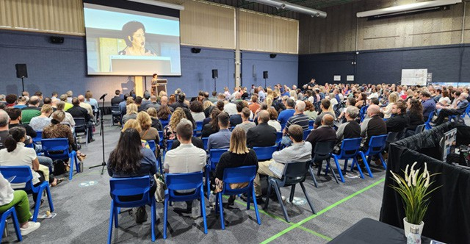
Interim CEO Christine Robertson addressing CIT staff at the ‘Looking to the Future 2023 CIT staff conference’.

Vision, Mission, and Values
Our Vision
To be the leading provider of vocational education and training in the ACT and Australia.
Our Mission
Changing lives through quality education and skills development for individuals, industry, and community.
Our Values
CIT shares the ACT Public Service Values of respect, integrity, collaboration, and innovation.
- Respect at CIT means treating others with the sensitivity, courtesy and understanding we would wish for ourselves, and recognising that everyone has something to offer. It means thinking “would
I be happy if this was happening to me” and rests on a foundation of fundamental decency in our dealings with colleagues and clients alike.
- Integrity at CIT means being apolitical, honest, dependable, and accountable. It means recognising achievement, not shirking uncomfortable conversations and implies a consistency in our dealings with others.
- Collaboration at CIT means actively sharing information and resources and working together towards shared goals. Collaboration relies
on genuine engagement with our colleagues, students, stakeholders and the broader community.
- Innovation at CIT means empowering colleagues at all levels to question the status quo, raise new ideas and engage in creative problem solving.
In addition, the Strategic Compass 2025 provides the aspiration for CIT to:
- collaborate
- be influential
- be recognised
- be inclusive
- be trusted.

Stakeholders
The key stakeholders essential for CIT to meet its corporate objectives include students, employers, industry, unions, governments and the ACT community.
Industry and business partnerships are critical in the delivery of bespoke courses, including specialist skill development for emerging industries.
Stakeholder relationships critically inform this practice by giving us a reliable local intelligence about what industry needs now, and in the future.

CIT Board
The CIT Board (the Board), established in 2015 under Section 9 of the CIT Act, consists of a minimum of seven and no more than 11 members, appointed by the ACT Government Minister for Skills. The CIT CEO is a Board member in accordance with Section 80 (4) of the Financial Management Act 1996 (FMA).
As required by Section 56 of the FMA, the Board is responsible, under the responsible Minister, for the efficient and effective financial management of CIT. The Board Charter outlines the roles and
responsibilities of board members, code of conduct, conflict of interest and other information relating
to meetings, subcommittees, and administration. The Board Charter is available on the CIT website. Appointments to the Board are conducted in accordance with the ACT Government Boards and Committees Handbook.
In 2023 there were changes to the membership of the Board. The elected student representative changed from Ms Louise Starr to Mr Lelio Laschkolnig and the elected staff member changed from Mr Sam Mills to Mr Keith Brown.
The appointments of Ms Tahlia-Rose Vanissum,
Ms Jane Madden, and Mr Raymond Garrand ended with Ms Jane Madden reappointed from 1 September (after her previous appointment ended on 31 March 2023) and Ms Tahlia-Rose Vanissum reappointed with no break from the end of her previous appointment. Ms Rosemary Bishop was appointed to the Board from 23 June 2023.
Board members bring a range of skills and expertise to CIT.

Functions of the CIT Governing Board
The functions of the Board are prescribed in section 77 of the FMA and are:
- Setting CIT policies and strategies.
- Governing CIT consistently with the authority’s establishing Act and other relevant legislation.
- Ensuring, as far as practicable, that CIT operates in a proper, effective and efficient way.
- Ensuring, as far as practicable, that CIT complies with applicable government policies (if any).

Board Meeting attendance in 2023
During 2023, there were eleven Board meetings. In addition, the Board conducted business out of session and met to discuss matters of interest such as WHS training, celebration of the 95th anniversary and to undertake site tours. Figure 2 below provides a list of Board Member meeting attendances for 2023.

The CIT Board Members

Ms Kate Lundy Ms Natalie Howson Ms Christine Robertson Prof Frances Shannon
Chair Deputy Chair Interim CIT CEO Member

Ms Tahlia-Rose Vanissum Mr Paul McGlone Mr Keith Brown Ms Roslyn Jackson
Member Member Staff Representative Member

Ms Jane Madden Ms Rosemary Bishop Mr Lelio Laschkolnig
Member Member Student Representative

Figure 1: Board Member Meeting Attendances 2023

Name | Position | Total Meetings
Kate Lundy | Chair | 11
Natalie Howson | Deputy Chair | 8
Raymond Garrand* | Member | 5
Professor Frances Shannon | Member | 8
Jane Madden* | Member | 6
Tahlia-Rose Vanissum | Member | 10
Paul McGlone | Member | 7
Roslyn Jackson | Member | 11
Louise Starr* | Student Member | 1
Sam Mills* | Staff Member | 5
Lelio Laschkolnig* | Student Member | 10
Christine Robertson | Interim CIT CEO | 9
Rosemary Bishop* | Member | 7
Keith Brown* | Staff Member | 6
* New or expired Board Members

CIT Board Subcommittees
There are two Board Subcommittees, the Audit and Risk Committee, and the Governance and Nomination Committee. Both Committees consist of and are chaired by members of the Board.
The CIT Audit and Risk Committee was established by the Board in accordance with the ACT Government Internal Audit Committee and Function Framework and Sections 56 and 77 of the FMA. The Audit and Risk Committee’s role is to provide independent and objective assurance and assistance to the Board
on CIT’s risk, control and compliance framework, internal audit function and its external accountability responsibilities. The Audit and Risk Committee also oversees the preparation of the financial statements on behalf of the Board. For further information on the activities of the Audit Committee see section on internal audit in this report. This Committee met on nine occasions in 2023 and progressed work out
of session.
The Board established the Governance and Nomination Committee in 2022. This Committee provides advice to the Board on appointments and governance practices. The Governance and
Nomination Committee has its own Charter which sets out the Committee’s objectives and includes authority, membership, frequency of meetings and context.
This Committee met on five occasions in 2023 and progressed work out of session.

Matters considered by the CIT Board
The Board plays a key role in setting the strategic direction of CIT as well as providing oversight for financial reporting and human resources matters.
In 2023, the Board continued to meet regularly to ensure detailed consideration of the strategic direction of CIT, operational matters and ensuring continuous improvements to processes including governance, procurement, and financial management. The Board remains focussed on providing strong governance and guidance to CIT.
Campus renewal remained a primary focus, including the new CIT Woden Campus and relocation of Yurauna to CIT Bruce Campus. The CEO and Chair participate on the Woden Project Board and Major Projects Canberra Board to oversee the planning and delivery of these works. The Board has also reinforced the need to ensure welcoming, inclusive and innovative learning and teaching environments across all of our campuses. This includes consideration of potential renewal opportunities at CIT Bruce, Fyshwick and Gungahlin.
The Board welcomed the ACT Budget announcement of $38.136m over five years to enable it to deliver a Cloud Campus Program. The program will improve the student experience by modernising CIT’s systems to support flexible, accessible, and contemporary learning. This, in turn, will enable students to access
flexible and virtual learning environments on their own

digital devices. Cloud Campus will apply to all existing campuses and will align with the vision for CIT Woden. The Board Chair also chairs the Oversight Governance Board for this program of work.
The Board has overseen a range of governance improvements for CIT in 2023. This has included development of a new strategic risk register and a robust framework to prevent fraud and corruption. The Board has also developed Key Performance Indicators (KPIs) for measuring success against our strategic plan and has focussed on other governance processes such as improving Board processes and record keeping.
The Board has also focussed on financial management and insourcing of capability to assist CIT, in the long term, address key skills shortages and building the ACT economy. The Board is currently responsible for making procurement decisions for procurement of goods and services over $1m and consultancies over
$500,000. This is due to changes to delegations by the Board to ensure greater oversight of procurement decisions.
The Board has been active in the oversight of academic quality and preparation for the 2024 Australian Skills Quality Authority (ASQA)
re-registration process. Academic quality and governance are essential to the role CIT plays in teaching over 20,000 students a year. As part of this oversight, the Board has appointed a Board member to the Academic Council to provide additional
Board oversight of academic processes, including the implementation of Fee-Free TAFE. Through this program, CIT successfully delivered 2,530 Fee-Free TAFE places.
The Board is actively looking to the future and focussing on the long-term direction of CIT. As such, the Board and Executive have commenced the development of a new strategic plan in consultation with CIT staff. The focus of the Board remains on ensuring CIT continues to deliver quality teaching and learning to students, has strong partnerships with industry and is building the skills needed for the ACT and region.

Remuneration for executives and Board Members
All CIT executives are paid in accordance with Determinations of the ACT Remuneration Tribunal and relevant laws and instruments, including the Public Sector Management Act 1994 and the Public Sector Management Standards 2006. Under the Remuneration Tribunal Act 1995, the Remuneration
Tribunal determines remuneration for the CIT CEO and members of the Board.

CIT Solutions
CIT Solutions delivers a range of professional development courses and nationally recognised qualifications from the Australian Qualifications Framework under CIT’s Registered Training Organisation status (RTO 0101) to government Commonwealth Register of Institutions and Courses for Overseas Students (CRICOS) and corporate sectors. These programs and consultancy services are delivered to ACT and regional clients and approved international students. CIT Solutions delivers a range of short recreational courses.

Internal Accountability, Governance and Oversight
Organisational Structure
CIT comprises three divisions, five teaching colleges, and CIT Yurauna, which is a service dedicated to Aboriginal and Torres Strait Islander peoples. Each College is led by a College Director and supported by management teams.
The Teaching Colleges are:
- Yurauna – CIT’s centre of excellence for Aboriginal and Torres Strait Islander students.
- Business and Leadership delivering skills in accounting and law, management and business, and business administration.
- Health, Community and Science delivering a range of courses focused on meeting the needs of the community and industry in forensic science, environment, animal science, and health and community services.
- Technology and Design delivering courses in hair and beauty, floristry and horticulture, photography, visual arts and fashion, information, communication technology, communication, media and music.
- Pathways delivering the ACT Senior Secondary Certificate, foundation and English language skills.
- Trade Skills delivering a range of trades courses, including construction, high-risk, electrical, culinary, building management, engineering, plumbing, automotive and metal fabrication.
The Education Futures and Students Division provides a dynamic learning experience, which prepares students for success and lifelong employability, and ensures our graduates have the tools and resources they need to succeed in an ever- changing world. The division is led by experienced and innovative education leaders and educators, who are committed to delivering future-focussed teaching and learning, and improving student outcomes.

The division’s work focuses on the integration of leading-edge education design and delivery
technologies, facilitated through digitally enabled learning and innovation spaces and teaching methods, and underpinned by academic quality and assurance systems and processes. The division is also dedicated to providing a broad range of student engagement and support services, to ensure an increasing number of lifelong learners can study and upskill at CIT. Collaborative relationships with industry partners ensure CIT’s education and training programs are responding to new and emerging skills needs, and are relevant to the local jobs market.
The Corporate Services Division is responsible for a comprehensive range of support services across CIT in the areas of, human resources, industrial relations, corporate governance, audit and risk, information technology, records management, work health and safety, the student administration system and corporate compliance.
Corporate Services is also responsible for ensuring CIT meets its obligations as a Territory Authority, to the ACT and Australian governments.
The Strategic Finance and Business Transformation Division is responsible for CIT’s procurement policies and procedures, maintenance of building and facilities assets and preparation of the annual budget and financial statements and associated external reporting obligations, while supporting CIT’s business units in meeting their financial, procurement and facilities management needs.

CIT Executive Team
(as of 31 December 2023)
The CIT Executive Team as of 31 December 2023 comprised the:
- Interim CEO;
- Executive Director, Education Futures and Students;
- Executive Director, Strategic Finance and Business Transformation;
- Executive Director, Corporate Services;
- Chief Financial Officer;
- Chief Information Officer;
- Executive Branch Manager, People and Culture;
- Executive Branch Manager, Audit, Risk and Corporate Governance;
- Executive Branch Manager, Campus Renewal;
- Executive Branch Manger, Policy and Governance.
The Executive Team works collaboratively and reports to the CEO.
(Interim) CIT CEO, Christine Robertson, reports directly to the CIT Board and provides strategic leadership across CIT. The CEO is responsible for ensuring, as far as practicable, that CIT’s statement of intent is implemented effectively and efficiently while managing the day to day operations of CIT in accordance with the policies set by the board. The CEO regularly advises the Board about the operation and financial performance of CIT.
Executive Director Strategic Finance and Business Transformation, Craig Jordan, provides support
to the CIT Board, CEO and senior executive team by providing strategic financial, procurement and
facilities management advice and assurance in relation to financial strategy, performance, and sustainability. The position takes a lead role in ensuring that CIT’s financial position is robust and sustainable.
Executive Director, Education Futures and Students, Josephine Andersen, works with CIT’s education leaders to ensure the design and delivery of teaching and learning is high quality, relevant and accessible, and meets students’ and employers’ needs. The position is the primary interface with Australian Skills Quality Authority (ASQA), Tertiary Education Quality and Standards Agency (TEQSA) and the ACT Board of Senior Secondary Studies (BSSS), and ensures CIT’s education governance meets all regulatory requirements for domestic
and international students. The Executive Director, Education Futures and Students also has responsibility to ensure CIT has broad and effective links with industry to grow CIT’s business; responsibility for
the CIT brand and ensuring stakeholders and the community are aware of the contribution CIT makes to individuals, employers and the ACT economy.
Executive Director, Corporate Services, Meghan Oldfield, has primary responsibility for ensuring the efficient operations of CIT through appropriate business and professional services supporting the strategic and operational needs of CIT. This includes overall management of CIT’s human resources, information technology, audit and risk, strategic communications, campus renewal and corporate compliance. This position is also the key liaison point for other ACT Government services supporting CIT.

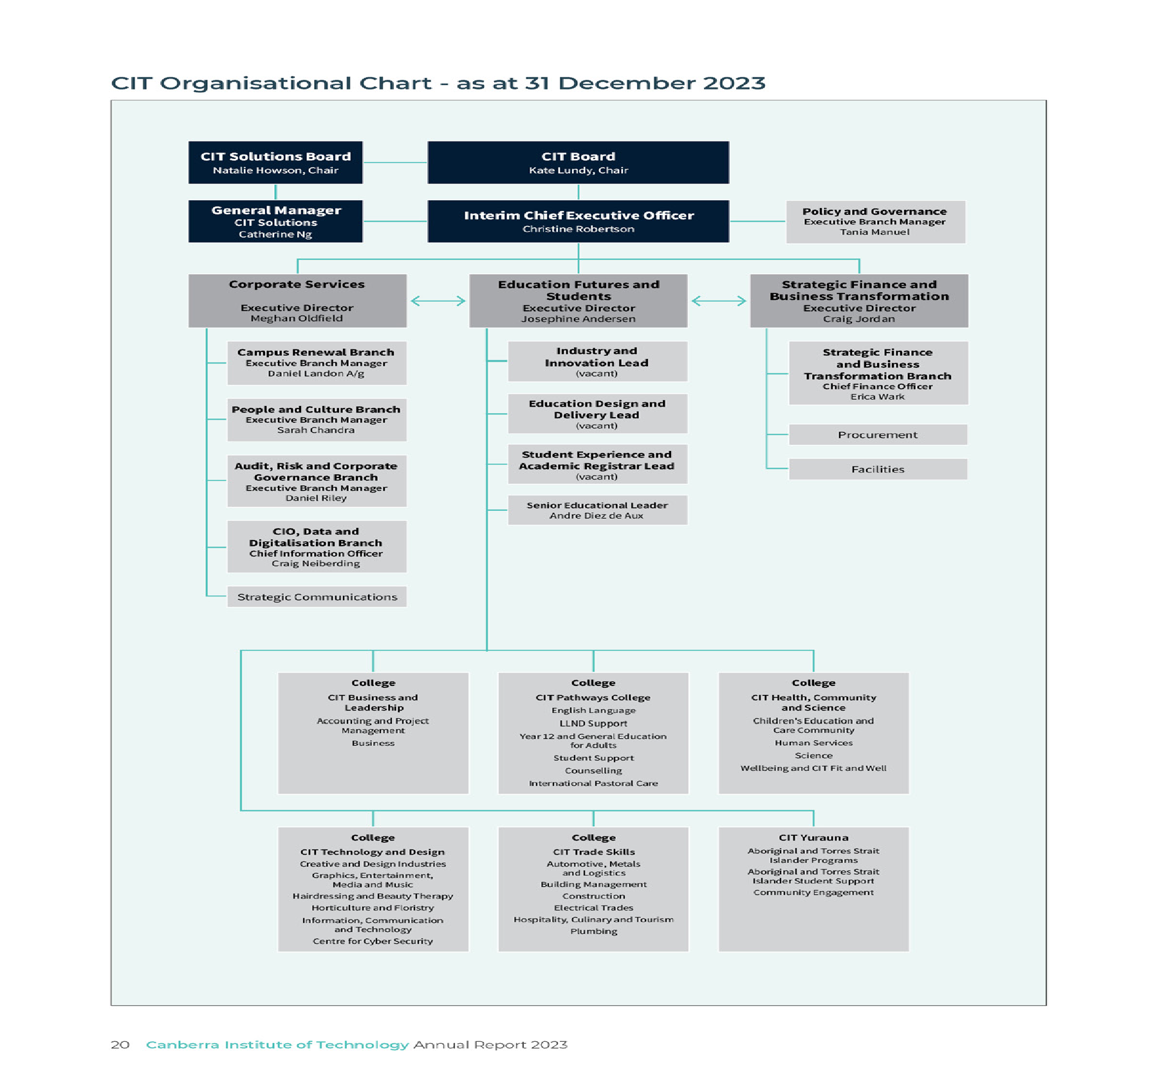

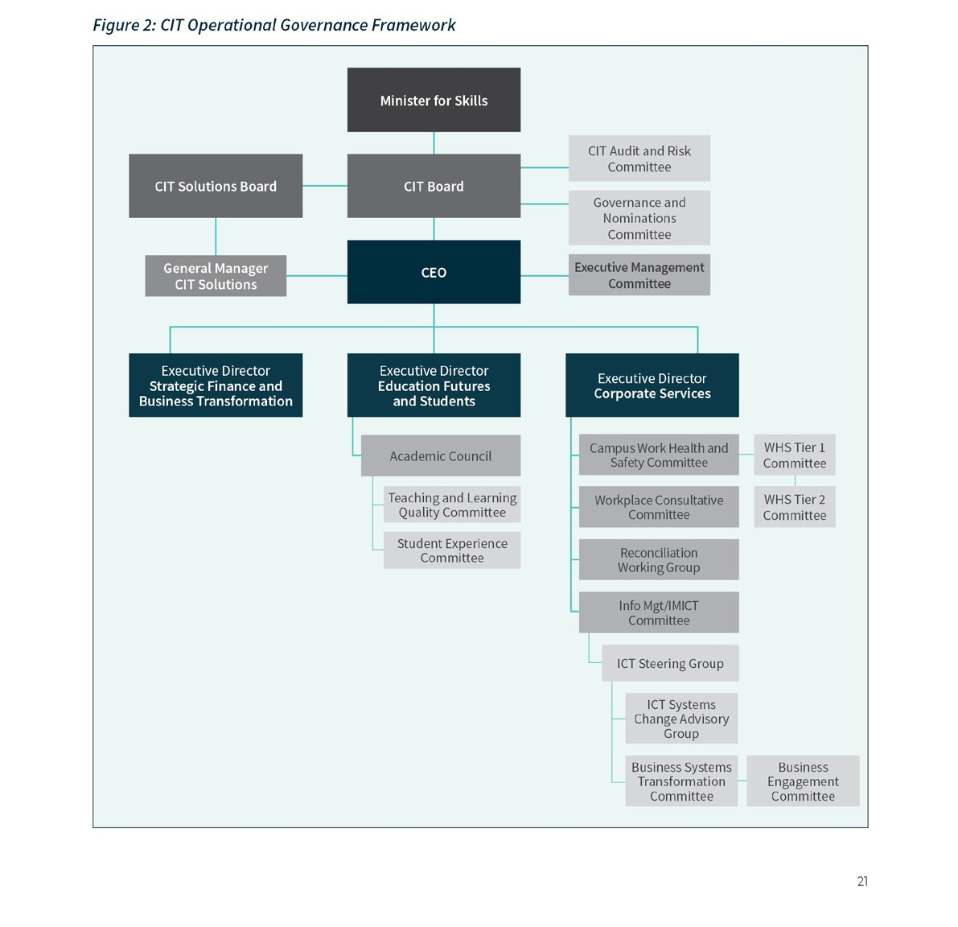
CIT Internal Governance
The CIT Operational Governance Framework provide guidance and directions for employees, students, other government directorates and the community as to how CIT ensures and applies appropriate governance arrangements across all of its decisions and activities.
The CIT Board and CEO are responsible for ensuring that CIT implements and maintains an appropriate governance framework. CIT Executive and Managers have responsibility for promoting a positive attitude towards compliance as part of organisational culture and continuous improvement of performance.
All CIT staff have individual responsibilities for compliance as a public servant and, as part of their work requirements, are encouraged to demonstrate compliance actions and behaviours.
The CIT Operational Governance Framework also establishes CIT’s operational level committees, subcommittees and working groups which inform decision making in the CIT. The committees:
- Support business/organisational operations to achieve corporate goals.
- Ensure that statutory and legal obligations are met.
- Manage risk.

Executive Management Committee
The Executive Management Committee (EMC) supports the CEO by providing timely, professional and ethical advice in relation to key strategic direction setting and the efficient and effective operation of CIT. The EMC is accountable for the performance outcomes of CIT through the implementation and monitoring
of strategic, operational, educational, people and financial business plans and processes and for ensuring that appropriate frameworks, delegations, policies, procedures and resourcing are in place to support the delivery of CIT strategic and operational objectives.
Academic Council
The role of Academic Council and its subcommittees is to provide critical internal oversight of CIT’s academic delivery and quality assurance arrangements and advise on matters relating to the quality and strategic direction of education and training at the Institute.
Academic Council operates with an annual workplan approved by EMC. The minutes of each Academic Council meeting are provided to EMC, and include any formal resolutions taken by Council. Resolutions endorsed by Academic Council are referred to EMC or the CIT Board for noting and/or approval.
Academic Council also provides quarterly updates to the CIT Board’s Audit and Risk Committee on its quality assurance monitoring and activities.
Reconciliation Working Group
The CIT Reconciliation Working Group engages collaboratively with all areas across CIT to advance reconciliation by implementing and monitoring the Reconciliation Action Plan and by gathering support and commitment through encouraging all CIT staff to participate in initiatives and events. Outcomes are reported to the EMC.
Teaching and Learning Quality Committee
The role of the Teaching and Learning Quality Committee is to report and make recommendations to the Academic Council on accreditation and quality of CIT’s vocational education and training and higher education programs and partnerships, including articulation arrangements.
Campus Work Health and Safety Committees
To facilitate cooperation between staff and management on the development, implementation and review of WHS policy and procedure and to monitor compliance with WHS legislation, standards, codes of practice, policies and procedures.
Tier 1 Work Health and Safety Committee
The Tier 1 Work Health and Safety Committee is established to:
- Facilitate cooperation between staff and management on the development,
implementation and review of WHS policy and procedures.
- Review information related to WHS performance to inform continuous improvement in the management of WHS.
- Monitor the management of CIT’s WHS Risk Register.
- Monitor the implementation and resolution of corrective actions arising from WHS audits and inspections.
- Monitor the implementation and resolution of issues arising from Tier 2 Work Health and
Safety Committee meetings via the Tier 2 WHS Committee Chair.
- Provide input and share initiatives to improve work health, safety and wellbeing across the institute.
- Coordinate engagement and strategies to promote and manage student health and safety.
- Provide input and consideration of injury prevention and injury management priorities and initiatives.
- Report to the Executive Management Committee.
Tier 2 Work Health and Safety Committee
The Tier 2 Work Health and Safety Committee is established to:
- Facilitate cooperation between staff and management on the development,
implementation, and review of WHS policies and procedures;
- Review information related to WHS performance to inform continuous improvement in the management of WHS;
- Monitor the management of business unit WHS Risk Registers;
- Monitor the implementation and resolution of issues arising from workgroups including via HSRs and/or business unit management;
- Provide input and share initiatives to improve work health, safety and wellbeing across CIT;
- Coordinate engagement and strategies to promote and manage student health and safety;

- Provide input and consideration of injury prevention and injury management priorities and initiatives.
Workplace Consultative Committee
CIT’s Consultative Committee (CITCC) is established, in accordance with the requirements outlined in the Enterprise Agreements (the Agreements):
- ACT Public Sector Canberra Institute of Technology (Teaching Staff) Enterprise Agreement 2021-2022, clause 106.5
- ACT Public Sector Canberra Institute of Technology Enterprise Agreement 2021-2022, Clauses G1.5.
The CITCC is established as the peak consultation forum between CIT and the unions bound by
the Agreements, on matters pertaining to the employment relationship.
Information Management and Communication Technology (IMICT) Committee
The CIT Information Management and Information and Communications Technology Committee (IMICT) was established to serve as a strategic advisory and decision body responsible for guiding the effective planning, implementation, and optimisation of IMICT resources within CIT. It ensures good governance, so CIT’s vision and Digital Transformation is aligned to support CITs needs now and into the future.
This committee supports the strategic relationship between CIT and broader ACT Government to ensure CIT’s ICT investment portfolio and Information Management is delivered in a financially sustainable manner, consistent with ACT Government policy where appropriate, and supports CIT’s ongoing digitalisation and data efforts.
The Information Communication Technology Steering Group
The role of the CIT Information and Communications Technology Steering Group (ICTSG) is to orchestrate and synchronise the various CIT digital capabilities to ensure that they support CIT’s digital vision. The focus of the ICTSG is on the operational level, by ensuring that individual tactical ICT changes are prioritised and are integrated into whole-of-CIT architecture, and that the boundary issues between the various systems are managed and controlled.
It reviews Change Advisory Group approvals and the health of key systems and initiatives under development via status reports and approves new
project initiation requests. The ICTSG will also support the Data and Digitalisation Portfolio to review and approve operational project change and exception
reports, and the outcome of assurance processes, including stage gate outcome reports.
Information Systems Advisory Change Group
The role of the Systems Advisory Change Group is to manage the day-to-day operations of specific CIT systems and coordinate required system upgrades and modifications to meet user requirements.
Business Systems Transformation Committee
The role of the Business Transformation Committee (BTC) is two-fold. Firstly, to review improvement requests recommended by the Business Engagement Committee and prioritising them based on predetermined criteria, assessing factors such as alignment with strategic goals, return on investment, risks and potential impact to stakeholders. Secondly, the Committee has a role to endorse feasible new systems or enhancements from the Business.
The Committee ensures that all system changes are aligned with the CIT Digital Transformation Strategy, and the organisation is kept well informed and ready for any proposed change. It provides advice and recommendations to the ICT Steering Group
(ICTSG) and maintains the link between the Data and Digitalisation Branch, Cloud Campus Program and the CIT Business regarding any system change impacts.
Business Engagement Committee
The role of this Committee is to act as the ‘front door’ and initial vetting mechanism for proposed business system improvements and process enhancements. The Committee will review and recommend feasible new systems or enhancement requests from the Business by engaging directly with requestors, coordinating presentations of needs and concepts and in-depth discussions to gain a comprehensive understanding of each proposal.
Subsequently, the Committee recommends qualified and feasible proposals to the Business Transformation Committee for further evaluation and potential implementation. This multi-step process ensures that impactful and aligned initiatives are prioritised for progress to higher levels of review and action.

B2 PERFORMANCE ANALYSIS

Accountability Indicators: Summary of Performance
CIT delivers VET through ACT Government Controlled Recurrent Payment (CRP), Fee-Free TAFE, the ACT Government Skilled Capital program, funding for Australian Apprenticeships, the JobTrainer Program and commercial activities delivered by CIT and its subsidiary, CIT Solutions. The CIT Budget for 2022-23 and 2023-24 is shown below (from CIT Statement of Intent 2023-24 ACT Budget Statements B, Chief Minister, Treasury and Economic Development Directorate (page 146):
Output Class 1: Provision of Vocational Education and Training Services
This output involves the provision of places in publicly funded programs at CIT, consistent with training needs for the ACT.
Table 2: Provision of Vocational Education and Training Services ($’000)

2023 Target |  | 2023 Actual
Total Cost ($’000) | 134,926 | 139,176
Controlled Recurrent Payments ($’000) | 81,195 | 84,209
Note(s): Total cost includes depreciation and amortisation of $13.875m in 2022-23 and $18.720m in 2023-24.
In 2023, student activity data for the ACT Budget accountability indicators (shown below) are included in all activity delivered by CIT, excluding any students enrolled at CIT Solutions. CIT has four accountability indicators for the 2023 academic year; subject enrolments, subject pass rates, learner satisfaction rate and employer satisfaction rate. These are described in the CIT Statement of Intent (CIT Statement of Intent 2023-24 ACT Budget Statements B, Chief Minister, Treasury and Economic Development Directorate (page 147) and further information is available in the Statement of Performance in Part C.
Strategic Objective: Student Outcomes
CIT’s objective is to provide training that meets student needs ensuring a job ready skill set for our future workers.
Strategic Indicator: CIT has continued to improve graduate outcomes in employment related indictors for the past five years. This objective has been met.

Output Class 1: Provision of Vocational Education and Training Services
Table 3: Accountability Indicators July to June Financial Year

2023 Target |  | 2023 Actual
a) Subject Enrolments | 100,000 | 97,324
b) Subject Pass Rates | 85% | 86%
c) Achieve key output targets:
i) Learner Satisfaction Rate | 85% | 88%
ii) Employer Satisfaction Rate 1 | 80% | 91%
- In 2023 there were 97,324 subject enrolments, 3% below the target of 100,000: This Target was not met.
- CIT recorded an 86% subject pass rate in 2023, 1% above the target of 85%. This Target was met.
- The 2023 Learner Engagement Survey (LES), which seeks feedback on student’s experiences about their training and assessment quality, found 88% of respondents were satisfied with the training at CIT in 2023. This Target was met.
- Overall, 91% of respondent employers were satisfied with CIT training in 2023, compared to 89 % in 2022. This Target was met.

The results for 2023 are detailed in the following sections.

Subject Enrolments
Subject Enrolments refers to student enrolments in each ‘Unit of Competency’ for the reporting period, as opposed to a full qualification. In 2023 there were 97,324 subject enrolments, 3% below the target of 100,000.
The number of subject enrolments for 2022 was 93,701, 8% below the target of 108,000. This accountability indicator was introduced in 2021. Comparative data across the three years has seen a 12.8% decline with subject enrolments falling from 111,464 in 2021 to 97,324 in 2023 (14,230 less).
The decline in subject enrolments is attributed to a combination of the flow-on effects of reduction in enrolments post-COVID and the strong local
employment market reducing the immediate demand for training.

Subject Pass Rate
Subject Pass Rate refers to the proportion of subject enrolments issued with a grade indicating successful completion of the ‘Unit of Competency’ during the reporting period.
CIT recorded an 86% subject pass rate in 2023, 1% above the target of 85%. This was the same result recorded in 2021 and 2022.

National Student Outcomes Survey
CIT’s key strategic objective is to provide vocational education and training that meets student and employer needs. The National Student Outcomes Survey, conducted annually by the National Centre for Vocational Education Research (NCVER) provides one measure of success. By focusing on students’
employment outcomes, the Student Outcomes Survey gauges how well CIT serves individuals, employers, and the community. The Student Outcomes Survey also collects information on VET students’ reasons for training, satisfaction with training, and further study outcomes. This data provides for a comparison across other state and territory TAFE Institutes. As illustrated in Figure 3 below, in 2023, CIT graduates exceeded national performance in all but one area; ‘enrolled in further study after training’. This shows an impressive performance in employment related indicators, the best results in the country.
Areas of assessment include:
- Employed after training.
- Not employed before training, employed after training.
- Employed or in further study after training.
- Enrolled in further study after training.
- Achieved main reason for training (reasons for studying include getting a job, gaining extra skills for current job, changing careers, getting a better job, and developing or starting a business).

Figure 3: Performance of CIT graduates against other Australian TAFE graduates 2023
100
90
80
70
60
50
40
30
20
10
0
Employed after training
Not employed before training, employed after training
Employed or in further study after training
Enrolled in further study Achieved main reason
after training
for training
CIT Graduates
TAFE and Other Government Providers Australia
Percentage

In percentage (%) terms, the results for CIT graduates in 2023 are:
- 87.4% were employed after training compared with 77.7% nationally.
- 61.4% who were not employed before training, were employed after training compared with 50.1% nationally.
- 92.6% were employed or in further study compared with 87.7% nationally.
- 32.7% were enrolled in further study after training compared with 36.6% nationally.
- 90.1% achieved the main reason for study compared with the national average of 86.6%.
These results in ‘employment related indicators’ have also improved over time. As shown in Figure 4 below, CIT has continued to improve graduate outcomes in employment related indicators for the past five years.

Figure 4: NCVER Student Outcome Survey 2023 Graduate Outcomes 2019 – 2023
CIT Graduate outcomes (2019 - 2023)
100
90
80
70
60
50
40
30
20
10
0
Employed after training
Not employed before Employed or in further training, employed after study after training
training
Enrolled in further study after training
Achieved main reason for training
2023
2022
2021
2020
2019
Percentage

Student Experience
CIT is committed to providing high-quality student experiences that enable students to meet their lifelong learning goals and improve their career prospects. This includes accessible, high-quality, and relevant skills and training, and opportunities to engage with industry.
The 2023 Student Outcomes Survey, conducted annually by the National Centre for Vocational Education Research (NCVER), found 90.1% of CIT 2023
graduates achieved the main reason for training. The 2023 Learner Engagement Survey (LES), which seeks feedback on student’s experiences about their training and assessment quality, found 87.7% of respondents were satisfied with the training at CIT in 2023.
CIT student support includes access to free and confidential services including counselling, disability support, tutoring, migrant support, and careers advice. The CIT Student Association (CITSA) also supports student wellbeing through social programs and events.

Employer Satisfaction Rate
The Employer Satisfaction Rate is measured through the annual Employer Satisfaction Survey, completed by employers of apprentices and trainees undertaking study at CIT. The CIT Employer Satisfaction Survey includes a series of 32 questions aligned to Australian Skills Quality Authority (ASQA) compliance requirements for Registered Training Organisations (RTOs).
Overall, 90.6% of respondents were satisfied with CIT training in 2023, compared to 89% in 2022. CIT’s satisfaction rate is higher than the 2023 ACT average satisfaction rate of 81.6%, which is the highest of all
the states and territories. Employer satisfaction rates at CIT have remained positive over 10 years, as shown in Figure 6 below.
Questions with the greatest increase in satisfaction from 2022 include:
- The training organisation was flexible enough to meet our needs – up 8% (86.7% to 94.7%).
- The training organisation developed customised programs – up 6% (81.7% to 87.7%).
- Trainers were effective with their teaching – up 4.3% (90.7% to 95%).
Questions with the greatest decrease in satisfaction from 2022 include:
- The training used up-to-date equipment, facilities, and materials – down 5.9% (90.7% to 84.8%).
- The training resources were appropriate for learner needs – down 2.1% (93.9% to 91.8%)
- Training resources and equipment were in good condition – down 2.0% (94.4% to 92.4%).

Figure 6: Employer satisfaction with CIT Training 2013 to 2023
100%
90%
80%
70%
60%
50%
40%
30%
20%
10%
0%
94.1%
89.2%
85.0%
87.5%
85.1%
87.4%
89.5% 89.9% 90.0% 89.0%
90.6%
2013
2014
2015
2016
2017
2018
2019
2020
2021
2022
2023

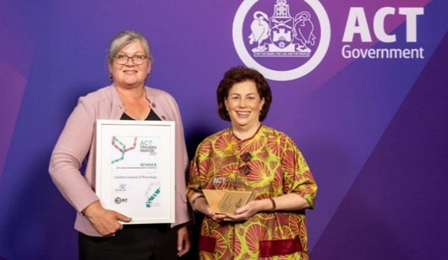
CIT Chair of the Board Ms Kate Lundy and Interim CEO Ms Christine Robertson accepting ACT Training Awards.

AWARD WINNING EDUCATION AND TRAINING
CIT won ACT Large Training Provider of the Year, while CIT educators, students and industry partners also received individual and collaborative awards,
as follows:
- ACT VET Teacher of the Year, Peter Redfern-Elliot (Hospitality, Culinary, Tourism)
- ACT Australian School-based Apprentice of the Year, Poppy Chalmers (Community Services)
- ACT Aboriginal and Torres Strait Islander VET Student of the Year, Emma Brown, Indigenous Apprenticeship Program (IAP) with CIT Solutions
- ACT Industry Collaboration Award, Women in Construction Program (Lendlease Construction ACT, Australian Training Company, Ginninderry SPARK, Creative Safety Initiative and CIT collaboration)

CIT Educators Making a Difference
Peter Redfern-Elliot is 2023 ACT Vocational Education and Training Teacher of the Year and was a finalist at the 2023 National Training Awards. On World Educators’ Day, October 27,
Peter said the greatest recognition any teacher can get is from their students. He explains: “That student, they got work in a café, I actually went there after they finished my course. They were so proud they got a job and said to me that I made a difference. They made the difference because
they believed in themself. It meant a lot to me.” Peter Redfern-Elliot the 2023 ACT Vocational Education
and Training Teacher of the Year with student.

WorldSkills 2023
WorldSkills raises the profile of vocational education and training, and demonstrates how skills and trades support individuals, communities, and the economy. WorldSkills competitions are held at regional, national, and international levels, and provide our students
with opportunities to benchmark their skill levels against peers, and compete for gold, silver, and bronze medals. In August 2023, 12 CIT students competed in the WorldSkills National Championships in Melbourne. Each student was supported by a CIT mentor throughout 2023 to assist in preparations.
Five CIT educators were also selected as judges.

CIT students claimed four medals at the championships, including gold for Floyd Lucas-Baxter in refrigeration and air conditioning, silver for Cooper Camden-Smith in wall and floor tiling, and bronze
for Charlie Elms in cabinet making and Lachlan Usher in plastering, pictured below with the Interim CEO Christine Robertson. Carpentry apprentice, Liam Dowling, was recognised with a Certificate of
Excellence and Rifaat Romzi received the Brody Young Star Award for the Most Potential, Creative
and Innovative Dishes in cookery.

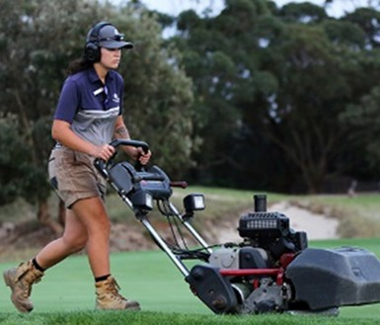
ACT Graduate of the Year
ACT Graduate of the Year, Annabelle (pictured) will progress to the national awards in Brisbane in June 2024. Annabelle said it was hard to believe how far she’d come after three years of study with CIT and her work with Royal Canberra Golf Course. CIT sports turf management teacher Jon Tait said the course attracted students from Canberra and surrounding regions, including the NSW South Coast and Riverina.

Advanced Construction and Engineering Bridge Challenge
An impressive 17 ACT school teams, and a record number of young women, competed in the 2023 CIT Construction and Engineering Bridge Challenge. Using only supplied materials, and under time constraints, students designed and built bridges that demonstrated creative application of a range of construction techniques. Teams received an award if their bridge could withstand a minimum static load of 40 kilograms.
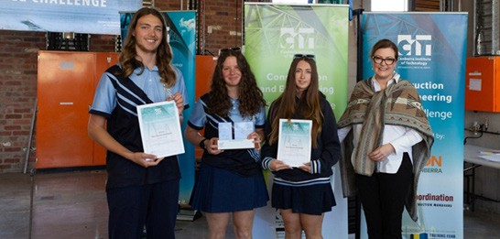
The Kingsford Smith Champs 1 team won for sustainable bridge design and construction.

2023 STRATEGIC PERFORMANCE HIGHLIGHTS

Launch of the ‘National Skills Agreement’ at CIT Fyshwick Campus
Alongside CIT educators, staff and students, Prime Minster Anthony Albanese launched the five-year National Skills Agreement (NSA), which was developed under principles agreed by National Cabinet and will take effect from January 2024. The NSA will involve co-investment by the Commonwealth, state and territory governments, with the Australian Government announcing it is prepared to invest $12.6 billion to expand and transform access to vocational education and training.
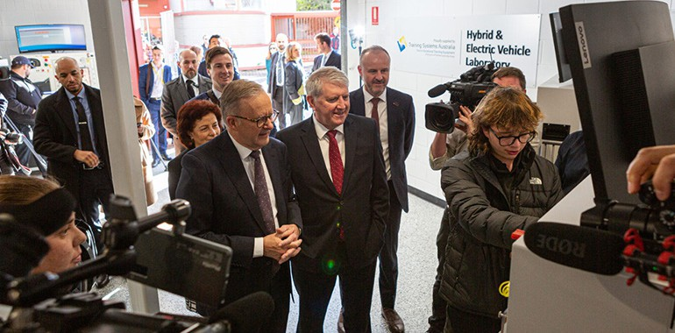
Prime Minister Anthony Albanese alongside CIT educators, staff and students at CIT Fyshwick Campus.

Degree-apprenticeship pathways for engineering CIT was provided $86,517 through an ACT Government Skilled to Succeed grant, to explore options for developing and piloting a unique degree apprenticeship in engineering. The project involves collaboration between the engineering industry, Australian National University (ANU) and other key stakeholders. The aim is to develop a blended work and study program to equip future workers with the practical and knowledge-based capabilities to support industry, and capitalise on opportunities presented through the ACT Government’s climate action and future energy policies.
Brewing for Success: supporting emerging industries – CIT was provided $79,740 through an ACT Government Skilled to Succeed grant, to consult with Canberra’s emerging brewing and distilling industry, and partner with BentSpoke, to develop a new and innovative workplace training program.
Leadership and Management Training: CEA Technologies – CIT collaborated with leading ACT organisation, CEA Technologies, to deliver
leadership and management training. CIT developed a fit-for-purpose program to provide relevant and contextualised skills training specific to CEA’s environment which provides advanced active phased array systems to satisfy demanding defence needs in the sea, land, and air domains.

Fee-Free TAFE – Skilling up our region’s economy
Fee-Free TAFE is a joint initiative of the Australian, state and territory governments, providing tuition- free courses to students wanting to train, retrain or upskill. In 2023, CIT delivered the ACT’s Fee-Free TAFE program, of 2,530 places across 81 approved courses, including 31 care sector courses, seven pre- apprenticeships and four foundation skills courses.
The top six Fee-Free TAFE courses by enrolment were:
- Certificate IV in Cyber Security (22603VIC) – 264 enrolments
- Certificate III in Early Childhood Education and Care (CHC30121) – 227 enrolments
- Certificate III in Business (BSB30120) – 163 enrolments
- Certificate IV in Community Services (CHC42015) – 139 enrolments
- Certificate IV in Mental Health (CHC43315) – 96 enrolments
- Diploma of Project Management (BSB50820) – 671 enrolments.
Fee-Free TAFE at CIT supported skills development in priority learning areas targeted at Canberrans from priority learning groups including:
- 166 First Nations enrolments
- 909 young people enrolments (aged 17-24)
- 1,087 job seeker enrolments
- 246 unpaid carer enrolments
- 697 enrolments for people with a disability
- 1,567 (62%) enrolments for women, including 449 enrolments for women in financial hardship and 24 enrolments for women in non-traditional fields of study
- 58 humanitarian visa holder enrolments and 165 enrolments for other eligible visa holders
- 165 enrolments for other eligible visa holders
- 31 veteran enrolments.
CIT has welcomed the continuation of Fee-Free TAFE by the Australian and ACT governments, enabling CIT to deliver another 3,600 places over three years from 2024 onwards.
In October 2023, CIT achieved the enrolment commitment of 2,530 Fee-Free TAFE enrolments valued at $7.95m. The ACT has committed to the extension of Fee-Free TAFE which will see 3,600 fee-free places delivered between January 2024 and December 2026, valued at $7.36m.

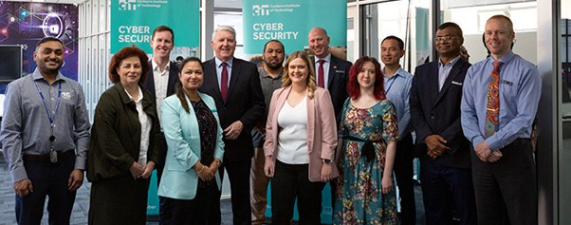
Federal Minister for Skills and Training Brendan O’Connor and ACT Skills Minister Chris Steel make the announcement at CIT Reid Campus while meeting with students already benefitting from Fee-Free TAFE.
Figure 7: Number of Fee-Free TAFE Enrolments by Priority Group 2023
1800
1600
Women
1400
1200
Unemployed
1000
(17-24)
800
With Disability
600
400
Carers
200
First Nations
Migrants
Refugees
0
1
2
3
4
5
PRIORITY GROUP
6
7
8
Veterans
9
NUMBER OF ENROLMENTS

CIT Fee-Free TAFE students Ava, Annabelle and Jason are studying Early Childhood Education and Care (pictured below). Ava, Annabelle, and Jason are learning how children develop, how to care for young children and how to support families and carers to create a supportive, enriching community for Canberra’s children.
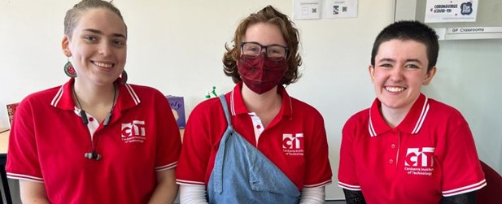
CIT Fee-Free TAFE students who are studying Early Childhood Education and Care.

Apprentices and Trainees
Apprenticeships and traineeships combine work,
on-the-job experience and structured training to learn a trade or skills, and receive a nationally recognised qualification. In 2023, CIT had 3,654 apprentices and trainees in training, including 68 who trained through CIT Solutions and 290 Australian School-based Apprenticeships (ASbAs).

Women in Trades
In November 2023, CIT partnered with Lendlease and the Umbrella Collective to deliver a five-week introduction to construction program to 15 students. This industry-led collaboration was funded through an ACT Government Skilled to Succeed grant and designed to support women and gender diverse people into the construction industry. It did this by:
- CIT delivering five accredited units of competency, including all of the required tickets/licenses to work on a construction site in the ACT, as well as non-accredited training in resume writing and interview skills.
- The Umbrella Collective providing wrap around support to participants, including travel, counselling, mental health support, mentoring, meals and referrals to other community support organisations. A case manager was with the group every day to address issues and answer questions.
- Australian Training Company – a group training organisation – providing employment information and offering seven traineeships on conclusion of the program.
- Creative Safety Initiatives – a private registered training organisation – delivering non-accredited training in mental health, bullying and harassment, gender equity and awareness, safe and respectful workplaces, and workplace health and safety hazard identification.
- The ACT Building and Construction Training Fund Authority providing subsidies for training.
- Icon Construction ACT also providing employment opportunities to participants.
The goal of this program was to remove barriers, increase awareness and open doors for women and gender diverse people to enter the industry. This was achieved through:
- Flexible training delivery to provide participants with a taste of industry and attract parents with school-aged children.
- Industry insights and career advice to give participants a better understanding of the types of careers available, both on and off the tools, in the construction industry.
- Cultural Awareness Training to provide participants with an understanding of Aboriginal and Torres Strait Islander cultures and histories.
- Personal protective equipment being provided to participants for their practical lessons at CIT and employment.
- Additional wraparound support for participants, including presentations from community organisations such as Legal Aid ACT, to ensure participants understood their rights at work.
- Celebrating the student success with a graduation ceremony.
This program was highly successful with all fifteen participants completing the program.
Case study – Women in Construction Program
CIT was proud to be one of Lendlease’s industry partners delivering the Lendlease Women in Construction Program. The program, funded through an ACT Government Skilled to Succeed innovation grant, provided fifteen women and gender-diverse people
an opportunity to gain practical knowledge about the construction industry, as well as the necessary skills, personal protective equipment, tickets, and licenses to support industry entry.

Picture from: Creating opportunities for women in construction - Our Canberra (act.gov.au)

CIT Woden Campus - Artist impression

CAMPUS RENEWAL
The CIT Campus Renewal team coordinates renewal activities across CIT’s five campuses, including planning for the move to the new CIT Woden Campus and relocation of Yurauna to the CIT Bruce Campus. The team works with ACT Government agencies to ensure CIT contributes to the culture, economy, and vitality of the ACT region, and ensures the campuses are catalysts for connecting students and industry through education, innovation, culture, and social inclusion.

CIT Woden Campus Project
CIT’s new 22,500m² Woden Campus will be a contemporary, flexible, smart and sustainable facility for 6,500 students each year at the site of the former bus interchange. The new campus will open a range of new collaboration opportunities for CIT students, with local businesses, industry and the broader community. From Semester 2025, courses currently delivered at the CIT Reid Campus will be delivered from the new CIT Woden Campus.
This state-of-the-art educational campus, facilitated through digitally enabled learning and innovation spaces will open a range of new collaboration opportunities for CIT students, with local businesses, industry and the broader community. In 2023, CIT worked with Major Projects Canberra (MPC), CIT
staff and students, ACT Government directorates, consultants and the community in the design and construction of the new CIT Woden Campus.
Throughout 2023, CIT continued to facilitate student workshops and staff specialist working groups. The feedback received from the working groups and

workshops has underpinned the design development, reflecting design excellence within the public realm and the CIT Woden Campus. CIT has conducted over 193 staff workshops and 38 student workshops during the design development phase of the project.

Community
Lendlease and CIT are leveraging existing and creating new relationships with the Canberra community and industry organisations to maximise and support the training outcomes under the CIT Learning Tool, supported by the ACT Government JobTrainer Initiative.
Partners already involved include SPARK Ginninderry, Lendlease sub-contractors and the Australian Training Company (ATC). This also includes support and guidance to CIT students from the following community organisations:
- Case management and mentoring of CIT students by UnitingCare Kippax as part of the Lendlease Women in Construction Initiative.
- Yerrabingin collaborating with CIT Yurauna students to provide an in-depth overview and understanding of Yerrabingin, their current projects, particularly the CIT Woden Campus Project and the type of career pathways available.
- Gray Puksand Architects providing guest lectures to CIT Interior Design students on ‘Professional Practice’.
- Case management and mentoring of CIT students by The Umbrella Collective as part of the Lendlease Women in Construction Initiative.
The connection with First Nations communities continues to be a key design development element, with the building façade, inspired by local fauna and

the Brindabella ridgeline landscape. The façade of the building mirrors the shape and form of the ridgelines, creating an aesthetic educational piece that tells of dreamtime stories and songlines. In 2024, CIT will form part of the Arts Steering Committee led by Major Projects Canberra, and an Arts Advisory Group led by Lendlease to commission artworks by Aboriginal and Torres Strait Islander persons.

Social Objectives
A key objective of the construction project is to improve employment and social outcomes in the construction industry. The training and diversity targets seek to:
- Increase participation of women in construction, across all sectors of the industry.
- Encouraging economic participation of Aboriginal and Torres Strait Islander people across the project with additional focus relating to the Yurauna package of works.
- Providing meaningful employment opportunities for those in our community living with disability.
- Supporting workers from culturally and linguistically diverse backgrounds.
Lendlease, as the construction company, has committed to training and diversity targets for CIT Woden Campus Project in collaboration with CIT, as a part of social and education commitments. Courses in Asbestos Awareness and White Card training
were delivered in the Woden Construction and Employment Hub throughout 2023.
The key targets of this project are tracking well, as shown below.
Lendlease’s subcontractors and consultants also provided a range of unpaid work experience placements for five CIT students during the construction of CIT Woden Campus during 2023 as part of the Understanding Building and Construction Program.
Opportunities for work experience for CIT staff and students will be on offer in areas such as, but not limited to, building design, interior design, engineering drafting, project management, and Work Health
and Safety (WHS). These opportunities are planned to commence in 2024.

Figure 8: CIT Woden Campus Project – key training and diversity targets

Project Commitment Targets Status

6,300 skilling and training hours  Includes site tours with CIT staff and students, Women in Construction Pathways Program, Asbestos Awareness, Silica Prevention and White Card Training, Understanding Building and Construction Program, and Work Placements. | As of 31 December 2023, Lendlease had completed 5,205.5 hours with 1,096.5 hours remaining - 82.5% completed.
15 new Australian School-based Apprenticeships (ASbAs) for girls. | As of 31 December 2023 - 100% completion.
15 new apprenticeships for women. | As of 31 December 2023 - 100% completion.
Commitment for people working on the project to be made up of 10% apprentices/trainees. | At or below the 10% target.  For October 2023, the apprentices/trainees workforce rate was 8%.
15% stretch target for participation of women in the design and construction of the project. | Continuously at or above the 15% target. As of October 2023, the female and gender- diverse workforce rate was 27%.
Commitment for people working on the project to be made up of 4% First Nations people. | Continuously at or above the 4% target. As of October 2023, the First Nations workforce rate was 5%.

CIT Yurauna
CIT continues to work collaboratively with Major Projects Canberra (MPC) on the establishment of CIT’s Aboriginal and Torres Strait Islander Educational Centre of Excellence, CIT Yurauna at
CIT Bruce Campus. The new CIT Yurauna will include new learning and community spaces, and an early childhood and education centre. In 2023, a functional design brief (FDB) was finalised. The FDB covers
the architectural planning requirements, design principles, siting requirements, and general building requirements for CIT Yurauna. It was developed in consultation with CIT Yurauna, MPC and First Nations stakeholders including the United Ngunnawal Elders Council (UNEC). The brief is a joint document with the Aboriginal Cultural Design Conceptual Directions Report prepared by Indigenous design and strategy consultants Balarinji.
The FDB and the Balarinji Aboriginal Cultural Design Conceptual Directions Report have been compiled through a number of engagement sessions leading to a conceptual design that helped with the translation of requirements and understanding of detailed inclusions. In May 2023, a request for tender was released and a design contract was then awarded
to Guida Mosely Brown Architects and Kaunitz Yeung Architects to develop the design for the new
CIT Yurauna.
CIT and CIT Yurauna have collaborated through stakeholder meetings and co-design workshops to establish scope, constraints and project objectives. This engagement included the development of a consultation plan, identification of key stakeholders and protocols, and development of a design program,
including scheduling of key briefing sessions. Guida Mosely Brown in close collaboration with MPC, CIT and CIT Yurauna developed a consultation plan to inform the communication and engagement with the stakeholders during the CIT Yurauna design
process. Stakeholder and community engagement will continue in 2024 during the design phases to ensure an iterative process of understanding perspectives.
The CIT Yurauna construction request for tender will be released early 2024.

Yurauna delivers
CIT Yurauna provides wraparound support for Aboriginal and Torres Strait Islander students at CIT, including study, personal, family, financial and
employment support. Yurauna trained 534 students in 2023. In 2023, Yurauna saw 24 students complete certificates across General Education, Alcohol and Other Drugs, Community Services, and Aboriginal and
Torres Strait Islander Cultural Arts, with other students continuing their studies in 2024. As part of this, Yurauna provided training to students at the Bimberi Youth Justice Centre and through the Job Readiness program, in partnership with the Community Services Directorate. Yurauna continued its partnership with Relationships Australia, which provided fortnightly access to counsellors for staff, students, and the wider Aboriginal and Torres Strait Islander community.
The Yurauna Early Childhood Centre provides Aboriginal and Torres Strait Islander staff and students access to early childhood education and care. Over the course of 2023, the centre cared for 24 children, including for parents and carers participating in the Job Readiness Program.

CIT shop of the future
On 20 November 2023, the Canberra Institute of Technology Student Association (CITSA) announced the launch of a new campus convenience store, YalaPlus, at CIT Bruce Campus, enabled by Amazon’s Just Walk Out technology. CIT is the first education institution in the southern hemisphere to deploy Amazon’s Just Walk Out technology.
Amazon’s Just Walk Out technology, uses artificial intelligence (AI) like computer vision and deep learning techniques to accurately determine what shoppers take or return to shelves, and simplifies the shopping experience by removing checkout lines - helping students to get in and out quickly and seamlessly.
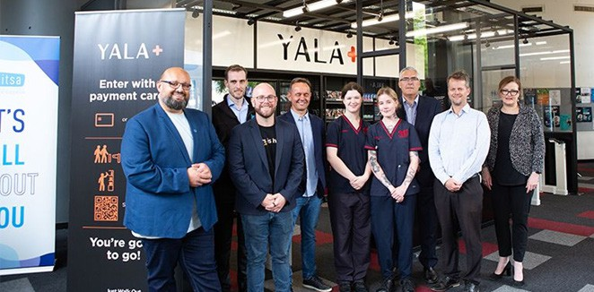
The Canberra Institute of Technology Student Association (CITSA) announce the launch of a new campus convenience store, YalaPlus, at CIT Bruce Campus, enabled by Amazon’s Just Walk Out technology.

INDUSTRY SKILLS NEEDS
In 2023, CIT continued to deliver courses to support our students professional and personal growth, and address the skills needs of local employers. Our commitment to continuous improvement means
course design and delivery is reviewed on an ongoing basis to ensure CIT’s programs are future-focussed, and graduates’ knowledge and skills meet emerging industry needs.

Community Work
- There was a record number of 36 applications for the Mental Health Consumer Scholarship, with 24 new places offered.
- The department conducted 14 Mental Health First Aid sessions, providing essential training for nearly 200 participants.
- Diploma of Community Development students hosted a successful Trivia Night, drawing around 200 attendees. The fundraiser generated $9,000 (pre-expenses), to support the Grind to Ground social enterprise.

Human Services
The Australian Nursing and Midwifery Accreditation Council (ANMAC) granted CIT accreditation to deliver the Diploma of Nursing for a five-year period, from 28 March 2023 to 27 March 2028. No conditions have been applied to delivery, a rare achievement for an RTO. The Nursing and Midwifery Board of Australia (NMBA) also approved the program.
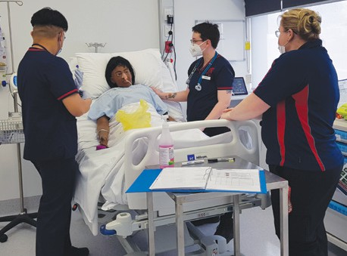
Nursing simulated learning environment

Science
Animal Ethics Committee: CIT animal courses are unique, compared to other programs, because they require direct interaction and assessment with live animals. CIT Science maintains a presence of animals at CIT Bruce Campus, including fish, dogs, cats and native mammals. This diverse range guarantees students are well prepared for their chosen paths in animal-related careers. To uphold ethical standards, an Animal Ethics Committee (AEC) oversees these activities.
In 2023, the AEC implemented a new Animal Policy and Complaints Procedure to safeguard the health and wellbeing of all animals being used at CIT.
Memorandum of Understanding RSPCA: A Memorandum of Understanding (MOU) with the RSPCA was established to support delivery of animal programs. This agreement enables CIT Science to foster kittens and cats, which is essential
for assessment purposes. Simultaneously, it provides opportunities for students to engage in activities at RSPCA and, most importantly, facilitates student placements.
Memorandum of Understanding – Sydney Dogs and Cats Home: CIT Science continued its partnership with Sydney Dogs and Cats Home, by
fostering and assisting with the adoption of two litters of kittens. This arrangement not only supports a
not-for-profit organisation, but also provides valuable learning opportunities for students to gain firsthand experience with kittens and cats at various life stages.
CIT Science Student Excursions
Certificate IV in Environmental Monitoring and Technology (MSS40222)– Geology South Coast Excursion
The Certificate IV in Environmental Monitoring and Technology includes excursions to enhance students’ practical knowledge. These events provide invaluable opportunities to observe diverse landscapes and common geological landforms, and analyse water and rock samples. An excursion to the NSW South Coast supported students to gain an appreciation for factors that influence landscape development in the Southern Highlands and NSW South Coast regions, and contributed to their understanding of the long- term landscape history of the area.
CIT Science Animal Staff Professional Development – National Zoo and Aquarium
Staff were fortunate enough to receive VIP access to the National Zoo and Aquarium, offering exclusive behind-the-scenes experience of aquatic animal care.
Educators found the experience highly beneficial and incorporated ideas and processes into the management of aquariums at CIT.
Certificate IV in Laboratory Techniques (MSL40122) – Pathology Excursions
For the first time in 2023, 11 graduates of the Certificate III in Laboratory Skills (MSL30122) completed work experience at the two main pathology providers in Canberra. This provided students with valuable real-world experience of how techniques and theory learned at CIT translate to the pathology industry, and helped to prepare them for entry into the workforce.
Feedback from students:
“I wanted to take a moment to express my gratitude for the incredible experience I had recently. The system, equipment, staff, and overall environment truly exceeded my expectations. Thank you sincerely for providing me with such a valuable opportunity, and I am so excited about next semester.”
– Certificate III student.
“I enjoyed the work experience especially in histology and molecular biology, there are so many new things to learn. The team members of every unit are helpful, and they explain everything well. Thank you for giving me this opportunity to learn.” – Certificate IV student.
Certificate IV in Veterinary Nursing (ACM40418)
– Wombat Sanctuary Excursion
Certificate IV in Veterinary Nursing students visited a wombat sanctuary, gaining practical experience for the Native Mammals unit. The sanctuary operator graciously extends an invitation to our students each semester, allowing students to acquire extensive knowledge about wombats.

CIT Dog Day Care
CIT Dog Day Care, a simulated training environment and business, was fortunate to secure funding for a shade structure to ensure protection and comfort for staff, students, and dogs.
Students get hands-on experience in caring for dogs.

Diploma of Early Childhood Education and Care students at a storytelling workshop in Burrumbah Early Learning Centre.

Children’s Education and Care
Burrumbah Early Learning Centre, located at CIT Bruce Campus, is used as a simulated environment for training and instructional purposes for students studying in the early childhood sector. In 2023, use of the facility was opened up to three organisations from the early childhood sector. These opportunities allow for a greater connection with the sector and the community more broadly. These arrangements enable our students to make relevant connections with
the community and the families they will work with, further enhancing our reputation as a provider.
The department also continued the Early Learning Connection program (Baringa Early Learning) pilot program. Baringa Early Learning was awarded a National Careers Institute Partnership Grant for training in the Certificate III in Early Childhood Education and Care (CHC30121). The purpose of the project was to:
- Create greater awareness and practical experience for women in the early childhood education profession.
- Enhance partnerships between leading tertiary and training organisations, and established employers in the early childhood education profession, with a shared commitment and investment in enabling women’s workforce participation and ongoing career development in the profession.
The commencing cohort of 20 were provided customised delivery, and additional academic support and wrap-around support services, such as coaching and counselling.
As part of the 2023 capital works program, an Education Support simulated learning environment was created for the Certificate IV in School-Based Education Support (CHC40221) program, providing students with an authentic environment to best prepare them for the transition to the workplace.
In 2023, the department commenced flexible delivery of the Certificate III and Diploma of Early Childhood Education and Care (CHC30121) to allow enrolments throughout the year; meeting the regulatory requirements of the sector and providing another learning delivery option for students. This initiative resulted in significant enrolments.

Wellbeing
The Community Assistance and Support Program (CASP) Skills for Carers program, funded by ACT Health, has provided flexible training for family carers in the ACT since 1995. CIT’s Health, Community and Science college has been involved in this program since the outset. CIT Skills for Carers facilitators all have professional qualifications in a health-related field.
In 2023, over 1,000 carers received our newsletter. In addition, over 30 workshops were held, including First Aid, Mental Health Awareness, Mindfulness and Meditation. Classes included Strength and Conditioning, Healthier Carers and Yoga. A total
of 1,000 carers participated. In mid 2023, CIT was advised that the Community Assistance Temporary Supports (CATS) program would replace the existing Community Assistance Support Program (CASP) and the Flexible Family Support (FFS) and Transitional Care programs from 1 October 2023.
The Indigenous Allied Health Australia (IAHA) ACT National Aboriginal and Torres Strait Islander Health Academy (the Academy) program commenced in 2022. This program provides First Nations students, in years 10, 11 and 12, with an opportunity to complete a Certificate III in Allied Health Assistance (HLT33021) in combination with their senior secondary studies.
As the program training provider, CIT works in partnership with IAHA, along with partners such as Canberra Health Services and the University of Canberra Clinic, to provide students with training
skills and experience in allied health. In 2023, the ACT program grew to include 12 students.
In 2023, the department offered First Aid training to staff and students at reduced or no fee.

Digital skills training in Tuggeranong
The Certificate III in Information Technology (ICT30120) (IT) moved from CIT Reid Campus to CIT Tuggeranong Campus, with classes commencing in July 2023. This relocation provided students with improved facilities for training and provides CIT with additional capacity to meet the region’s growing need for digital and technical IT skills. The relocation occurred after extensive consultation with industry partners, students and staff.

ICT and Cyber Security Student Pathways events
ICT and Cyber facilitated two networking events at CIT Tuggeranong Campus. These events provided students with opportunities to connect with a variety of industry representatives, including Canberra Cyber Hub, Department of Foreign Affairs and Trade, KPMG, Leidos, Attura and Fifth Domain.

Closing the Cyber Skills Gap – Work-Integrated-Learning pilot
The Closing the Cyber Skills Gap - Work-Integrated- Learning pilot was a collaboration between CIT, Canberra Cyber Hub, the Future Skills Organisation (FSO), and private training organisations, designed to produce job-ready cyber experts to bridge the skills gap and bolster Canberra’s cyber security workforce.
The pilot included a four-week Power-Skills Bootcamp and four micro-credentials, featuring a combination
of hands-on training, theoretical knowledge, and industry-focused collaboration, to equip interns with the skills needed in the rapidly evolving world of cyber security.

Essential Eight Assessment Course
On 4 July 2023, the Australian Cyber Security Centre, in partnership with TAFEcyber launched the rollout of the co-developed Non-Accredited Training Essential Eight Training for cyber security professionals. This course aims to build the capabilities of government and industry to enhance Australia’s cyber resilience.
The Essential Eight Assessment Course has been designed by the Australian Signals Directorate’s Australian Cyber Security Centre (ACSC) and is delivered in partnership by TAFEcyber.
This course uses a blend of specialist knowledge, experience and hands-on technical training to enable cyber security and ICT professionals to understand the ACSC’s Essential Eight Assessment Guidance Package and the Essential Eight Maturity Model.
These skills and knowledge will enable participants to effectively assess and improve their organisation’s cyber security posture.
Students learn the intent and application of ASCS’s Essential Eight mitigation strategies, how to use ASCS-designed tools, how to accurately test the implementation of the Essential Eight security controls and how to develop an accurate actionable assessment report.

The first graduates of the Closing the Cyber Skills Gap - Work-Integrated-Learning pilot will help address a critical shortage of professionals needed to safeguard the ACT’s digital environment.

A night of originals and covers from CIT Music Performance students, hosted by the CIT Music department, MICFest features an eclectic line-up of tunes spanning jazz/improv fusion and rock/pop, plus some interesting re-interpretations of contemporary classics from CIT student bands. All the music is performed by CIT music performance students, with live sound coordinated by CIT sound production students.

Design, Music, Photography, and Visual Arts
As a culmination of their course, students across Fashion Design, Graphic Design, Interior Design, Music, Photography, and Visual Arts came together in individual End of year Exhibition events.
These events were student-led, with invitations extended to industry representatives, and provided students an opportunity to curate and showcase their talent, collaborate, celebrate and network with employers.

Photography
‘Captured’ was an end of 2023 academic year celebration that showcased a year of unforgettable moments captured through the lenses of CIT’s emerging student photographers at the High Court of Australia. The website displays their achievements as they showcase their finest work, representing the culmination of their 2023 CIT journey, at: Captured! At the High Court (cit-captured.photography)
cit-captured.photography/

Screen and Media – The Buzz!
Diploma of Screen and Media studies produced a regular show known as ‘The Buzz’ to support learning the technical and creative skills in a simulated work environment. For each show, students invite guests, produce segments, and grapple with the challenges of live television (TV) production.
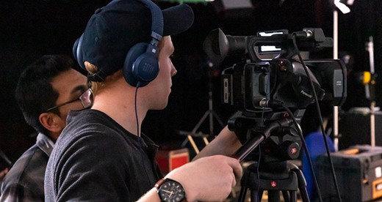

Hairdressing, Barbering, Makeup and Beauty Therapy
Special guest and former student of CIT, Claudia Cataldo, addressed students and guests at CIT Hairdressing, Barbering, Makeup and Beauty Therapy Awards Night. The evening was an opportunity to celebrate CIT’s partnerships with industry and our students in the hair and beauty industry.

The Hair and Beauty Bar at CIT is a salon open to the general public and staffed by supervised apprentices and full-time students who work in industry. At the CIT Hair and Beauty Bar, the community can enjoy a wide range of services including semi, demi and permanent hair colouring, style cuts, conditioning treatments and blow-dries. The CIT salon is Sustainable Salons Australia accredited, meaning 95% of all salon waste is successfully recycled. The Beauty Bar offers a range of body treatments, massage, facials, body-wraps, manicures and pedicures and waxing treatments.

Work Experience and Support Program
The ACT Government’s Work Experience and Support Program (WESP) sets students up with understanding many of the skills needed in government administration roles over six weeks.
Many of the students already have postgraduate qualifications, from Australia and overseas, and many of the participants have previously worked in areas such as accounting, IT, Sales and marketing and finance.
Students study a nationally recognised Certificate II in Workplace Skills (BSB20120) and take part in eight weeks of full-time work experience in various administrative roles throughout the ACT Government.
Work Experience and Support Program (WESP) students.

Trade Skills
Construction and High Risk Department Split
In the second half of 2023, the Construction and High-Risk department split to form two separate
departments: one focusing on Carpentry and Cabinet Making, the other on High Risk and Finishing Trades. This restructuring resulted in more effective and efficient management of the respective areas.
Carpentry and Cabinet Making
CIT’s carpentry and cabinet making courses are meticulously designed to provide students with specialised skills and in-depth knowledge essential for mastering these crafts. The carpentry course offers training in constructing, installing, and finishing buildings, while the cabinet making courses focus on
the precision and artistry required to create and install cabinetry and fine furniture.
Through a blend of theoretical learning and practical experience, students engage in hands-on projects that simulate real-world scenarios, ensuring they develop proficiency in using tools, materials, and techniques specific to these trades.
CIT’s expert instructors, guide students through every step, from interpreting plans and measurements, calculating and cutting advanced roofing structures to applying finishes. Graduates from CIT’s carpentry and cabinet making courses emerge ready for industry, ready to excel in their chosen field and contribute to the construction and manufacturing industries with their expertise.

High Risk and Finishing Trades
- Success in Finishing Trades: The Finishing Trades area had a busy year, with three educators serving as judges at the National WorldSkills competition in Melbourne. Students from the department
also won a silver and a bronze medal for wall and floor tiling.
- Engagement with Schools: Educators participated in the Try a Trade Day, where up to a hundred school students visited CIT and engaged in practical trade activities. This engagement helps introduce young students to potential career paths in the trades.
- Transformations in Glass and Glazing: The glass and glazing area underwent significant transformations aimed at growth and innovation. Despite challenges, the team embraced change and successfully implemented a comprehensive package update ahead of schedule.
- Investment in Equipment and Facilities: Following the package update, the team conducted a thorough audit and invested in cutting-edge equipment, including a double head glass drill press, an aluminium up saw, and a double belt glass sander. Additionally, a new $2.1m structure was approved to enhance facilities and support growth.
- High-Risk Safety Training: The High-Risk department continued to provide safety training, including courses on Working Safely at Heights, Confined Spaces, Elevated Work Platforms, Forklift operation, Dogging, Rigging, Hoist training, and Tower Crane operation.
Overall, these developments demonstrate a commitment to excellence, innovation, and providing quality education and training in the Carpentry, Cabinet Making, High Risk, and Finishing Trades departments.

Automotive and Metal Fabrication
- Certificate III in Automotive Refinishing Technology (AUR32420) – Spray Booth Technology: The Certificate III in Automotive Refinishing Technology course was fortunate to receive capital funding for the design and construction of two state of the art automotive spray booths. The new facilities enable greater alignment with industry standards, flexibility with delivery, and place CIT at the forefront of
educational training delivery. Due to efficiency of the new spray booths and paint technology being used in the training environment we have been able to reduce our overall energy consumption by 70%.
- Certificate III in Automotive Refinishing Technology (AUR32420) – Women in Trade: The Certificate III in Automotive Refinishing Technology course has seen a significant uptake for woman in trades with 30-35% of our current student cohort made up of female apprentices.
- Certificate III in Metal Fabrication – Fabrication Trade (MEM31922) – Advanced Manufacturing:
CIT staff were privileged to visit ANU facilities on 21 July 2023, which included site tours
at Mount Stromlo Observatory and ANU manufacturing facilities. Staff discussed training and collaboration opportunities to address the advanced manufacturing skills shortage, and this has informed the future development of training options being provided.

In a world where gender stereotypes and biases continue to shape career choices and opportunities, women at Canberra Institute of Technology (CIT) are breaking barriers and making their mark in traditionally male-dominated industries.

Hospitality, Culinary and Tourism
The Hospitality, Culinary and Tourism (HCT) department hosted many wonderful events that provided students unique learning opportunities to develop their skills, knowledge and collaborate with industry experts.
Examples include:
- The Proud to be a Chef dinner event held on 18 May was successfully crafted by the culinary and hospitality students, who collaborated with some of Canberra’s inspiring chefs and apprentices from the Akiba, Wilma and Loquita restaurants and Canberra Southern Cross Club. Students presented an outstanding three course dinner for the Canberra community.
- The HCT team collaborated with 13 embassies in Canberra to design a menu to incorporate 13 different cuisines to host a Latin American Gastronomy and Cultural Festival (dinner) for 130 people on 16 November.
- 40 culinary students were provided with the opportunity to be creative with Italian provolone cheese and contended in a competition on 15 November supported by celebrity chef Luca Ciano with a winning prize pool totalling $4,000.
- The HCT team worked closely with the Australian Olive Association to prepare and cook a menu for 120 people on 26 October incorporating olives/ olive oil in every dish.
Furthermore, the event management students showcased their event skills in hosting the TASTE event on 2 June, providing a taste for Hospitality, Culinary and Tourism to 250 college students.

CIT Taste
CIT Taste showcased career possibilities in bakery, patisserie, commercial cookery, events, hospitality, travel, and tourism. Senior secondary students participated in fun, hands-on practical activities, workshops, and heard from CIT graduates about their professional journey and how CIT kick-started their careers.

Building, Engineering and Design
CIT’s building and construction courses are designed to meet the needs of builders and managers of small to medium-sized building businesses, including selecting contractors, overseeing the work and its quality, and liaising with clients. We also have several building design courses providing practical skills in drafting and producing three-dimensional models for building designs.
The delivery of our commercial courses in Asbestos Awareness, White Card, and Silica exposure prevention, continue to be well-received by Industry and schools alike, ensuring we have healthy student numbers of over 5,000 students on an annual basis. This coupled with the delivery of our six standard programs ensures we continue to be the one-stop construction stop for the ACT and surrounding regions.

Plumbing
The CIT Plumbing Trade offers a range of plumbing courses each day of the week through a mixture of theory and practical course work, delivered in state- of-the-art plumbing facilities and equipment.
Course offerings include:
- Certificate III in Plumbing – incorporating subjects of Common, Roof, Water, Sanitary, Drainage and Gas (CPC32420), (CPC32620), (CPC20720).
- Certificate III in Roof Plumbing (CPC32620).
- Certificate II in Drainage (CPC32620).
- Post Trade Courses in the evening and weekends: Drainage, Gas Fitting Plumbing, Water Plumbing, Plumbing Work Practices Sanitary Pipework, Temperature Control Devices and Duct Installation.
Pathways towards trade-related qualifications and plumbing or gas fitting licences also allow for CIT plumbing apprentices to have their industry
skills assessed through recognition of prior learning (RPL) and to undertake gap training to gain a
trade qualification.

Electrical Trades
The CIT Electrical Trades includes the delivery of qualifications in:
- Certificate III in Electrotechnology Electrician, Air Conditioning and Refrigeration and Electronics and Communications; (UEE30820), (UEE3220), (UEE30920) and
- Certificate II in Electronics (UEE21920) and Commercial courses in Renewable Energy and Restricted Electrical.
Non-accredited training was delivered in September 2023 in Electric Vehicle charging systems and regulations.
A highlight for the department in 2023 was one of our students achieving a Gold medal at the WorldSkills Australia national competition for Refrigeration and Air Conditioning.

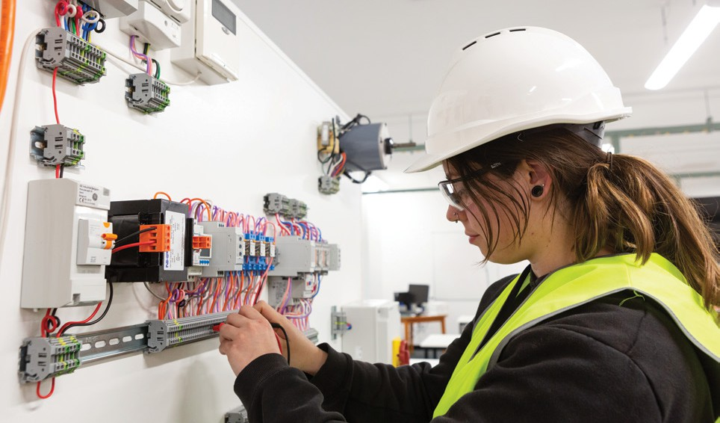

CIT SOLUTIONS
CIT Solutions Pty Ltd, established in 1988 as a wholly owned subsidiary of CIT under the Corporations Act 2001 to undertake commercial activities in delivery, development and customisation of training programs as well as consultancies, research and analysis in
the learning, personal development and training field. CIT Solutions’ audited financial statements are consolidated within CIT’s financial statements in this report (see Part C). The CIT Board appoints the CIT
Solutions Board including the appointment of two CIT Board members, one as Chair. The CIT Board receives regular performance reports from CIT Solutions.
CIT Solutions supports government agencies locally, nationally and internationally in their workforce development and capacity building. One of our flagship programs is the Indigenous Apprenticeship Program (IAP) in partnership with Services Australia. CIT Solutions supports First Nations learners for successful careers in the Australian public services, aligning with the whole-of-government priority
of ‘Closing the Gap’. Emma Brown, an Indigenous Apprenticeship Program (IAP) participant, was celebrated as the Aboriginal and Torres Strait Islander Student of the Year at the Australian Training Awards 2023.
The Centre for Modern Languages (CML) achieved success in 2023, delivering language training in 27 foreign languages to government agencies through our dedicated 150 language instructors and tutors, reinforcing CML’s position as a leader in language training.
Aligned with our diversification and growth strategy, a noteworthy accomplishment was gaining accreditation from the ACT Board of Senior Secondary Studies as a Specialist Education Provider for Y11 and Y12 foreign language studies, scheduled to commence in 2024.

CIT Solutions 2023 at a glance
- Learners enrolled in accredited programs – 1,908
- Learners enrolled in Indigenous Apprenticeship and Development programs – 599
- Aboriginal and Torres Strait Islanders learners studying at CIT Solutions – 642
- Learners enrolled in non-accredited professional short courses – 1,547
- Learners enrolled in recreational short courses – 1,036
- 27 foreign languages and 150+ language instructors and tutors
Despite a slower uptake of non-accredited professional short courses in the public training calendar, strategic adjustments are underway to enhance their appeal. In addition, we are reviewing our recreational short course offerings to reignite community interest.
Projected revenue to the end of December is
$11.086m with a minor operating loss of -$0.175m. The ratio of current assets to current liabilities is at
2.98: 1 and with net assets of $4.717m, demonstrating CIT Solutions is in a solid financial position.

CIT Solutions Employees
- 66 core employees
- 193 flexible workforce.
Emma Brown, well respected in the Australian Public Service and the First Nations community of the
ACT, recently completed a Diploma of Government (PSP50122) with CIT Solutions, as part of the 12-month Indigenous Apprenticeship Program (IAP). Emma said she commenced the IAP program as she “wanted to have a stable income, expand her skillset and be able

Emma Brown – Aboriginal and Torres Strait Islander Student of the Year, ACT and National Training Awards 2023.

to network with a range of people, and to prove to herself that she is able to accomplish anything she puts her mind to, even with a learning disability”.
Emma’s uplifting spirit and positive feedback were a constant source of encouragement and enthusiasm for her colleagues, peers and others working in the Australian Public Service.
She is also well-known for her tireless support and contributions to the Aboriginal and Torres Strait Islander community of the ACT and the wider Canberra region.
As we celebrate Emma Brown, we acknowledge how one person can make a significant positive impact on the community and in their workplace.

Skills for the Care Economy
CIT Solutions provides My Aged Care Learning and Development Services to the Department of Health. Through our MyMACLE online learning platform, 258 learners enrolled in My Aged Care training
competencies. There were also 134 learners enrolled in the Continuous Professional Development (CPD) modules and 31 enrolments in Home Support and Reablement programs.

Skills for Information Security
In support of the Australian Signals Directorate’s agenda to ensure higher standards for security assessments, CIT Solutions offered six Infosec Registered Assessor Programs (IRAP) and introduced a new one-day IRAP Annual Renewal Exam. We
also have developed a 2-day Information Security Management (ISM) Fundamentals program for Commonwealth government agencies to better prepare for IRAP Assessments.

Global reach
CIT Solutions supports CIT by promoting courses and studying in the ACT to prospective students
worldwide through the CIT International Student Unit.
Facing post-Covid challenges and contending with constraints on the reduced number of international student program offerings, the CIT International Student Unit successfully implemented a strategy to foster recovery and spur growth. The number of international students at CIT in 2023 increased by
approximately 9% compared to 2022. There were 535 international students from 62 countries compared with 486 international students in 2022.
Due to the anticipated changes from the Australian Government migration review, it has reduced the student enrolments of the final term of 2023 and is likely to impact future enrolments.
The CIT International Student Unit continues to work closely with our education partners and government agencies in target key markets to drive enrolments. In 2023, we worked closely with the Indonesian Ministry of Education, Culture, Research, and Technology
to support eight participants under the Indonesian International Student Mobility Awards (IISMA) to complete six months of studies at CIT.
CIT Solutions continues to be a trusted and responsive education provider delivering bespoke training services, enriching the lives of Canberrans and Australians each year by offering lifelong learning opportunities.

B3 SCRUTINY

ACT Legislative Assembly Inquiries
In 2023, there were three Legislative Assembly inquiries related to the CIT. There were no recommendations directly attributed to the CIT.

Standing Committee on Justice and Community Safety (Legislative Scrutiny Role)
The Standing Committee on Justice and Community Safety in a report entitled: Scrutiny Report 33 and dated September 2023, examined five Disallowable Instruments regarding the appointment of the CIT Board Members without comment.

Standing Committee on Education and Community Inclusion
The Government had one recommendation relating to CIT in the Committee’s report dated April 2023 and entitled: Inquiry into Annual and Financial Reports 2021-2022. Recommendation 12: The ACT Government reintroduce certified Auslan courses through the Canberra Institute of Technology.
The Government ‘Noted’ this recommendation in June 2023 and responded with the following comment: “CIT will work with Skills Canberra to explore the viability of establishing Auslan courses. Deaf Services Australia has a Training Initiative Funding Agreement (TIFA) to deliver Auslan in the ACT.”

Select Committee on Estimates Inquiry into Appropriation Bills 2023-24 Government Responses
This Select Committee made seven Recommendations relating to CIT and the Government responded to all, as follows:
Recommendation 20: The Committee recommends that the ACT Government expands the CIT Gungahlin footprint, offering more study options/courses to north-side residents in the next CIT Strategic Compass (strategic plan).
Government response Noted. The Government is supportive of increasing CIT courses at CIT Gungahlin Campus – subject to future Budget decisions. This will be dependent on market analysis and finding appropriate teaching spaces in Gungahlin for expansion.
Recommendation 21: The Committee recommends that the ACT Government expand Fee-Free TAFE.
Government response Existing Government Policy. Proposals on the expansion of Fee-Free TAFE are being developed for consideration in collaboration with the Commonwealth Government.
Recommendation 22: The Committee recommends that the ACT Government explore further opportunities to reduce out-of-pocket costs experienced by TAFE students.
Government response Existing Government Policy. The Government is supportive of exploring further opportunities to reduce out-of-pocket costs for TAFE students, including apprentices and trainees including through extensions of Fee-Free TAFE.
Recommendation 23: The Committee ecommends that the ACT Government expand the AUSLAN course offering at CIT.
Government response Agreed in principle. The Government provides training subsidies for AUSLAN courses for Registered Training Organisations with a Training Initiative Funding Agreement through the
Skilled Capital program. Government Response to the Select Committee on Estimates 2023-2024: Following release of the report of the Inquiry into access to services and information in Auslan, all AUSLAN qualifications and the Diploma of Interpreting were added to the ACT Skills Needs List. The Government agrees in principle to explore delivery of AUSLAN courses, noting this is demand-driven and dependent on appropriately qualified teachers. A careful viability assessment will be required when revisiting these options, noting the Government, through Skills Canberra, currently subsidises an Auslan training provider in Sydney.
Recommendation 24: The Committee recommends that the ACT Government continue to support an increase in the number of women in the construction industry including setting a target such as 10% for procurement.
Government response Existing Government Policy. The Government has been consulting with the construction industry on targets as part of the development of a Women in Construction
Procurement Policy. The Government has not finalised

specific targets at this time noting that women make up 25% of the Australian construction workforce so 10% would therefore be lower than currently employed nationally. The Government has been consulting on a range of more ambitious targets, across apprentices, trades, organisations and management and supervisory roles.
Recommendation 25: The Committee recommends that the ACT Government continue to set targets
for apprentices and women on major projects and publish how this is monitored through the duration of these projects and compliance with these targets.
Government response Existing Government Policy. The Government will continue to review targets and opportunities to report on progress for apprentices and women in major projects. These form part of Local Industry Participation Plans submitted by suppliers to which they are held accountable under contractual arrangements.
Recommendation 26: The Committee recommends that CIT should work with EPSDD to undertake an audit of fossil fuel powered plant and equipment and develop a plan to replace these with zero-emissions alternatives when they reach end of life or by 2045 whichever is sooner.
Government response Existing Government Policy. An audit of CIT gas assets has already been undertaken as part of the whole of government audit to inform the electrification of Government gas assets program.

ACT Auditor-General
There were two Auditor General Reports in 2023 that mention CIT:
- Activities of the Government Procurement Board
- CIT is used as a case study.
- 2022-23 Financial Audits Overview – CIT received an “unmodified” rating overall.
An auditor’s report with an unmodified audit opinion is issued where the Auditor-General concludes the financial statements provide, in all material respects, a true and fair presentation of a reporting agency’s
financial performance and position in accordance with the relevant reporting and disclosure requirements.

ACT Ombudsman Reports
There were no ACT Ombudsman reports relating to CIT during the reporting year 2023.

Integrity Commission
During 2023, the ACT Integrity Commission continued its investigations regarding the circumstances surrounding the consultancy contracts to ThinkGarden and Redrouge Nominees Pty Ltd.

B4 RISK MANAGEMENT

CIT’s risk management functions are managed by the Audit, Risk and Corporate Governance Branch who report regularly to the Executive Management
Committee, the CIT Audit and Risk Committee and the CIT Board on risk related issues and initiatives.
CIT faces a range of strategic, operational and fraud and corruption related risks in its everyday business functions. CIT maintains a Strategic Risk Register, capturing risks, current controls, and treatment plans. In 2023, this register was reviewed and updated,
with key events such as the Integrity Commission investigation into contractual arrangements and changes to CIT Executive being reflected.
In 2023, there were twelve strategic risks on the register, across the categories of compliance/ regulation, technology, project, products and services, and operational. Treatment plans are in place for
risks with current controls assessed as ‘has room for improvement’. Progress on the treatment plans is monitored quarterly by the Executive Management Committee and CIT Audit and Risk Committee.
A comprehensive review of risk management arrangements across CIT commenced in late 2022 by the ACT Insurance Authority (ACTIA). In 2023, the recommendations for improvement contained
within the report commenced implementation under the newly established Risk Improvement Project, including:
- Risk management training run, in person for key staff and via eLearning for all staff.
- Commenced review of existing artefacts and development of new artefacts below:
  - Risk policy
  - Risk management plan
  - Risk focused reporting
  - Risk appetite statement
  - Risk champions model commenced implementation.
CIT will continue implementation of the Risk Improvement Project in 2024.

B5 INTERNAL AUDIT

CIT Audit and Risk Committee
CIT internal audit function and Audit and Risk Committee (Committee) is conducted in accordance with the ACT Government Framework for Internal Audit Committee and Function (February 2020), the International Professional Practices Framework and CIT Internal Audit Charter.
The Committee, a subcommittee of the CIT Board, performs a key corporate governance role within CIT, supported by the Head of Internal Audit and the Audit, Risk and Corporate Governance Branch. The Audit and Risk Committee provides independent, objective advice and assurance on risk and control, compliance, and external accountability responsibilities.
The Committee is authorised by the CIT Board to carry out its roles and responsibilities under the Audit and Risk Committee Charter and through the Audit, Risk and Corporate Governance team to:
- Obtain any information required from any employee and/or external party (subject to their legal obligation under the Information Privacy ACT 2014 and Public Sector Management Act 1994).
- Discuss any matters with internal or external auditors, or other external parties.
- Request the attendance of any employee, including the Chief Executive Officer, at Committee meetings.
- Obtain legal or other professional advice, as considered necessary to meet its obligations, at CIT expense.
The Committee meeting agendas are based on an annual program of work derived from CIT’s strategic risks, and responsibilities are documented in the Audit and Risk Committee Charter. The Committee also reviews and endorses the Audit and Risk Committee Charter and the Internal Audit Charter annually for approval by the CIT Board.
In 2023, there were four members on the Committee. The deputy Chair resigned from the Committee in April 2023, leaving a three-member Committee. In late 2023, the CIT Board appointed an additional Committee member to commence on 1 January 2024.
All members are currently Board directors and are remunerated as Board members. Independent members of the Committee are remunerated on a set rate per meeting attended under contract with CIT.
There were nine Committee meetings held during 2023, three of which focused on end-of-year financial matters. Members’ attendance at Committee meetings from 1 January – 31 December 2023 is detailed in the table below.

Figure 9: Audit and Risk Committee Members Meetings Attended 2023

Name of Member | Position | Duration | Meetings eligible to attend | Meetings attended
Ms Ros Jackson | Chair – Board Member | January – December | 9 | 9
Dr Margo Wade  (Resigned April 2023) | Deputy Chair - Independent member | January – December | 4 | 4
Professor Frances Shannon | Board Member | January – December | 9 | 9
Mr Paul McGlone | Board Member | January – December | 9 | 6
Mr Daniel Riley | Head of Internal Audit | January – December | 9 | 9

The Head of Internal Audit, in consultation with the CIT Executive, Directors and Senior Managers, is responsible for the development of an annual
internal audit program, based on CIT strategic risks, for endorsement by the Committee. Four audits were completed as part of the internal audit program
in 2023.
These were:
- Internal Audit Function and Internal Audit Program
- Procurement Practices at CIT
- Fees Management
- Financial Management Reporting.
The Committee receives reports of all internal audits and summaries of lower-level management reviews and educational compliance activities, and monitors progress of the program at each ordinary meeting through status update reports. Findings and actions to address audit recommendations are discussed and monitored to ensure they are on track and effectively addressing identified risks.
Enhancements to the internal audit function were made following the Internal Audit Function audit including the development of a central register to capture management-initiated reviews and audits across CIT as well as preliminary work to establish a quality assurance and improvement program. A
three-year strategic internal audit program was also established as part of this process.
CIT engages external auditors, sourced from the ACT Government panel of external audit service providers, to conduct the internal audit program.

B6 FRAUD PREVENTION

The Public Sector Management Standards 2016, ACTPS Integrity Framework and ACTPS Integrity Governance Policy outline the formal responsibilities of agencies to promote integrity and prevent fraud and corruption. CIT’s Fraud and Corruption Control Framework (the Framework), Fraud and Corruption Control Plan (the Plan) and Fraud and Corruption Policy (the Policy)
are the agency’s strategic documents that have recently been updated to raise awareness of fraud and corruption prevention and provide accessible information to all staff and students on the agency’s approach to prevention, detection, response and reporting of fraud and corruption. These documents were reviewed and endorsed by the CIT Audit and Risk Committee, CIT Board and the interim CEO.
The review of the documents included reminders to executives on their mandatory reporting obligations under the Integrity Commission Act 2018.
The Framework and Plan covers the period 2023 to 2025 and sets the benchmark on what a strong integrity culture will look like. The Framework and Plan is in line with the Fraud and Corruption Control Australian Standard AS8001:2021 and is
based on a thorough assessment of CIT’s integrity risks and identifies roles and responsibilities for all staff (including CIT teaching staff) and students
who equally have a role in promoting integrity and preventing and reporting misconduct, including fraud and corruption through their daily operations.
Fraud prevention and risk management remains an integral part of CIT’s strategy to tackle fraud and
corruption. The activities within CIT’s strategies will continue to be promoted, managed, and monitored regularly.

Fraud and Corruption Awareness
Education is the most effective method in building capability and raising awareness on preventing and reporting fraud and corruption. CIT have several strategies that aim at building awareness and preventing fraud and corruption as part of its core ongoing business. Some of these strategies have been communicated through CIT newsfeeds which are published on the intranet and are sent out to all staff weekly while others are embedded in CIT’s ongoing business. These include:
- Updating, communicating, and implementing CIT’s Fraud and Corruption Control Framework, Policy, and Plan.
- Updating and communicating CIT’s Fraud and Corruption Prevention intranet page.
- Information for all staff to declare any perceived or actual conflicts of interest on the CIT intranet.
- Information for all staff to declare the receiving or giving of gifts, benefits, or hospitality on the CIT intranet.
- Implementation of the agency’s 2023 internal audit program with two audits completed and two in near completion.
- Issuing newsfeeds through the intranet and all staff emails promoting education and awareness of other preventative measures of
fraud and corruption, including but not limited to; international anti-corruption day and methods in keeping CIT’s data assets safe.
- Fraud and ethics online training for all staff, which in 2023, had a completion rate of 36.5%.

Allegations of fraud or corruption reported
CIT is committed to ensuring all allegations of fraud and corruption are taken seriously, addressed appropriately, and ensuring confidentiality is always maintained. In 2023, the SERBIR received seven allegations of possible fraud. Two of the matters have been closed where one was not substantiated and the other resulting in appropriate internal action
being taken in line with the Enterprise Agreement. The other five matters were referred to the ACT Integrity Commission with one of the matters currently being investigated by the ACT Public Sector Standards Commissioner.
In 2023, there were two public interest disclosures received under the Public Interest Disclosure Act 2012 (PID Act). One of the disclosures did not meet the definition of disclosable conduct and was addressed through other avenues under the Enterprise Agreement. The other disclosure was investigated
in accordance with the PID Act and resulted in an unsubstantiated finding.

B7 FREEDOM OF INFORMATION

CIT is committed to the principles of open, transparent, and accountable governance, decision making and operations consistent with the objectives and provisions of the Freedom of Information Act 2016 (FOI Act). Summary data for each access application received during 2023 is provided below. Details of individual applications and decisions are published on the CIT FOI Disclosure log. cit.edu.au/about/freedom_of_information/ disclosure_log

Making an access application
To apply for access to information under the FOI Act please visit the Freedom of Information page at: Freedom of Information: Canberra Institute of Technology (cit.edu.au). There is no application fee,
but processing charges may apply. We publish details of FOI requests we receive, including the access application, decision, and any released documents, on the CIT Disclosure Log. We do not publish access applications for personal information.

Availability of open access information
Open access information is publicly available government-held information that can be freely used, reused, and redistributed (noting any copyright and attribution requirements). Open access information includes agencies’ functional information, policies, budgetary papers, information about government grants and other categories of government-held information listed under Section 23 of the FOI Act.

Figure 10: Open Access Information - Section 96 (3) (a) (i), (ii) and (iii)

Description Total

Number of decisions to publish Open Access information 22
Number of decisions not to publish Open Access information 0
Number of decisions not to publish a description of Open Access information withheld 0

Figure 11: FOI Applications received and decision type - Section 96 (3) (a) (iv), (vii), (viii) and (ix)

Description Total

Number of access applications received | 6*
Number of applications where access to all information requested was given | 1
Number of applications where access to only some of the information requested was given (partial release) | 0
Number of applications where access to the information was refused | 1
Number of applications transferred, withdrawn, completed outside of the FOI Act or still pending a decision at 31 December 2023 | 3
Number of applications where no requested information was held by CIT | 1
* Including 3 applications in progress as at 31 Dec 23.

Figure 12: FOI processing timeframes - Section 96 (3) (v) and (vi); Section 96 (3) (d)

Description Total

Total applications decided within the time to decide under section 40 2*
Applications not decided within the time to decide under section 40 1*
Number of working days taken to decide over the time to decide in section 40 for each application 10
* excluding 3 applications in progress as at 31 Dec 23. 1 application made in 2022 had decision extended by agreement with the applicant.

Figure 13: Amendment to personal information - Section 96 (a) (x) and Section 96 (3) (e)

Description Total
Number of requests made to amend personal information, and the decisions made 0

Applications for ACT Civil and Administrative Tribunal (ACAT) review
There were no applications for ACAT review under section 84 of the FOI Act in 2023.

Figure 14: Reviews – Section 96 (3) (b); Section 96 (3) (c)

Description Total

Number of applications made to Ombudsman under section 74 and the results of the application 0
Number of applications made to ACAT under section 84 and the results of the application 0

Figure 15: Fees - Section 96 (3) (f)

Description Total
Total charges and application fees collected from access applications 0

B8 COMMUNITY ENGAGEMENT AND COMMUNITY SUPPORT

VET Engagement and Outreach to School Aged Students
Research from the National Centre for Vocational Education Research (NCVER) indicates that work- based education can lead to better employment outcomes for VET students and provide productivity gains for employers in the form of job-ready workers.
CIT has designed a range of accredited and non- accredited courses specifically for high school and college students. These courses enable an opportunity for school students to experience
studies in a particular field or sample different fields to help them discover where they enjoy the most engagement. CIT also offered accredited and non- accredited short courses to support young people to develop skills, establish industry contacts and consider options for their future study pathways and careers.

School engagement
Skills development starts in our schools, and CIT delivered a range of programs and activities through the year to inspire and inform school students about the range of learning pathways on offer.
In 2023, CIT attended 18 career expos; delivered information sessions to approximately 20 government, catholic and independent school cohorts; and hosted tailored school engagement events, taster workshops and campus tours. Events included: CIT TASTE,
the Schools Cooking Competition, the Advanced Construction and Engineering Bridge Challenge, Studio 23, and Try-a-Trade.

Try-a-trade day!
To encourage women’s participation in the trades, CIT welcomed 100 young women from four ACT secondary schools to our Try-a-Trade Day in August. Activities included plastering, tiling, carpentry, concrete and materials testing, landscaping, and bricklaying. Participants were provided personal protective equipment, and completed white card, asbestos awareness, and silica prevention training prior to the day. Try-a-Trade was organised in partnership with the Office for Women and Education Directorate.

Studio 23
Senior secondary students were invited to
Studio 23, CIT’s showcase careers event for creative and arts industries. Students attended photography, graphic design, visual arts, fashion, interior design, screen and media, and music and sound production workshops, with CIT educators on-hand to answer questions and share their expertise.
Hosting around 100 year 11 and 12 students across the region on 14 September, CIT provided a hands- on showcase what it is like to pursue careers in the creative, entertainment and design industries.

Barbering – Canberra Homeless Connect
CIT barbering students extended a helping hand at Canberra Homeless Connect 2023, providing free haircuts and barbering services. Homeless Connect brings together people who are homeless or at risk of homelessness with free support services, including toiletries, haircuts, clothes, and food.

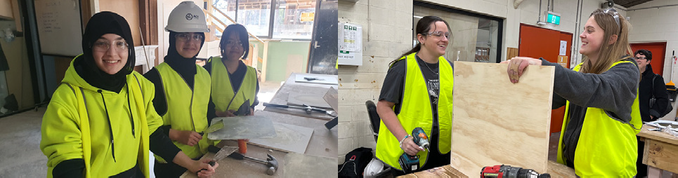
High school students getting hands-on experience in building and construction as part of the Try-a-Trade event.

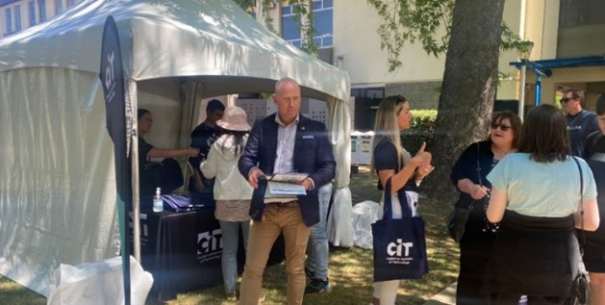

Visitors receiving welcome packs at CIT Reid

2023 Open Day
CIT welcomed over 2,000 attendees to Open Day 2023
- an integrated marketing campaign, across digital, print, radio, and out-of-home advertising, generated a high-level of interest across all campuses.
Visitors enjoyed over 95 activities across CIT’s three primary campuses at Bruce, Fyshwick, and Reid, including tours, presentation sessions, interactive workshops, displays and exhibitions. Attendees also had the opportunity to explore career options with specialist advisors and ask questions about courses and enrolment.
The event coincided with the opening of 2024 enrolments, allowing prospective students to enrol on the day.

Floristry at Floriade
CIT floristry teacher Narelle Phillips said Canberra’s tourism festival Floriade was a highlight for students every year and a wonderful opportunity to showcase their new skills. The students go through the full experience of creating a public floral display, including initial client meetings with Floriade organisers through to building their displays on site. Narelle said spring was an exciting time for CIT and its students, with
17 students recently touring Sydney for a two-day excursion. “We visited the Australian Botanic Garden Mt Annan, the Sydney Flower Market and prominent public displays in department stores and hotels. It’s just a great chance for students to see where a career in floristry can take them.”

Horticulture at Floriade
Pauline (pictured below) is one of five CIT horticulture students who has designed gardens for this year’s Floriade festival, with some 50 CIT students and apprentices also part of the garden builds and maintenance. CIT’s horticulture department linked with Canberra’s industry partners in landscaping give students the opportunity to get real job experience at Canberra’s prestigious tourism event.
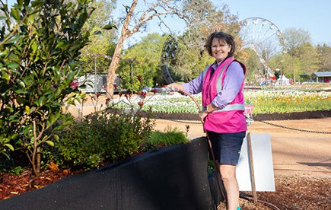

CIT Post School Senior Secondary Program
CIT aims to build academic skills and confidence for work and further study. Students can enrol in this course to gain an Australian Tertiary Admission Rank (ATAR) for university entry or improve an existing ATAR. CIT offers the Senior Secondary qualification for students in a supported and flexible environment.
In 2023, the program had 171 students enrolled, with 60 graduating in December. Of the 60 graduating students:
- 16 completed the Tertiary studies and received an ATAR. The highest-ranking student receiving a score of 91.1 and 38% receiving a score above 70.
- University offers were made to 11 ATAR graduates.
- 13 graduated the program with a Senior Secondary Certificate and a VET qualification.
- Two accredited students accessed the VET Pathway into university courses, having attained a Certificate IV.
- Three students received early entrance into university courses having completed Tertiary studies but opting not to receive an ATAR.
CIT has used historical data to create a program for 2024 onwards that reflects our cohorts’ needs and skills. The BSSS Psychology T/A course was taught in 2023 and Human Biology T/A has been adopted for 2024. Furthermore, Senior Science A has been developed and will be delivered in 2024. This unit caters for those students with an interest in the sciences but who lack the required skill set to enter specialist subjects such as Biology, Human Biology, Physics and Chemistry.
The year also saw the continuation of voluntary student participation in the Senior Secondary leadership group. The aim of the group is essentially to create activities and a culture that promotes student engagement and connectedness.
The group meets in their own time and this year were involved in a variety of projects, including:
- Helping to run barbeques for the Year 12 Cohort and for the CIT Student Association (CITSA).
- Organising, running, and participating in fundraisers.

Scholarships

Fee Assistance
The Fee Assistance program provides financial assistance for eligible CIT students experiencing financial hardship.
In 2023, the availability of JobTrainer and Fee-Free TAFE courses offered at no cost to the student, led to a decrease in the number of applications received.
Fee Assistance also assists with funding for eligible CIT students with a one-off payment ($150) towards the cost of a desktop computer or laptop through the CITSA Laptop Initiative program.
This initiative was launched during the COVID-19 pandemic to ensure that students had access to a device to study at home. The program is continuing post-pandemic as the shift to a cloud-based model has made it essential for students to have their own device.

Figure 16: Funding for CIT Fee Assistance 2023

Recipients Sponsor Support Purpose Amount

682 | CIT Fee Assistance | To assist CIT Students experiencing financial hardship with support towards eligible fees and/or course materials available through the CITSA Bookshops.  Support limits - up to 65% of outstanding invoices (after the initial $20 payment) and/or required course materials to a semester limit of $750 per student. | $172,504.10  inc GST
200 | CIT Fee Assistance | To assist eligible CIT students with a one-off payment ($150) for the purchase of a desktop computer or laptop through the CITSA Laptop Initiative program. | $30,000  inc GST

Adult Learners Week Scholarship
Student Hayley Drummond was invited to Parliament House to receive her scholarship from Federal Minister for Skills and Training, The Hon Brendan O’Connor MP to support her ongoing education. Hayley, who is studying Foundation Skills - also presented a special memento to her CIT educator, Fran Handoko, who nominated Hayley for the scholarship. Hayley gave Fran a hand-made figurine she had sculpted of her supportive educator.
Canberra Institute of Technology (CIT) student, Hayley Drummond, received a scholarship as part of Adult Learners Week.

B9 ABORIGINAL AND TORRES STRAIT ISLANDER REPORTING

CIT is committed to providing a culturally safe space for students, staff, and the community.
CIT is addressing the gap in educational outcomes through policy, programs and practices to attract and support Aboriginal and Torres Strait Islander students and improve their vocational education and training outcomes. CIT is also working to improve the Aboriginal and Torres Strait Islander staff experience and promote an understanding of reconciliation to everyone in our learning community.

Aboriginal and Torres Strait Islander Staff and Students
In December 2023, CIT employed 28 Aboriginal and Torres Strait Islander staff, representing 3.4% of
the staff cohort. Nine of these staff are in identified positions, open only to Aboriginal and Torres Strait Islander people. In 2023, CIT trained 674 Aboriginal and Torres Strait Islander students and CIT Solutions trained 631, representing 6% of the total student cohort for the year. A total of 90 scholarships were provided to Aboriginal and Torres Strait Islander students, 35 for Yurauna students and 55 students for Indigenous students not studying at Yurauna.
A further 120 Aboriginal and Torres Strait Islander students accessing CIT courses through the
Fee-Free TAFE.

Improved Leave for Cultural Activities and Reconciliation
The Staff Enterprise Agreements negotiated this year, including the ACTPS Canberra Institute of Technology Enterprise Agreement 2023-2026 - General Staff and ACTPS CIT Educators Enterprise Agreement 2023-2026 have improved leave entitlements for Aboriginal and Torres Strait Islander staff to attend ceremonies and other cultural activities, including 10 days paid leave (previously unpaid). This is an important provision
in ensuring our Aboriginal and Torres Strait Islander staff can fulfil their cultural commitments. The Enterprise Agreements also includes leave for all staff to participate in NAIDOC Week activities, providing opportunities for CIT staff to learn more about Aboriginal and Torres Strait Islander cultures
and achievements.

Working towards Reconciliation – Reconciliation Action Plan (RAP)
CIT has been working to develop its third RAP, building on the progress made from the previous Innovate RAP. After an Expression of Interest (EOI) process seeking new RAP Working Group members, 22 staff from across CIT volunteered to join. The Working Group met for multiple co-design sessions throughout the year to learn about reconciliation, identify actions, and develop a plan. The RAP will be launched in
2024, after a period of consultation and work with Reconciliation Australia.

First Nations Students Shine in 2023
Several Aboriginal and Torres Strait Islander students won awards in 2023, including:
Australian Training Awards
- Aboriginal and Torres Strait Islander Student of the Year – Emma Brown (CIT Solutions Indigenous Apprenticeship Program (IAP) Diploma of Government PSP50122).
ACT Training Awards
- ACT Australian School-based Apprentice of the year – Poppy Chalmers (Certificate III in Allied Health Assisting HLT33015 with IAHA/CIT
Wellbeing and Certificate III in Community Services CHC32015).
ACT 2023 NAIDOC Awards
- Person of the Year – Papunya Connors (Certificate III in Community Services CHC32015 and Certificate IV in Alcohol and Other Drugs CHC43215 at CIT Yurauna).
- Youth of the Year – Poppy Chalmers (Certificate III in Allied Health Assisting HLT33015 with IAHA/CIT Wellbeing and Certificate III in Community Services CHC32015).
- VET Indigenous Student – Jarrod Clarke (Certificate III in Glass and Glazing MSF30422).

Staff training – Cultural Awareness Training
In 2023, Yurauna delivered 11 Cultural Awareness Training sessions to 195 staff. This full-day training course aims to develop participants’ awareness and skills, including effective engagement with Aboriginal and Torres Strait Islander colleagues, students, and communities. The course introduces the history and impact of colonisation and reconciliation, builds understanding of Aboriginal and Torres Strait Islander culture and identities, and develops cross-cultural communication skills.

Encouraging Cultural Awareness
CIT continues to act as an industry lead to encourage a culture of diversity, respect and understanding with Aboriginal and Torres Strait Islander people and culture in the workplace and in community.
In addition to the Cultural Awareness Training for CIT staff, CIT also provides Cultural Awareness Training to external organisations. In 2023, CIT Yurauna delivered eight sessions to 97 participants. These training sessions were tailored to organisational needs and offered culturally sensitive training in a range of critical areas.

Mental Health First Aid
In response to COVID-19, CIT collaborated with Mental Health First Aid (MHFA) Australia to deliver an Aboriginal and Torres Strait Islander MHFA course, with a focus on supporting Aboriginal and Torres
Strait Islanders managing mental ill health or a mental health crisis.
In 2023, Yurauna delivered three Aboriginal and Torres Strait Islander MHFA courses. This two-day training course covers Aboriginal and/or Torres Strait Islander social and emotional wellbeing, mental health issues, and mental health first aid strategies for those working with Aboriginal and/or Torres Strait Islander peoples and communities.

National Reconciliation Week
CIT has a proud history of reconciliation. Our reconciliation vision promotes a culture that strengthens respect for, relationships with, and opportunities for Aboriginal and Torres Strait Islander peoples through positive and inclusive learning and workforce innovation practices.
In 2023, CIT hosted Reconciliation Week activities at the Bruce, Reid and Fyshwick campuses, with a comprehensive program of events including:
- Welcome to Country and Smoking Ceremony conducted by Uncle Brad Bell and Braithan Bell-Garner.
- Performances and speeches about truth-telling and culture by Dr Caroline Hughes (AIATSIS) and Duncan Smith OAM and his daughter Jakida (Wiradjuri Echoes).
- Children’s story time at Reid and Bruce Libraries.
- Barbecue run by CIT Student Association, featuring kangaroo, crocodile, emu, and beef sausages.
- A Yarning Circle hosted by Yurauna staff, where staff and students engaged in a yarn about reconciliation and Aboriginal and Torres Strait Islander issues and culture.
These events brought staff and students together to discuss CIT’s strengths and areas for improvement and explore meaningful and tangible ways for individuals and CIT to contribute to reconciliation.

NAIDOC
NAIDOC is an annual celebration of Aboriginal and Torres Strait Islander culture, with a week of events, performances, and activities across Australia in July. CIT marked NAIDOC week in November 2023, during semester time, so that all staff and students could celebrate together as a community. The theme for this year was ‘For Our Elders’, to show gratitude and appreciation for the contribution of Elders to
our nation.
The main CIT NAIDOC event was held at CIT Reid Campus, including a performance by Wiradjuri Echoes and traditional weaving workshops led by Wiradjuri fibre-weaving artist, Jessika Spencer. These events showcased the culture and traditions of our First Nations peoples and communities, and provided
CIT an opportunity to bridge the gap and build more meaningful connections in a community where everyone feels valued, heard, and empowered.

B10 WORK HEALTH AND SAFETY

In 2023, CIT continued to manage its Work Health and Safety (WHS) obligations. As the year progressed, community and whole of government restrictions related to COVID-19 were reduced and CIT remained diligent in COVID-19 risk management practices.

Health and Safety Structures and Consultation Arrangements
CIT monitored and managed WHS issues through the tiered committee structures, the Executive Management Committee, and reports to the Board. CIT’s WHS arrangements are supported by 14 health and safety representatives. CIT has two
committees designed to facilitate communication and consultation between staff and management on WHS issues. These Tier 1 and Tier 2 WHS Committees met quarterly and comprise representation from Executive Management, WHS and facilities management, and Health and Safety Representatives.
COVID Safe arrangements were monitored, reviewed, and up-to-date requirements were communicated to staff and students throughout the year. This assisted with integration of COVID-19 into risk management practices and provided guidance to staff and students requiring leave and when returning to the workplace. CIT increased the resourcing of the WHS team, recruiting an additional WHS Assistant Director to support the WHS Initiatives across CIT.

Health, Safety and Wellbeing Initiatives
During the reporting period, work has commenced on improving CIT’s WHS management and safety culture. This included the recruitment of an additional WHS Assistant Director, and the implementation of a corrective actions register following several strategic WHS audits that were undertaken in 2022. Several health, safety and wellbeing initiatives occurred at CIT during 2023, including:
- The implementation and ongoing review of COVID-19 safe work practice, including review and revision of the CIT COVID Safety Plan Framework.
- Influenza vaccination program for staff.
- Commencing the development of a new safety management system to be rolled out in 2024.
- Program of site visits to develop a comprehensive, independent, and contemporary report of health and safety hazards across the campuses,
focusing on WHS risks and existing controls in high-risk areas.
- WHS spot check program for workplaces which have a high inherent risk, e.g., building and construction.
- Activities to promote safety, health, and wellbeing at work during National Safe Work Month.

Wellbeing of Staff
Staff wellbeing is promoted via the Wellness Hub which offers employees physical, mental, and financial health resources including:
- Discounted gym membership information.
- Links to health apps such as Ted Talks and activities across the Canberra Community including Park Run.
- Healthier work webinars for physical and mental health.
- Budget planning.
- Information on building a psychologically healthy and safe workplace.
- Workplace mental health toolkits for supervisors and managers.
- Self-care and teacher wellbeing resources,
- Mental health first aid training.
- Healthier work newsletter.
- Employee Assistance information.
Wellness activities during 2023 included:
- Interactive Webinars on Building Resilience and Mental Health.
- Promotion of wellbeing focused webinars presented by the EAP provider.
- Promotion of R U OK day.
- National ride to work day.

Early Intervention and Injury Management
Early intervention action was undertaken by CIT to minimise the impact and duration of emerging
symptoms of ill health and/or actual injury or illness. Initiatives to support early intervention and injury management included:
- Reasonable adjustment service.
- Early intervention physiotherapy program.
- Engagement of safe supportive services.
- Promotion of the Employee Assistance Program (EAP) arrangements.
Benefits of the initiatives include:
- Fostering a productive and supportive work environment increasing the likelihood of return to work.
- Demonstrating that management is committed to employees.
- Reducing the cost of incapacity and, in the long term, premiums.
- Reducing indirect costs such as lost productivity, recruitment, and training costs for replacement staff.

Incident Reporting and Notices Under the WHS Act
In 2023, there were 208 reported incidents across CIT and of those, six were reported to WorkSafe in
accordance with Part 3, Section 38 of the Work Health and Safety Act 2011 (WHS Act). This is a decrease from the 234 incidents reported last year. In 2023, CIT was not issued with any improvement, prohibition, or non- disturbance notices (under Part 10), nor did CIT fail to comply with any enforceable undertakings under Part 11 or Part 2 (Divisions 2.2, 2.3 and 2.4) of the WHS Act.

Performance Against Targets
The tables and graphs below represent CIT’s performance against the Australian Work Health and Safety Strategy 2012–22 targets for 2022/2023.
Please note, performance against the targets is reported by financial year to enable consistency with previously reported data, and with performance of the ACT Public Service (ACTPS). Data is provided by Shared Services as at 13 December 2023.
Target 1 – Reduce the incidence rate of claims resulting in one or more weeks off work by at least 30%
In the 2022-23 reporting period CIT has not achieved this target, with increases in the incident rate of claims resulting in one or more weeks off work.
Target 2 – Reduce the incidence rate of claims for musculoskeletal disorders (MSD) resulting in one or more weeks off work by at least 30%
In the 2022-23 reporting period, CIT recorded four MSD incidence claims resulting in one or more weeks of work, meeting its target of 4.36 (See Figure 17 below).

Figure 17: Reduce the Incidence Rate of Claims resulting in one or more weeks off work by at least 30%
Financial year | CIT new  5-day claims | Rate per 1,000  employees | CIT Target | ACTPS new 5-day claims | ACTPS rate per 1,000 employees | ACTPS Target
2013–14 | 5 | 6.66 | 5.86 | 257 | 12.20 | 11.70
2014–15 | 6 | 8.19 | 5.67 | 228 | 10.49 | 11.33
2015–16 | 1 | 1.42 | 5.49 | 205 | 9.36 | 10.96
2016–17 | 3 | 4.38 | 5.30 | 243 | 10.83 | 10.58
2017–18 | 2 | 2.94 | 5.11 | 202 | 4.07 | 10.21
2018–19 | 5 | 7.08 | 4.93 | 201 | 8.50 | 9.84
2019–20 | 4 | 6.08 | 4.74 | 231 | 9.32 | 9.46
2020–21 | 3 | 4.58 | 4.55 | 325 | 12.48 | 9.09
2021–22 | 0 | 0 | 4.36 | 255 | 9.37 | 8.72
2022–23 | 4 | 6.27 | 4.36 | 255 | 8.98 | 8.72

Figure 18: Reduce the Incident Rate of Claims resulting in one or more weeks off work by at least 30%
16
14
12
10
8
6
4
2
0
Baseline 2012–13 2013–14 2014–15 2015–16 2016–17 2017–18 2018–19 2019–20 2020–21 2021–22 2022–23
(Avg FY 09-12)
CIT rate per 1000 employees
ACTPS rate per 1000 employees
CIT target 1
ACTPS target 1
New 5 day claims per 1000 employees

Notes:
- Dates are based on claims received by the Insurer in each financial year.
- Data is taken at 30 June 2023 to allow for direct comparisons to be made between years.
- The report includes accepted claims that result in one or more weeks off work.
- Data includes claims up to 30 June 2023.

Figure 19: Target 2 – Reduce the incidence rate of claims for MSD over time 2013-14 to 2022-23

Financial year | CIT new 5-day MSD claims | Rate per 1,000 employees | CIT Target | ACTPS new 5-day MSD  claims | ACTPS MSD  rate per 1,000 employees | ACTPS Target
2013–14 | 3 | 4.00 | 5.08 | 175 | 8.31 | 8.03
2014–15 | 2 | 2.73 | 4.92 | 144 | 6.63 | 7.78
2015–16 | 0 | 0.00 | 4.75 | 146 | 6.67 | 7.52
2016–17 | 2 | 2.92 | 4.59 | 150 | 6.69 | 7.26
2017–18 | 2 | 2.94 | 4.43 | 128 | 5.66 | 7.01
2018–19 | 4 | 5.66 | 4.27 | 102 | 4.31 | 6.75
2019–20 | 2 | 3.04 | 4.11 | 126 | 5.09 | 6.49
2020–21 | 3 | 4.58 | 3.94 | 194 | 7.45 | 6.24
2021–22 | 0 | 0.00 | 3.78 | 118 | 4.33 | 5.98
2022–23 | 1 | 1.57 | 3.78 | 106 | 3.73 | 5.98

Figure 20: Reduce the incidence rate of claims for MSD over time (Trend)
10
9
8
7
6
5
4
3
2
1
CIT rate per 1000 employees
ACTPS rate per 1000 employees
CIT target 1
ACTPS target 1
Baseline 2012–13 2013–14 2014–15 2015–16 2016–17 2017–18 2018–19 2019–20 2020–21 2021–22 2022–23
(Avg FY 09-12)
0
New 5 day claims per 1000 employees

Notes:
- Dates are based on those claims received by the Insurer in each financial year.
- Data is taken at 30 June to allow for direct comparisons to be made between years.
- The report includes accepted claims that result in one or more weeks off work.
- Data includes claims up to 30 June 2023.

B11 HUMAN RESOURCES MANAGEMENT

The CIT workforce of educators, trainers and assessors and support staff are vital to VET being at the heart of jobs and skills transformation for the ACT and region, now and into the future.

Strategic Alignment Review
In October 2022, CIT engaged the Strategy and Transformation Office (STO), within the Chief Minister, Treasury and Economic Development Directorate (CMTEDD), to review the alignment between the executive leadership structure and CIT’s strategic priorities; and to propose a future-proof structure that will support CIT through the current period
of transition.
The review of CIT’s executive leadership structure identified six opportunity areas:
- Reflect strategic priorities in the executive leadership structure.
- Assign responsibility for student experience and bring all student support functions together.
- Elevate industry partnerships in line with strategic importance.
- Balance the organisational structure between strategic oversight and operations.
- Enable a greater strategic emphasis on academic governance and delivery.
- Enable business continuity and succession planning through clear lines of reporting.
A proposed realigned executive structure was endorsed for consultation with staff by the CIT Board at their December 2022 meeting. The transitional structure is aligned to the Strategic Compass - CIT Futures 2025 and provides clear accountabilities across the Executive Team for delivery on the priorities and related projects. In addition, the new structure includes temporary executive positions to guide CIT through the present period of transition and financial reform and to provide the necessary focus on building financial stability and strategic finance capability, which are critical to both the immediate and long- term future of CIT.
Consultation of a realigned executive structure was undertaken in early 2023 and a range of feedback from CIT employees was received and actioned.
Phase one of the Strategic Alignment was completed in mid-2023, which has seen the Corporate Services and Strategic Finance and Transformation Divisions appoint new Executive Branch Managers, implement a new structure, and commence working towards the opportunity areas as listed above. Phase two of the Strategic Alignment focuses on the Education Futures and Students Division and is expected to be complete in 2024.

CIT Workforce Development
During 2023, CIT’s suite of e-learning modules grew to provide a range of on-demand opportunities to build staff capability. Staff can access CIT specific modules via the internal E-Learn system and can access whole of government training offerings via Human Resources Information Management Solution (HRIMS).
Key initiatives included
- Access to online Fraud and Ethical Awareness, Sexual Harassment Response Training and Cyber Security Essentials Courses as part of the Annual Training Suite.
- Refreshed Online Induction unit and guiding documents for new starters.
- Promotion of face-to-face Cultural Awareness Training for all employees.
- Promotion of a range of self-directed wellbeing offerings via online Wellness Hub.
The renewed focus on pedagogy to meet emerging technologies and create contemporary accessible learning has seen Teacher Capability deliver a variety of professional learning (PL) through both accredited training and non-accredited PL initiatives.

The CIT Learning and Development Priorities
In February 2023, the CIT Interim CEO endorsed the CIT-wide Learning and Development (LandD) Priorities 2023. These priorities align to the core workforce skill development needs and upskilling for the future. The 2023 Learning and Development Priorities are:
- Learning, teaching, and assessment design (teaching and educational support staff only)
- Digital pedagogies (all staff)
- Cultural awareness (all staff)
- Fraud and corruption prevention (all staff)
- RTO Standards 2015 (all staff).
The LandD priorities were devised through staff surveys and various data identifying workforce needs.
Teacher Capability developed a staff calendar and a suite of professional learning aligned with these priorities. All staff were encouraged to participate in professional learning opportunities throughout the year including the Fraud and Ethical Behaviour training and the Reporting Corruption to the ACT Integrity Commission training.
To support the achievement and delivery of the LandD priorities for teaching staff, 14 hours of directed, targeted professional learning toward these key priorities was mandated. The delivery and timing of LandD offerings was negotiated through Directors and Managers. The renewed focus on pedagogy to meet emerging technologies and create contemporary accessible learning has seen Teacher Capability deliver a variety of professional learning (PL) through both accredited training and non-accredited PL initiatives.

Accredited Professional Learning
Enterprise Trainer – Presenting Skill Set (TAESS00014) superseded by Work Skill Instructor Skill Set (TAESS00028)
- Provides initial training for people with no formal teacher qualifications to enable entry into the VET educator workforce.
- Delivered to 71 candidates using a continuous enrolment system.
- Graduated 61 candidates eligible to commence teaching with CIT.
Certificate IV in Training and Assessment (TAE40116)
- This is the minimum qualification required for teaching in the VET sector.
- Supports CIT educators through the induction of workplace practices.
- Delivered 18 Fee-Free TAFE places to the public.
- Delivered work-based training and assessment including recognition of prior learning to 70
CIT educators.
Diploma of Vocational Education and Training (TAE50116)
- Provides an opportunity for experienced CIT educators to expand professional practice.
- The Diploma of VET was redesigned to be facilitated as a Community of Practice (COP) to enable practitioners to learn from one another. The COP met to share and discover new practices in the CIT community and supported and promoted individual reflections.
- Provides CIT educators with skills and knowledge in the design and development of curricula and facilitation as well as mentoring and coaching
of colleagues.
- Delivered work-based training and recognition of prior learning to 35 CIT educators.
Additional Professional Learning delivered and hosted by Teacher Capability aligned to the CIT Learning and Development Priorities 2023, included:
- 228 teaching staff were upskilled in competency and currency training for the CIT Trainer Skills Matrix (TSM) for VET teaching staff only.
- Professional learning on the Standards for RTOs 2015 was delivered to 78 CIT staff.
- 53 teaching staff were upskilled in the use of digital technologies for enhanced learning and
assessment under the theme of Digital Pedagogies.
- Guest Speaker events included:
  - Adam Nobilia from Lost for Words and language, literacy (reading and writing), and numeracy (LLN) specialist to share strategies to support learners with literacy and numeracy challenges.
  - Richard Lindsey CIT EV teacher and 2022 Australian VET Teacher/ Trainer of the Year to explore innovative learning and teaching and how to collaborate with industry to develop course design and curricula.

Valuing our Workforce
CIT recognises that this is a pivotal time for Vocational Education and Training in the ACT, and Australia more broadly, as we address current and future skills needs. Attracting and retaining high quality educators and supporting staff will be integral to Australia achieving a skilled workforce of the future. We value our educators and the key role they play in skilling our community

to match our future workforce and industry needs. Initiatives to progress a positive culture, attract and retain staff in 2023 included:
- Ongoing work towards CIT campus renewal, including the CIT Woden Campus Project. CIT Woden Campus is a once-in-a-generation campus renewal and is a key priority of the Strategic Compass – CIT Futures 2025, delivering for CIT staff and students a 22,500m² purpose-built educational facility that will increase CIT’s industry engagement and extend the innovation and tertiary education sector from Canberra City into Woden and surrounding areas.
- Building and promoting staff engagement and feedback, via a specific feedback email address, forums and consultations.
- In response to concerns raised by staff, the Committee on Workload Pressures was established to understand workload issues and offer solutions.
- Participation in the 2023 whole of government Employee Engagement Survey.
- Participation in whole of government initiatives such as the Vocation Employment Program, the Graduate Program and the Work Experience and Support Program.
- Celebrating and supporting teacher participation in industry leading course development awards and programs throughout the year, including the Australian Training Awards, and the TAFE Directors Awards.
- The delivery of an annual workplace influenza vaccination program.
- Engagement, support, and promotion of EAP (Employee Assistance Program) for staff and members of their immediate family.
- The finalisation of enterprise bargaining to replace both CIT’s General Staff and Educators Enterprise Agreements. Throughout this process CIT acknowledged the opportunity to focus on
attracting and retaining our Educators cohorts’ skills and experience and restructured the salary classifications to enhance our competitiveness within the VET sector and industry.
- The Health, Community and Science College has been a recognised participant of the ACT Government Healthier Work Initiative for over
eight years, achieving platinum status, the highest level. The program continued to grow in strength and in 2023 provided a range of activities and services in 2023 including: monthly newsletters, free physical health checks conducted by CIT Nursing students, continuation of the walking group and meditation group (including the introduction of mindful colouring), and social activities (including Mental Health Priori-Tea, trivia night and all-of-college lunches).

Workforce Profile
As the ACT‘s public provider of Vocational Education and Training (VET), the CIT workforce of educators, trainers and assessors and support staff are
vital to VET being at the heart of jobs and skills transformation for the ACT and region, now and into the future. The following data provided by the
Whole of ACT Government Shared Services Reporting Performance and HR Quality Assurance team reflects CIT staff information as at payday 7 December 2023. The data excludes CIT Board members, staff not paid by the ACT Public Service and staff on leave without pay. The number of CIT paid staff increased from 829 at payday 8 December 2022 to 891 at the same time in 2023. Over 2023 Phase one of the Strategic Alignment Review was implemented which makes a comparison of workforce data year on year difficult. The overall organisational structure of the CIT is changing to meet the recommendations provided by the Strategic Transformation Office and as such new Divisions
and Branches have been created. Phase two of the Strategic Alignment focuses on the Education Futures and Students Division and is expected to be complete in 2024.

Figure 21: FTE and Headcount by Division

Division FTE Headcount

CIT Chief Executive Office | 6.8 | 7
CIT Corporate Services | 82.7 | 85
CIT Education and Training Services | 558.0 | 719
CIT Industry Engagement and Strategic Relations | 34.3 | 37
Strategic Finance and Transformation | 42.9 | 43

Totals 724.7 891

Division FTE Headcount

CIT Trade Skills 140.6 160
CIT Health, Community and Science 133.3 201
CIT Education and Training Services 98.7 110
CIT Technology and Design 96.5 133
CIT Pathways College 55.0 71
CIT Business and Leadership 24.2 34
CIT Yurauna Centre 9.8 10
CIT Corporate Services 82.7 85
CIT Industry Engagement and Strategic Relations 34.3 37
Strategic Finance and Transformation 42.9 43
CIT Chief Executive Office 6.8 7

Totals 724.7 891

Figure 23: Headcount by Division and College (%)
Headcount by Division and College
Strategic Finance and Transformation
5%
CIT Industry Engagement and Strategic Relations 4%
CIT Chief Executive Office
1%
CIT Trade Skills
CIT Corporate Services 18%
9%
CIT Yurauna Centre
1%
CIT Business and Leadership
4%
CIT Health, Community and Science
CIT Pathways College 23%
8%
CIT Technology and Design
15%
CIT Education and Training Services 12%

FTE by Gender | 396.6 | 326.8 | 1.3 | 724.7
Headcount by Gender | 491.0 | 398.0 | 2.0 | 891.0
% of Workforce | 55% | 45% | <1% | 100%

Figure 25: Headcount by Gender 2021 to 2023
Headcount by Gender
1000
853
891
828
800

600
482
469
491
400
371
359
398
200

0
2
2021
2022
2023

Figure 26: Headcount by Gender (%)
Female
Male
Total
Female
Male
Total
Female
Male
Non-Binary
Total
Headcount by Gender

Non-Binary
<1%

Male
45%

Female
55%

Female Male Non-Binary Total

Casual | 75 | 75 | 1 | 151
Permanent Full-time | 255 | 229 | 1 | 485
Permanent Part-time | 87 | 30 | 0 | 117
Temporary Full-time | 45 | 47 | 0 | 92
Temporary Part-time | 29 | 17 | 0 | 46

TOTALS 491 398 2 891

Figure 28: Headcount by Classification Group and Gender

Female Male Non-Binary Total

Administrative Officers | 157 | 71 | 2 | 230
Senior Executives | 8 | 6 | 0 | 14
General Service Officers and Equivalent | 15 | 19 | 0 | 34
Professional Officers | 12 | 5 | 0 | 17
Senior Officers | 42 | 35 | 0 | 77
Technical Officers | 7 | 12 | 0 | 19
VET Teacher Managers | 27 | 15 | 0 | 42
VET Educators | 222 | 234 | 0 | 456

TOTALS 491 398 2 891
Note: for privacy reasons 2 people have been removed from the data.

Figure 29: Headcount by Classification Group (%)
Administrative Officers
26%
VET Educators
51%
Senior Executives
1%
General Service Officers and Equivalent
4%
Professional Officers
2%
Senior Officers
9%
VET Teacher Managers
5%
Technical Officers
2%

Aboriginal and/or Torres Strait Islander | 28 | 3.1%
Culturally and Linguistically Diverse | 192 | 21.5%
People with a disability | 42 | 4.7%
Note: Staff may identify with more than one of the diversity groups.
Figure 31: Headcount by Age and Gender

Age Group Female Male Non-binary Total

Under 25 | 13 | 9 |  | 23
25-34 | 63 | 53 |  | 117
35-44 | 128 | 96 |  | 224
45-54 | 154 | 119 |  | 273
55 and over | 133 | 121 |  | 254
Age not disclosed |  |  | 2 | 2
Note: for privacy reasons age has not been disclosed for nonbinary people.
Figure 32: Headcount by Age and Gender (%)

Age Group Female Male Non-binary Total

Under 25 | 1% | 1% |  | 3%
25-34 | 7% | 6% |  | 13%
35-44 | 14% | 11% |  | 25%
45-54 | 17% | 13% |  | 31%
55 and over | 15% | 14% |  | 29%
Age not disclosed |  |  | <1% | <1%
Note: for privacy reasons age has not been disclosed for nonbinary people.
Figure 33: Headcount by Age 2021 to 2023
180
160
140
120
100
80
60
40
20
0
153
146
154
135
131
128
133
119
125
120
116
119 121
101
106
96
87
88
61
63
52
56
43
53
14
16
6
6
13
9
Female Male Female Male Female Male
2021 2022 2023
Under 25
25-34
35-44
45-54
55 and over
Note: for privacy reasons 2 nonbinary people have been removed from the data.

Headcount by Age
Under 25
28%
55 and over
28%
25-34
13%
35-44
25%
45-54
31%
Note: for privacy reasons 2 nonbinary people have been removed from the data.

Figure 35: Recruitment and Separation Rates of permanent staff for the 2023 calendar year

Classification Group Recruitment Rate Separation Rate
Total 15.32% 9.33%

Gender Action Plan and Gender Impact Assessment Reporting
In line with the requirements set out within the Parliamentary and Governing Agreement for the 10th Legislative Assembly, CIT is actively working towards the development and implementation of a Gender Action Plan that addresses key areas for improvement on workforce gender equity. Several key actions were taken towards CIT’s Gender Action Plan as outlined below:
In August 2023, CIT was the first TAFE to sign a Memorandum of Understanding with NGO Our Watch, a national leader in the primary prevention of violence against women and all gender-based violence. CIT is one of six TAFEs involved in the Gender and Equality at TAFE pilot. The initiative is funded through the Federal
Department of Social Services and will be rolled out across all TAFEs in 2025.
The partnership will use Our Watch's Respect and Equality Framework to conduct a Gender Equity Self-Assessment to inform CIT's first Gender Equity Action Plan.
CIT has established a Gender Equity Working Group, who have attended training on gender inequality and the drivers of gendered violence and have begun an organisational audit using the Respect and Equality Framework developed by Our Watch.
Josephine Andersen has been nominated as CIT’s Executive Champion for Gender Equity.
CIT has developed LGBTIQA+ training for staff which will be facilitated in early 2024.

Figure 36: Average Length of Service

Gender Female Male Non-binary Total
Average years of service 8.9 8.5 0.7 8.7

Classification Group Female Avg Salary Male Avg Salary Pay Gap

Administrative Officers | $85,758.24 | $84,188.62 | -1.86%
Senior Executives | $251,108.16 | $237,306.12 | -5.82%
General Service Officers and Equivalent | $55,989.80 | $73,444.10 | 23.77%
Information Technology Officers | $93,178.57 | $93,178.57 | 0.00%
Professional Officers | $104,838.78 | $104,190.41 | -0.62%
Senior Officers | $136,213.53 | $137,273.94 | 0.77%
Technical Officers | $79,518.08 | $87,753.62 | 9.38%
VET Teacher Managers | $139,711.45 | $143,155.03 | 2.41%
VET Educators | $106,941.28 | $106,169.65 | -0.73%

TOTAL $106,159.12 $107,017.64 0.80%
Please note: The Gender Pay Gap uses a methodology adopted by ACTPS and it is based on the full-time salary for the Employees classification. Salary Rates are normalised to the equivalent of a 75-hour fortnight (allowing even
comparison across different awards) and the calculations exclude Casual Staff. For privacy reasons 2 non-binary people have been removed from the data.

B12 ECOLOGICALLY SUSTAINABLE DEVELOPMENT

In 2023, CIT remained committed to supporting the ACT Government’s targets for climate change and greenhouse gas reduction. We again continued pursuing initiatives that improve energy efficiency through capital upgrades, refurbishments, and routine maintenance programs. CIT used several energy monitoring systems including ENVIZI and Schneider Electrical BMS Dashboard and several analog systems to capture energy usage in program delivery areas.
In the reporting period, CIT was not requested to provide any assistance in the preparation of the State of the Environment Report. The Commissioner for Sustainability and the Environment did not conduct any investigations or make recommendations in relation to CIT.

CIT Green and Partnerships in Sustainability
The CIT Green Network continued its focus on supporting staff, students, and volunteer groups to adopt sustainable practices and encourage a Reduce, Reuse and Recycle philosophy in the delivery of learning programs.
During 2023, CIT Green Network met formally once and continued networking through teams’ groups and local department meetings.
CIT Green Network continued its relationship with industry groups, other ACT Government departments and the wider whole of government Zero Emissions Government Implementation Committee to maintain consistency and share sustainability initiatives.
The Network continues to provide access to online resources for staff and students to raise awareness of environmental impacts associated with daily
work practices.
The Network also continued to have input into
the ongoing design of the new CIT Woden Campus promoting sustainability as a core principle of the design, build and use of the campus.
In November 2023, CIT hosted a delegation of 25 participants from the Griffith University Aus4ASEAN Green Skills in Technical and Vocational Education Australian tour. The purpose of their visit was to gain insights into how Australian VET institutions are delivering the skills needed to facilitate the transition towards green energy.
The delegation toured CIT’s Renewable Energy Skills Training Centre, enjoyed a presentation by CIT’s Senior Manager of Renewables on the ACT renewable energy sector. Key focus areas included the ACT’s renewable energy credentials, ACT Zero Emissions Vehicles Strategy, CIT’s partnerships and agreements, and CIT’s Electric Vehicle training program.

Electric/Hybrid/Hydrogen Vehicles
CIT continues to review its fleet holdings with a view to moving to a fully electric fleet. CIT currently has five fully electric Hyundai IONIQ and three hybrid Toyota Corolla vehicles available to staff to undertake CIT business. Staff are always encouraged to consider public transport before using a CIT Fleet vehicle. CIT also maintains five commercial vehicles held within the trade program areas to support the delivery of courses. CIT is monitoring closely the emergence of electric commercial vehicles by several manufactures and will work with our fleet partner when these vehicles become available in Australia.
CIT continues to operate electrical vehicle charging stations at Bruce, Reid and Fyshwick campuses.
The CIT continues to work with Transport Canberra and City Services to monitor the use of the existing charging stations and evaluate the provision of additional charging stations at each campus.
In 2023, CIT also trialed the use of a hydrogen vehicle in its Reid fleet. Unfortunately, due to the sporadic opening hours of the refueling station in Fyshwick CIT is yet to fully evaluate the use of this vehicle.

Recycling
In 2003, CIT continued to look at innovative ways to reduce, reuse and recycle products used by the Institute centrally and within its program delivery areas.
There was a whole of organisation focus on reducing the use of printed material by better utilisation of electronic documents and the delivery of course materials through the CIT’s Learning Management System E Learn.
A concerted effort by educators within the Construction department has seen a reduction in waste to landfill by reusing timber products on average three times within the program before
disposal. The department aims to develop a better method of capturing these figures in 2024.

The Hospitality and Culinary department continued its composting of food waste which in 2023 diverted around 5.5 tonnes from landfill into dehydrated compost. The department continues to improve monitoring and efficiency of the equipment. In addition, the department also recycled around
750 litres of cooking oil from its kitchens in cooperation with Cookers Oil a local oil recycling company.
The Plumbing Department and Automotive, Metals and Logistics Department continued their recycling commitments by partnering with several local recycling companies to recycle copper, miscellaneous metals and eight pallets of automotive batteries.
The Hairdressing and Beauty Therapy department continues its partnership with the Sustainable Salons organisation to recover hair, paper, plastic and metal container packaging for recycling and diversion
from landfill.
In addition to these delivery program initiatives, CIT continued its support of the Grind to Ground program in 2023. CIT provides space at its Bruce campus where the program transforms used coffee grounds and sawdust into compost while providing work for young adults living with an intellectual disability. In 2023, Grind to Ground collected around 200 tonnes
of sawdust and coffee grounds from business around the ACT, including CIT, to produce a soil enhancing product for retail sale.
In addition to the above programs, CIT continued to work with industry in support of our commitment to sustainability. We continue to investigate programs to recycle co-mingle waste, paper, cardboard, fluorescent tubes, batteries printer cartridges and IT waste.

Green Training Initiatives
In the year 2023, CIT continued to expand its program delivery offerings to embed sustainability in many qualifications and deliver specific programs for
solar, battery storage, electric vehicle service, home insulation, sustainable construction, and wind turbine technician safety training.

Sustainable Performance Reporting Summary
In 2023, many areas of CIT continued a trend to more flexible working arrangements. This has resulted in a reduction in on site person activities. As a result of these changes, CIT expects to see some reduction in energy usage across campuses although the many legacy heating and cooling systems used throughout the campuses make it difficult to isolate the parts of the buildings that are not being used as frequently.

Skills for a Net Zero Economy
CIT has continued to enhance its reputation as a leader in training for the renewable energy sector. In partnership with industry, including Neoen, Global Power Generation, Tesla and Global Wind Organisation (GWO), CIT delivered industry-relevant skills and training including:
- Small scale photovoltaic and battery storage systems design and installation.
- Automotive electric vehicle (EV) technology.
- High risk wind turbine-specific accredited training and GWO certified basic safety training.
- Insulation installation training.
CIT developed nation-leading EV technology training in partnership with a range of manufacturers and
is currently the only RTO in Australia to deliver the Certificate III in Automotive Electric Vehicle
Technology (AUR327120). In collaboration with Tesla, CIT developed and delivered an innovative and flexible training program for all Tesla’s EV apprentices. The first cohort completed their study at CIT in 2023 and embarked on a year of practical workforce training to complete their apprenticeships. CIT also commenced the first ACT-based electric vehicle apprentice cohort in 2023.

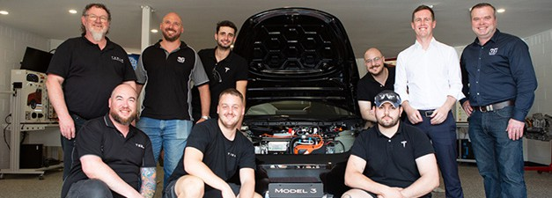

Figure 38: Sustainable development performance – current and previous calendar years

Indicator at 31 December 2023 | Unit | Current 2023 | Previous 2022 | %  Change
Stationary energy usage
Electricity use | Kilowatt hours | 7,887,745 | 7,568,665 | 4%
Natural gas use (non-transport) | Megajoules | 23,174,575 | 25,567,091 | -9%
Diesel use (non-transport) | Kilolitres | 1.78 | 1.06 | 68%
Transport fuel usage
Electric vehicles | Number | 5 | 5 | 0%
Hybrid vehicles | Number | 3 | 5 | -40%
Hydrogen vehicles | Number | 1 | 1 | 0%
Total number of vehicles | Number | 13 | 15 | -13%
Fuel use – Petrol | Kilolitres | 2.15 | 3.12 | -31%
Fuel use – Diesel | Kilolitres | 4.4 | 3.57 | 23%
Fuel use – Liquid Petroleum Gas (LPG) | Kilolitres | 0.43 | 0.63 | -32%
Fuel use – Compressed Natural Gas (CNG) | Gigajoules | 0 | 0 | 0
Water usage
Water use | Kilolitres | 34,103 | 28,219 | 21%
Resource efficiency and waste
Reams of paper purchased | Reams | 1,535 | 2,955 | -48%
Recycled content of paper purchased % |  | 20% | 20% | 0%
Waste to landfill | Litres | 380,432 | 401,500 | -5%
Co-mingled material recycled | Litres | 25,677 | 21,520 | 19%
Paper and Cardboard recycled (incl. secure paper) | Litres | 29,569 | 0
Organic material recycled | Litres | 55,000 | 48,670 | 13%
Greenhouse gas emissions
Emissions from natural gas use (non-transport) | Tonnes CO2-e | 1,187 | 1,317 | -10%
Emissions diesel use (non-transport) | Tonnes CO2-e | 0 | 0 | 0
Emissions from transport fuel use | Tonnes CO2-e | 17.52 | 17.85 | -2%
Emissions from refrigerants | Tonnes CO2-e | 0.83 | 0.83 | 0%
Total emissions | Tonnes CO2-e | 1205.74 | 1,336.15 | -10%
Note: Some data reported for 2022 in the table above may differ slightly from figures reported in the 2022 annual report. These are due to retrospective updates to historical data. Some utility data may be incomplete at the time of data extraction. Where
appropriate, accrued data is used to address any gaps. There may be some residual data gaps that will be addressed retrospectively in next year’s reporting period.
CIT captures these figures from the ENVIZI sustainable reporting platform and a number of other analog reporting methods.

CIT continued to deliver the Battery Electric Vehicle Inspection and Servicing Skill Set and the Depower and Reinitialise Battery Electric Vehicle Skill Set to upskill current automotive technicians in electric vehicle safety and servicing. In addition, CIT developed and delivered a non-accredited electric vehicle charging station course for electricians and late-stage apprentices.
The ACT Government Home Energy Support Team (Environment, Planning and Sustainable Development Directorate) funded five groups of installation installers to complete insulation installation training at CIT in 2023. This training is mandatory for ACT retailers, contractors, and installers of insulation products, and contributes to installer accreditation.
CIT’s Renewable Energy Centre of Excellence hosted the 2023 Skilling for Renewables Forum. CIT was joined by industry partners to discuss the education and training capability required to equip the renewable energy workforce of the future. CIT also hosted two delegations as part of the Griffith
University Aus4ASEAN Green Skills in Technical and Vocational Education Australian tour.
Two renewable energy scholarships for women, supported by Brighte and Global Power Generation, and a pilot initiative to attract skilled people from migrant and refugee backgrounds to renewable careers were developed for implementation in 2024.

Net Zero Emissions
CIT will continue its leading position in upskilling and developing training applicable for the national
aspiration for jobs and skills growth in the renewable energy sector. CIT first partnered with industry in the renewables sector in 2015 to deliver industry relevant skills and training in:
- Solar installation and maintenance.
- Battery storage systems.
- Wind turbine technical and safety training (Pictured below).
CIT has been internationally recognised by the Global Wind Organisation (GWO) Safety Training Awards. CIT continues to deliver in demand safety training and emergency procedures for the wind turbine industry. These are foundation credentials for the safety and evolution of the wind industry workforce. A workforce marked for growth.

Sustainable Fashion
Old white sheets get some fashionable upcycling.
Each year, the CIT fashion school engages first-year students in the “White Out” project, that repurposes donated white sheets from Capital Linen Services. CIT director, technology and design, Shaun Haidon said: “We are incredibly proud of our students’ creativity and the skills they have demonstrated in
their design and production of these garments.” These non-gendered garments, exhibited in the Canberra Museum and Gallery (CMAG) as “White Out,” aim to challenge consumers to reconsider their purchasing habits, as the fashion industry contributes to more than 90m tonnes of textile waste annually worldwide.

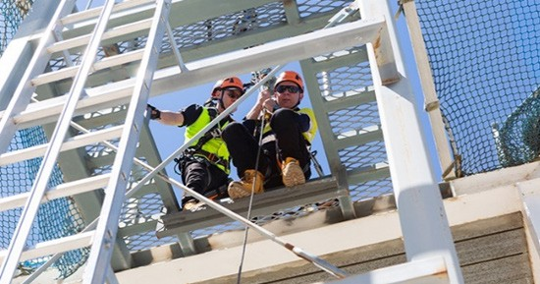

Part C
Financial Management Reporting

C1 MANAGEMENT DISCUSSION AND ANALYSIS

OVERVIEW
During 2023, the Canberra Institute of Technology (CIT) continued to deliver quality government funded and commercial training to students in the ACT region while maintaining its high student and employer satisfaction levels.
CIT delivered the Fee-Free TAFE initiative, a jointly funded initiative of the Commonwealth and ACT Governments. CIT was selected as the preferred training organisation to provide tuition-free vocational education and training to 2,530 places across 46 qualifications on offer in the ACT.
CIT enrolments increased in 2023 following a positive response to Fee-Free TAFE. CIT continues to seek opportunities for continued growth and innovation amid a challenging financial environment due to the competitive training market, changing study needs of students and the strong local employment market reducing the immediate demand for training. CIT
has continued to actively improve its effectiveness and responsiveness in skilling students using contemporary training methods, which continue to be positively received by industry and students alike.

OBJECTIVES
CIT is continuing to focus on the strategic directions outlined in The Strategic Compass 2025 – CIT Futures, where CIT is at the centre of a vibrant and constantly adapting ecosystem of students, business, and
the community in its dual public and commercial vocational education and training (VET) provider roles.

FINANCIAL OVERVIEW OF CIT
CIT achieved an operating deficit of $6.3 million compared to the budget of $22.7 million, a favourable result by $16.4 million. This result was achieved through:
- revenue exceeding budget by $18.9 million (16%)
- offset by expenses exceeding budget by
$2.5 million (2%).
Included in expenses for the year is $10.1 million for depreciation and amortisation.
The individual income and expense variances affecting the operating result are summarised in the Revenue and Expense sections following.
The end of year Cash and Cash Equivalents balance was $8.3 million, a favourable result from the budgeted cash deficit of $7.6 million. This result was driven by significantly lower than budgeted net cash outflows from operating activities. CIT has maintained sufficient cash balances to ensure its ability to meet ongoing payment commitments and to meet contract liabilities.
The liquidity position has improved since 2022, from Working Capital ratio of 0.38 to a Working Capital ratio of 0.52 in 2023. This is mainly due to an increase in Receivables relating to services delivered in 2023 for which payment is expected in early 2024.
CIT continues to manage its expenses as well as monitor its cash position to ensure it continues to be solvent. A significant component of current liabilities relates to employee benefits which are provided for in the regular appropriation from the ACT Government. For further information, refer to the Liquidity section.

OPERATING RESULT CIT
(OPERATING STATEMENT)

Revenue
Components of revenue
Total revenue (Figure 39) for 2023 was $132.9 million, consisting primarily of $84.2 million (64%) controlled recurrent payments appropriation from the ACT Government and $40.4 million (30%) generated from sale of goods and services from contracts with customers (including local and international student fees and training course income as well as Fee-Free
TAFE, Job Trainer, funded apprenticeships, and other traineeship funding).

Grants and Contributions
5%
Sale of Goods and Services 30%
Other
1%
Controlled Recurrent Payments
64%

Comparison to budget
Total income of $132.9 million was $18.9 million higher than the 2023 budget of $114.0 million due primarily to:
- the recognition of $4.7m revenue for the finalisation of the Job Trainer 1 initiative which was not anticipated to be recognised in full in the 2023 Budget.
- $5.1 million revenue recognised for the delivery of Fee-Free TAFE in 2023, partially offset by lower student fee revenue of $0.5 million.
- additional $3.0 million of controlled recurrent payments was drawn in December 2023 to cover cash requirements over the annual shutdown period.
- NSW Smart and Skilled funding related to the training of NSW apprentices following agreement in 2023 of $2.7 million.
- ACT Government resources received free of charge not included in the budget of $4.3 million due
to the change implemented in the 2023-24 ACT Government Budget to a direct funding model for Data, Digital and Technology Solutions services resulting in CIT recognising these services as resources received free of charge from 1 July 2023.
Comparison to 2022 actual
Total income of $132.9 million was $22.2 million higher than the 2022 actual of $110.7 million due primarily to:
- the recognition of $4.7m revenue for the finalisation of the Job Trainer 1 initiative.
- $5.1 million revenue recognised for the delivery of Fee-Free TAFE in 2023.
- additional controlled recurrent payment appropriation of $5.5 million due to funding for agreed pay rises and the advance drawdown in December 2023 to cover cash requirements over the Christmas shutdown period.
- NSW Smart and Skilled funding related to the training of NSW apprentices following agreement in 2023 $2.7 million.
- ACT Government resources received free of charge increased by $4.6 million.
Future trends
The National Skills Agreement will commence on
1 January 2024, a five-year joint agreement between the Commonwealth and states and territories to strengthen the vocational education and training sector. CIT will continue to work closely with the ACT Government to identify opportunities for growth in delivery under this agreement. The Commonwealth and ACT governments commitment to Fee-Free TAFE will continue with CIT expected to deliver 600 tuition free places per semester for the next three years.
These initiatives will ensure access to a wide range of training opportunities in skill needs areas for eligible Canberrans, to support vital and emerging industries within the ACT economy.
The ACT Government’s forward budget includes additional appropriation reflecting increased cost of delivery as wages and the cost of supplies and services are indexed.

Supplies and Services 28%
Depreciation and Amortisation 7%
Other
1%
Employee Expenses
64%

Expenses
Components of expenses
Operating expenses in 2023 totalled $139.2 million, with the most significant component being Employee Expenses and Superannuation of $88.7 million (64%), and Supplies and Services expenses accounted for
$38.8 million (28%) (Figure 40).
Comparison to budget
Total expenses of $139.2 million in 2023 were
$2.5 million (2%) higher than the 2023 budget of
$136.7 million, this increase is primarily due to higher employee expense ($2.2 million) resulting from
the cost-of-living allowance and higher wage rates provided for in the new employment agreements which were not included in the budget.
Comparison to 2022 actual
In 2023 total expenses of $139.2 million are
$13.8 million (11%) higher than the 2022 expense total of $125.4 million). The variance is due to:
- Higher employee expenses including superannuation ($10.7 million) resulting from the impact of wage increases and other economic factors on both wages and salaries and associated leave balances and a 3% increase in average staffing levels.
- Increases in Repairs and Maintenance expenses of
$1.7 million due to additional works required on ageing infrastructure.
Future trends
CIT is anticipating an increase in total expenditure over the short to medium term for costs associated with maintaining CIT’s ageing facilities, reducing information technology risks, and increased employee expenses with the new employment agreement.
CIT continue to review resource allocations to ensure they are appropriately allocated to make the most of growth opportunities as they arise.

FINANCIAL POSITION
(BALANCE SHEET)

Assets
Components of total assets
As at 31 December 2023, $200.5 million (90%) of the assets of CIT were in Property, Plant and Equipment. Cash and Cash Equivalents of $8.3 million (4%) and Receivables of $7.9 million (4%) comprised 4% each (Figure 41).

Capital Works in Progress
<1%
Property, Plant and Equipment
90%
Asset Held for Distribution to Owner
1%
Cash and Cash Equivalents
4%
Receivables
4%
Other
<1%

Comparison to budget
The total asset position as at 31 December 2023 of
$222.5 million was $13.2 million higher than budgeted. This increased asset position is due to:
- Higher than budgeted Cash and Cash Equivalents by $15.9 million resulting predominately from increased cash inflows related to Fee-Free TAFE ($3.7 million), additional appropriation drawn at year end to ensure cash availability for expenses in early 2024 ($3.0 million) and reduced cash outflows related to employee pay rises agreed but not paid in 2023 ($2.4 million) and the change in funding arrangement for CMTEDD ICT services to resources received free of charge.
- Higher receivables by $5.1 million due to services delivered in 2023 for which are expected to be paid in early 2024 related to Fee-Free TAFE and the NSW Smart and Skilled agreement.
- Lower property, plant and equipment ($8.7 million) partially offset by higher than budget assets held for distribution which was not budgeted in 2023 related to the property at Watson under license
to the Academy of Interactive Entertainment ($2.6 million).
Comparison to 2022 actual
The total asset position as at 31 December 2023 of
$222.5 million is consistent with the 2022 position of
$222.8 million.

Liabilities
Components of total assets
Total liabilities as at 31 December 2023 of $76.1 million predominately consists of Other Provisions $39.1 million (51%) and Employee Benefits $28.6 million (37%).
The Other Provisions category consists of a $38.6 million provision recognised in relation to remediation of CIT Reid Campus as agreed under the Precinct Deed that was executed with the University of New South Wales during 2023.
Comparison to budget
Liabilities as at 31 December 2023 of $76.1 million were
$39.9 million (110%) higher than the 2023 budget of
$36.2 million. This was mainly due to:
- Recognition of $38.6 million remediation provision that was not included in the original budget.
- Higher employee benefits by $4.1 million related to the impact on Enterprise Bargaining Agreement increases agreed in 2023 on employee leave entitlements.
Comparison to 2022 actual
Liabilities as at 31 December 2023 of $76.1 million were
$38.0 million (100%) higher than the 2022 actuals of
$38.1 million. This was due primarily to the recognition of the remediation provision related to the CIT Reid Campus following the execution of the Masterplan with the University of New South Wales (UNSW).

Other Liabilities
3%
Employee Benefits
38%
Other Provisions
51%
Payables
5%
Lease Liabilities
3%

LIQUIDITY – CIT
Liquidity is a measure of the ability of an entity to meet its short-term financial obligations as they fall due. The working capital ratio (ratio of current assets to current liabilities) is a common indicator for liquidity and measures the ability to fund short-term liabilities from short-term assets.
The current working capital ratio of 0.52:1 is higher than the budget target of 0.11:1, due predominately to a significantly higher than budgeted bank balance.

Figure 43: Working Capital
As at 31 December 2023, current assets of $17.5 million (excluding Assets Held for Distribution to Owners) were less than the total current liabilities ($34.0 million) by $16.5 million. This is not considered a liquidity risk as along with external revenue, cash needs are funded through Controlled Recurrent Payment appropriation from the ACT Government.
It is important to note that although employee benefits of $27.2 million are classified as current liabilities under Accounting Standards, based on historical data, less than $6.0 million for Long Service Leave and Annual Leave is paid out in any one year.

Actual 2023 Budget 2023  $’000 $’000 | Actual 2022  $’000

Cash and Cash Equivalents | 8,314 | – | 8,841
Receivables | 7,812 | 2,800 | 2,554
Other Assets | 1,417 | 1,600 | 1,357
Total Current Assets (a) | 17,543 | 4,400 | 12,752

Cash and Cash Equivalents | – | 7,567 | –
Payables | 3,862 | 3,500 | 3,557
Employee Benefits | 27,189 | 23,300 | 23,253
Other Liabilities | 2,909 | 5,080 | 7,139
Total Current Liabilities | 33,960 | 39,447 | 33,949
Working Capital Ratio 0.52 0.11 0.38
(a) Current Assets exclude Assets Held for Distribution to Owners (2023: $2.9 million and 2022: $5.6 million), which represents the carrying amount of the remaining Watson facility that CIT will transfer back to the ACT Government for no consideration.

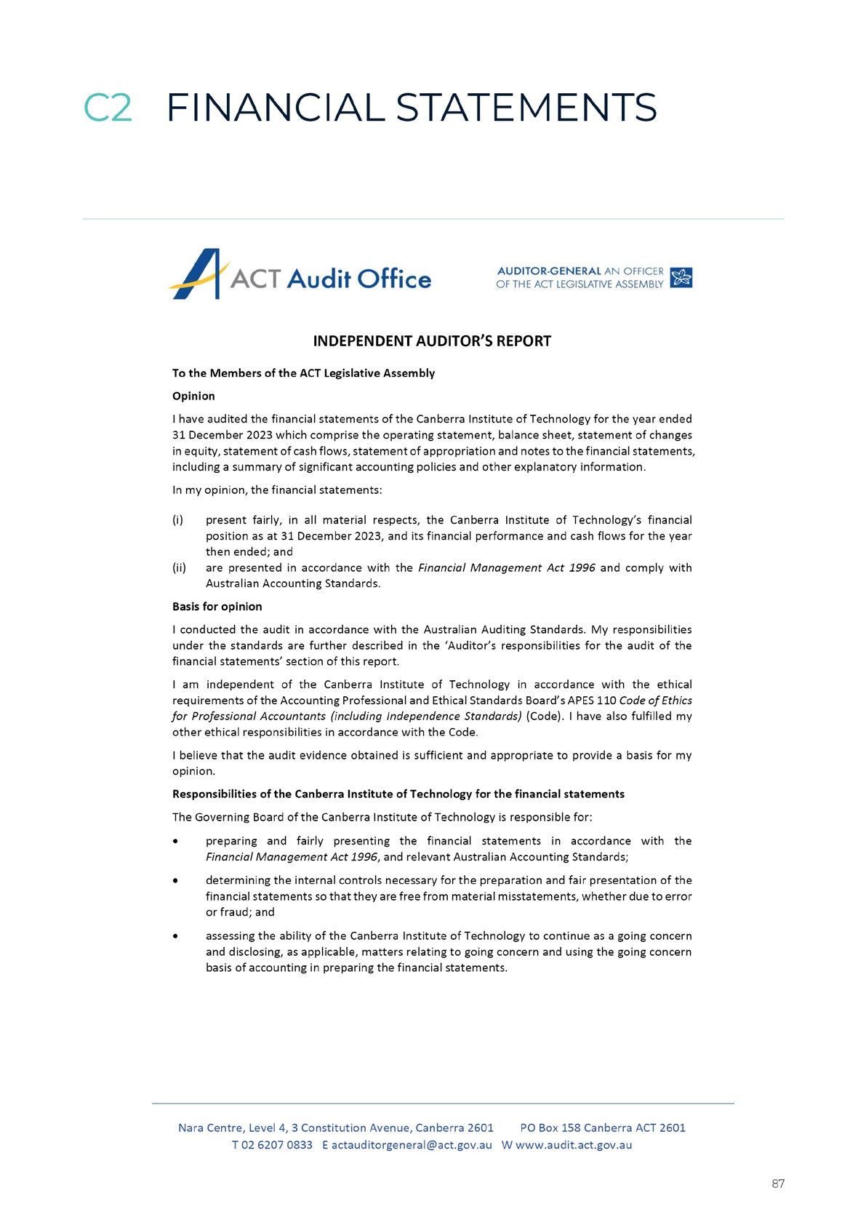

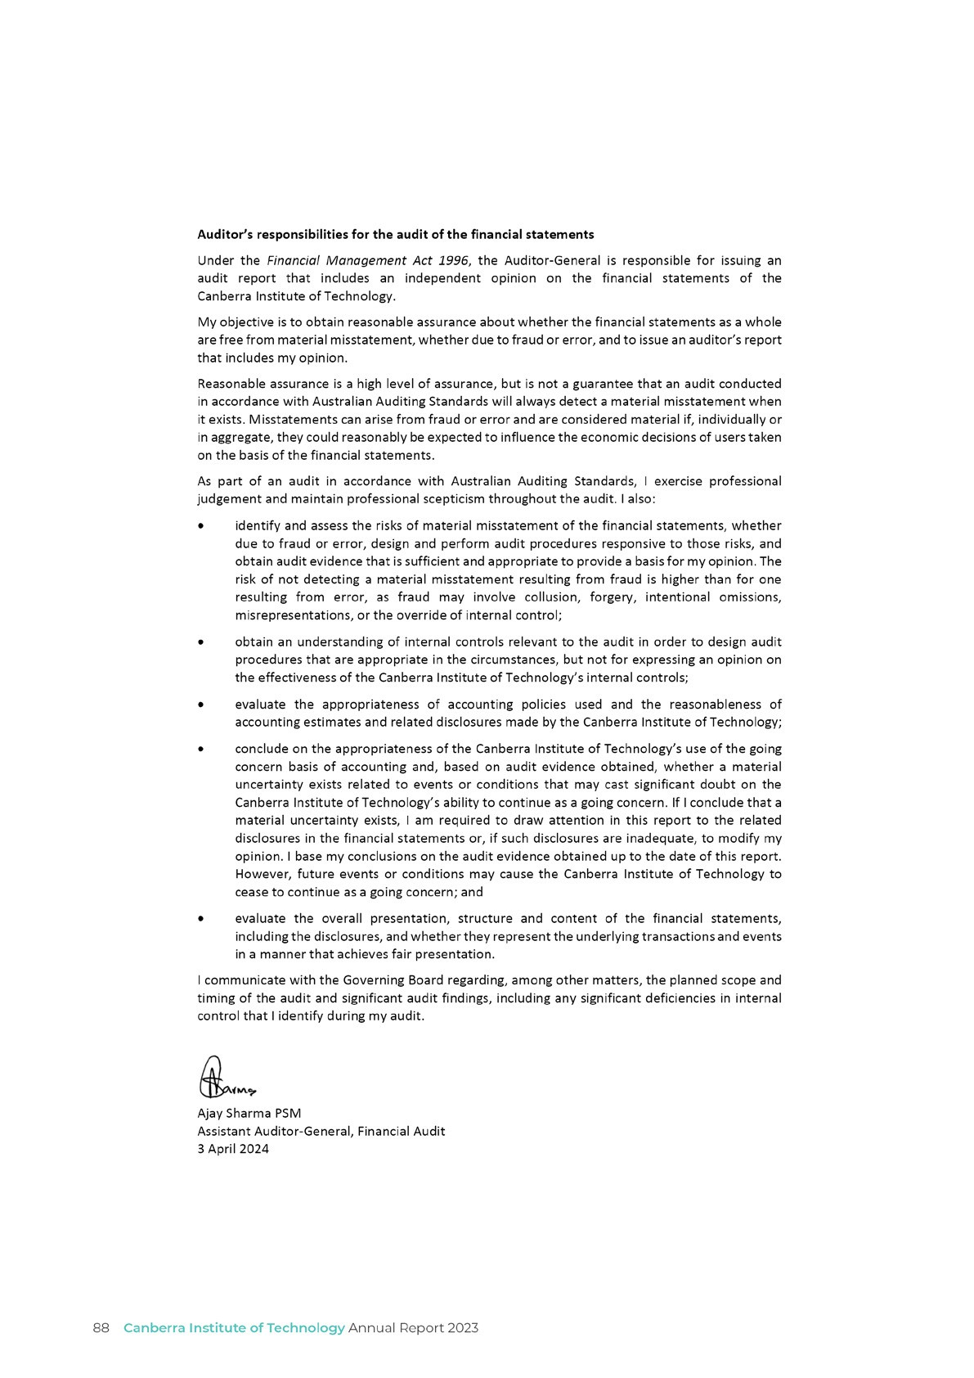

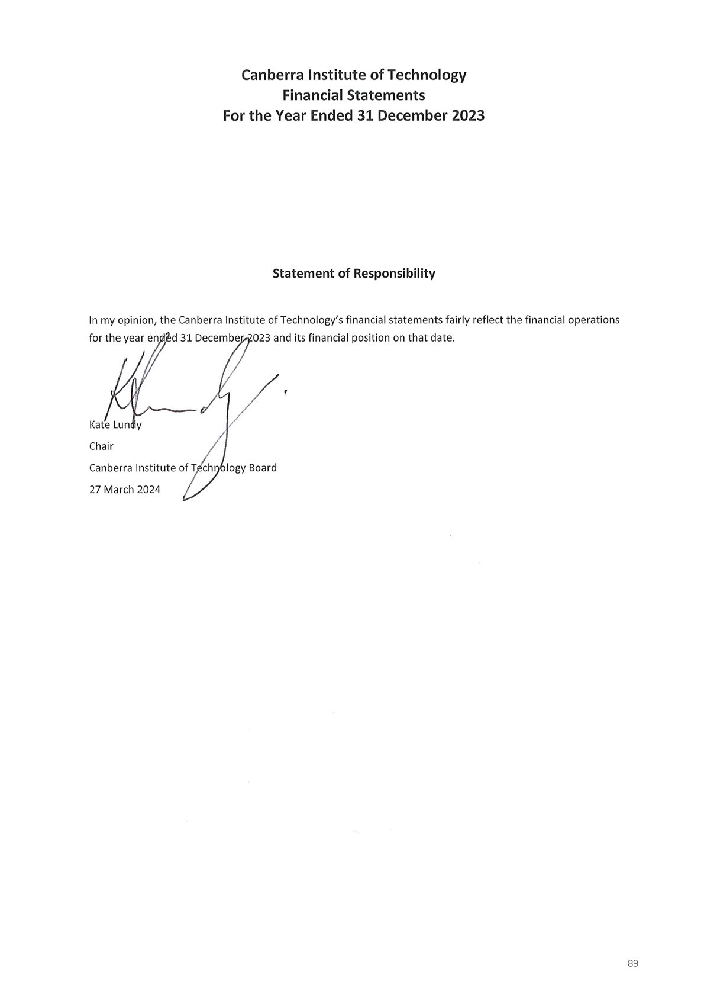

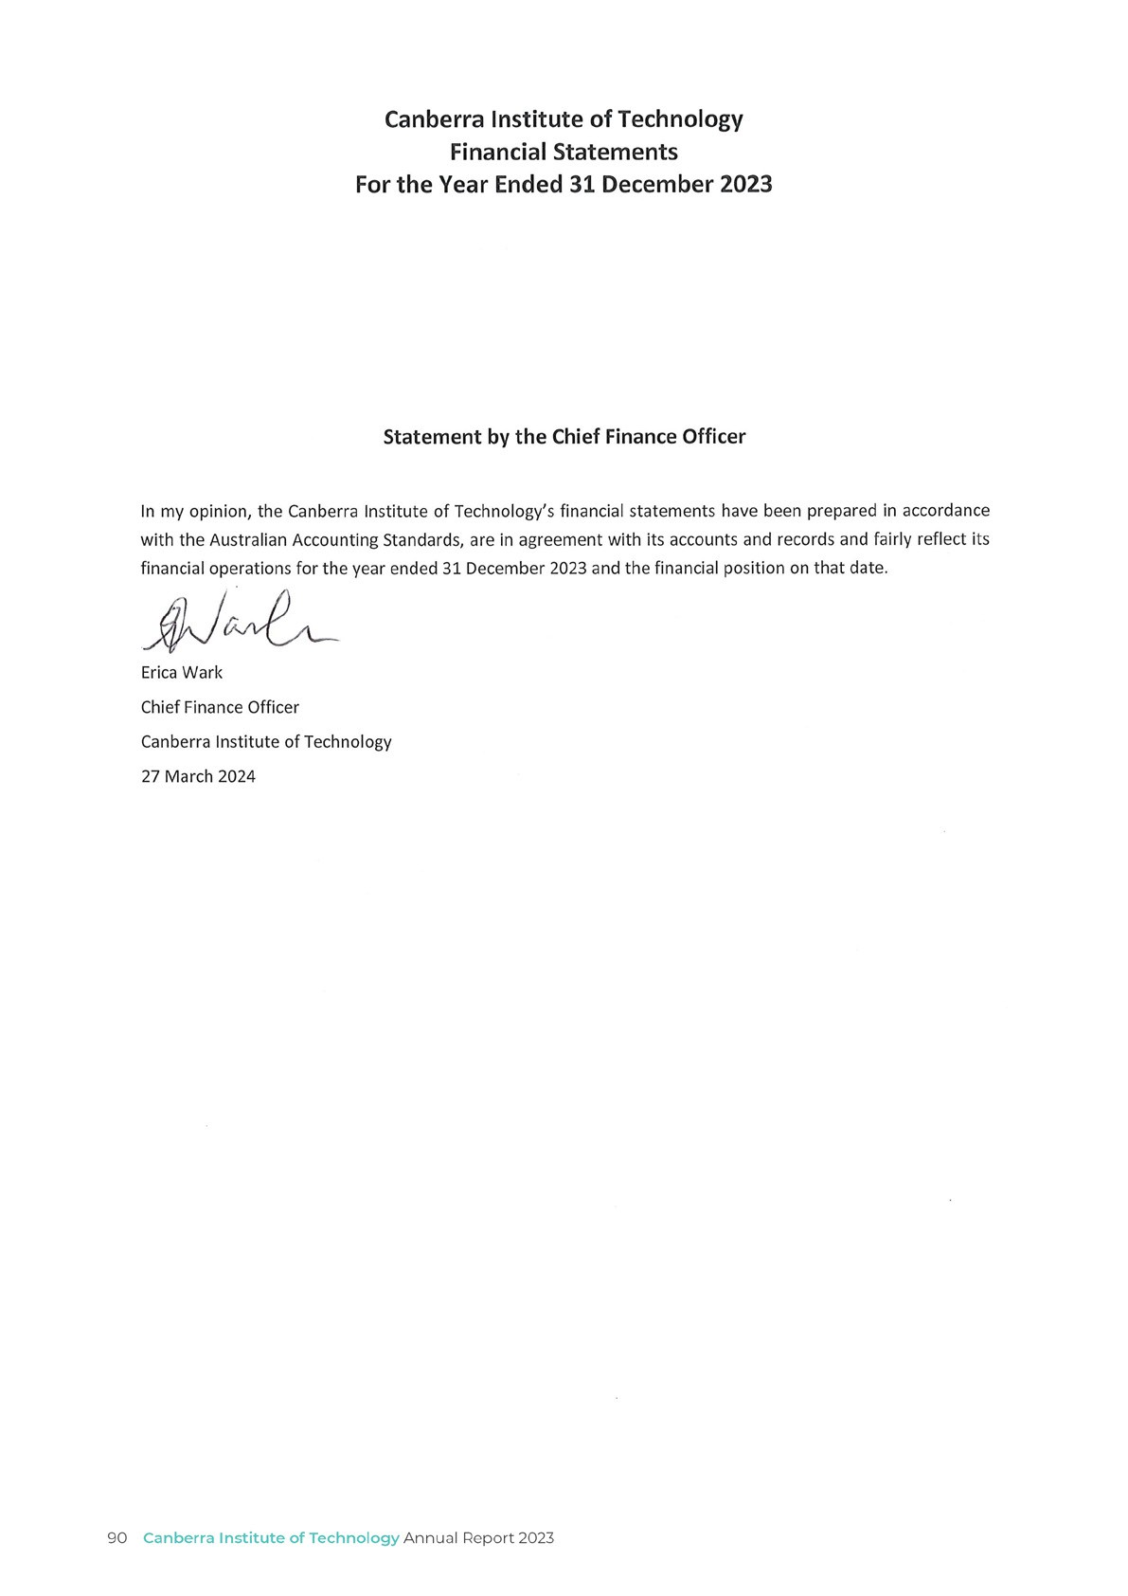

For the Year Ended 31 December 2023 Content of Financial Statements

Financial Statements Operating Statement Balance Sheet
Statement of Changes in Equity Statement of Cash Flows Statement of Appropriation
Overview Notes

Note 1 Objectives of the Canberra Institute of Technology Note 2 Basis of Preparation of the Financial Statements
Note 3 Impact of Accounting Standards Issued But Yet to be Applied
Income Notes
Note 4 Sales of Goods and Services from Contracts with Customers Note 5 Grants and Contributions Revenue
Expense Notes
Note 6 Employee Expenses
Note 7 Supplies and Services
Asset Notes
Note 8 Cash and Cash Equivalents
Note 9 Receivables
Note 10 Assets Held for Distribution to Owner Note 11 Property, Plant and Equipment
Liability Notes
Note 12 Payables
Note 13 Lease Liabilities
Note 14 Employee Benefits
Note 15 Other Provisions
Note 16 Other Liabilities
Other Note
Note 17 Financial Instruments
Note 18 Commitments
Note 19 Contingent Liabilities and Contingent Assets Note 20 Third Party Monies
Note 21 Related Party Disclosures
Note 22 Budgetary Reporting

Canberra Institute of Technology Operating Statement
For the Year Ended 31 December 2023

Note No.
Consolidated |  | CIT
 |  |  | Original
Actual | Actual | Actual | Budget | Actual
2023 | 2022 | 2023 | 2023 | 2022
$’000 | $’000 | $’000 | $’000 | $’000
84,209 | 78,758 | 84,209 | 81,195 | 78,758
48,453 | 41,201 | 40,336 | 28,945 | 27,546
6,846 | 2,266 | 6,846 | 2,562 | 2,266
1,523 | 1,425 | 1,515 | 1,250 | 2,166
141,031 | 123,650 | 132,906 | 113,952 | 110,736
96,338 | 88,826 | 88,719 | 85,550 | 77,992
38,914 | 36,914 | 38,772 | 39,479 | 36,428
10,201 | 9,673 | 10,134 | 9,670 | 9,651
2,027 | 1,767 | 1,551 | 1,980 | 1,354
147,480 | 137,180 | 139,176 | 136,679 | 125,425
(6,449) | (13,530) | (6,270) | (22,727) | (14,689)
uently to profit or loss  (38,380) 25,774 |  | (38,380) | - | 25,774
(38,380) | 25,774 | (38,380) | - | 25,774
(44,829) | 12,244 | (44,650) | (22,727) | 11,085

Income
Controlled Recurrent Payments # Sales of Goods and Services from
Contracts with Customers 4
Grants and Contributions
Revenue 5
Other Income
Total Income
Expenses
Employee Expenses 6
Supplies and Services 7
Depreciation and Amortisation 11
Other Expenses
Total Expenses Operating Result
Other Comprehensive Income
Items that will not be reclassified subseq

(Decrease)/Increase in the Asset Revaluation Surplus
Total Other Comprehensive Total Comprehensive Result

The above Operating Statement is to be read in conjunction with the accompanying notes.
The Canberra Institute of Technology (CIT) has only one output class and as such the above Operating Statement is also CIT’s Operating Statement for Output Class 1.1: Provision of Vocational Education and Training Services.
# Refer to the Statement of Appropriation.

Balance Sheet
As at 31 December 2023

Note No.
Consolidated |  | CIT
 |  |  | Original
Actual | Actual | Actual | Budget | Actual
2023 | 2022 | 2023 | 2023 | 2022
$’000 | $’000 | $’000 | $’000 | $’000
12,753 | 15,918 | 8,314 | (7,567) | 8,841
7,990 | 3,681 | 7,812 | 2,800 | 2,554
2,914 | 5,573 | 2,914 | - | 5,573
1,537 | 1,520 | 1,417 | 1,600 | 1,357
25,194 | 26,692 | 20,457 | (3,167) | 18,325
200,547 | 201,765 | 200,486 | 209,141 | 201,735
1,411 | 2,542 | 1,411 | 2,800 | 2,542
98 | 224 | 118 | 520 | 244
202,056 | 204,531 | 202,015 | 212,461 | 204,521
227,250 | 231,223 | 222,472 | 209,294 | 222,846
2,461 | 4,245 | 3,862 | 3,500 | 3,557
964 | 862 | 964 | 680 | 862
28,143 | 24,353 | 27,189 | 23,300 | 23,253
2,378 | 7,854 | 1,945 | 4,400 | 6,277
33,946 | 37,314 | 33,960 | 31,880 | 33,949
1,280 | 2,218 | 1,280 | 2,000 | 2,169
1,483 | 1,224 | 1,408 | 1,200 | 1,157
39,067 | 309 | 39,067 | 309 | 309
364 | 550 | 364 | 841 | 550
42,194 | 4,301 | 42,119 | 4,350 | 4,185
76,140 | 41,615 | 76,079 | 36,230 | 38,134
151,110 | 189,608 | 146,393 | 173,064 | 184,712
83,111 | 83,229 | 78,394 | 66,685 | 78,333
67,999 | 106,379 | 67,999 | 106,379 | 106,379
151,110 | 189,608 | 146,393 | 173,064 | 184,712

Current Assets
Cash and Cash Equivalents 8
Receivables 9
Assets Held for Distribution to
Owner 10
Other Assets
Total Current Assets Non-Current Assets
Property, Plant and Equipmentª 11
Capital Works in Progress Other Assets
Total Non-Current Assets Total Assets
Current Liabilities
Payables 12
Lease Liabilities 13
Employee Benefits 14
Other Liabilities 16
Total Current Liabilities Non-Current Liabilities
Lease Liabilities 13
Employee Benefits 14
Other Provision 15
Other Liabilities 16
Total Non-Current Liabilities Total Liabilities
Net Assets
Equity
Accumulated Funds
Asset Revaluation Surplus
Total Equity

The above Balance Sheet is to be read in conjunction with the accompanying notes.
CIT has only one output class and as such the above Balance Sheet is also CIT’s Balance Sheet for Output Class
1.1: Provision of Vocational Education and Training Services.
a. Property, Plant and Equipment was incorrectly reported as $196.78 million in the 2023-24 Original Budget resulting in a discrepancy between Net Assets and Total Equity. The correct value of $209.141 million has been reported above.

Canberra Institute of Technology Statement of Changes in Equity
94 Canberra Institute of Technology Annual Report 2023
For the Year Ended 31 December 2023
Consolidated |  |  | CIT
 | Asset |  |  | Asset |  | Total
Accumulated | Revaluation | Total | Accumulated | Revaluation | Total | Equity
Funds | Surplus | Equity | Funds | Surplus | Equity | Original
Actual | Actual | Actual | Actual | Actual | Actual | Budget
2023 | 2023 | 2023 | 2023 | 2023 | 2023 | 2023
$’000 | $’000 | $’000 | $’000 | $’000 | $’000 | $’000
83,229 | 106,379 | 189,608 | 78,333 | 106,379 | 184,712 | 184,712
(6,449) | - | (6,449) | (6,270) | - | (6,270) | (22,727)
- | (38,380) | (38,380) | - | (38,380) | (38,380) | -
(6,449) | (38,380) | (44,829) | (6,270) | (38,380) | (44,650) | (22,727)
8,989 | - | 8,989 | 8,989 | - | 8,989 | 11,079
(2,658) | - | (2,658) | (2,658) | - | (2,658) | -
6,331 | - | 6,331 | 6,331 | - | 6,331 | 11,079
83,111 | 67,999 | 151,110 | 78,394 | 67,999 | 146,393 | 173,064

Note No.

Balance at 1 January 2023 Comprehensive Income Operating Result
Decrease in the Asset Revaluation Surplus 11
Total Comprehensive Result
Transactions Involving Owners Affecting Accumulated Funds
Capital Injections #
Net Assets transferred out to ACT Government 10
Total Transactions Involving Owners Affecting Accumulated Funds
Balance at 31 December 2023
The above Statement of Changes in Equity is to be read in conjunction with the accompanying notes. # Refer to the Statement of Appropriation.

Canberra Institute of Technology Statement of Changes in Equity - Continued For the Year Ended 31 December 2022
95
Consolidated |  |  | CIT
 | Asset |  |  | Asset
Accumulated | Revaluation | Total | Accumulated | Revaluation | Total
Funds | Surplus | Equity | Funds | Surplus | Equity
Actual | Actual | Actual | Actual | Actual | Actual
2022 | 2022 | 2022 | 2022 | 2022 | 2022
$’000 | $’000 | $’000 | $’000 | $’000 | $’000
95,196 | 80,605 | 175,801 | 91,459 | 80,605 | 172,064
(13,530) | - | (13,530) | (14,689) | - | (14,689)
- | 25,774 | 25,774 | - | 25,774 | 25,774
(13,530) | 25,774 | 12,244 | (14,689) | 25,774 | 11,085
2,931 | - | 2,931 | 2,931 | - | 2,931
(1,368) | - | (1,368) | (1,368) | - | (1,368)
1,563 | - | 1,563 | 1,563 | - | 1,563
83,229 | 106,379 | 189,608 | 78,333 | 106,379 | 184,712

Note No.

Balance at 1 January 2022 Comprehensive Income
Operating Result
Increase in the Asset Revaluation Surplus 11
Total Comprehensive Result

Transactions Involving Owners Affecting Accumulated Funds
Capital Injections #
Capital Distributions
Total Transactions Involving Owners Affecting Accumulated Funds

Balance at 31 December 2022

The above Statement of Changes in Equity is to be read in conjunction with the accompanying notes. # Refer to the Statement of Appropriation

Cash Flows from Operating Activities Receipts
Consolidated |  | CIT
 |  |  | Original
Actual | Actual | Actual | Budget | Actual
2023 | 2022 | 2023 | 2023 | 2022
$’000 | $’000 | $’000 | $’000 | $’000
84,209 | 78,758 | 84,209 | 81,195 | 78,758
38,222 | 42,934 | 30,737 | 28,700 | 27,941
540 | 254 | 403 | 150 | 249
4,429 | 3,400 | 4,170 | 3,430 | 3,172
1,612 | 2,113 | 1,140 | 1,500 | 1,247
26 | 64 | 26 | 1,477 | 64
- | - | - | 100 | 600
958 | 998 | 1,086 | - | 1,144
129,996 | 128,521 | 121,771 | 116,552 | 113,175
92,913 | 90,716 | 85,121 | 87,511 | 79,746
32,542 | 34,456 | 30,846 | 38,548 | 34,481
6,145 | 5,410 | 5,392 | 4,300 | 4,291
1,900 | 1,872 | 1,425 | 1,800 | 1,459
133,500 | 132,454 | 122,784 | 132,159 | 119,977
(3,504) | (3,933) | (1,013) | (15,607) | (6,802)
- | 173 | - | - | 173
- | 173 | - | - | 173
7,662 | 1,846 | 7,515 | 11,079 | 1,862
7,662 | 1,846 | 7,515 | 11,079 | 1,862
(7,662) | (1,673) | (7,515) | (11,079) | (1,689)

Controlled Recurrent Payments Sales of Goods and Services from
Contracts with Customers Interest Received
Goods and Services Tax Input Tax
from the Australian Taxation Office Goods and Services Tax Collected
from Customers
Grants and Contributions Receipts Dividends Received
Other
Total Receipts from Operating Activities
Note No.

Payments
Employee Paymentsª Supplies and Services
Goods and Services Tax Paid to Suppliers Other
Total Payments from Operating Activities
Net Cash (Outflows) from Operating Activities 8

Cash Flows from Investing Activities Receipts
Proceeds from Sale of Property, Plant Equipment
Total Receipts from Investing Payments
Purchase of Property, Plant and Equipment
Total Payments from Investing

Net Cash (Outflows) from Investing Activities

Cash Flows from Financing Activities Receipts
Consolidated |  | CIT
 |  |  | Original
Actual | Actual | Actual | Budget | Actua
2023 | 2022 | 2023 | 2023 | 202
$’000 | $’000 | $’000 | $’000 | $’00
8,989 | 2,931 | 8,989 | 11,079 | 2,93
8,989 | 2,931 | 8,989 | 11,079 | 2,93
988 | 932 | 988 | 800 | 93
988 | 932 | 988 | 800 | 93
8,001 | 1,999 | 8,001 | 10,279 | 1,99
(3,165) | (3,607) | (527) | (16,408) | (6,492
15,918 | 19,525 | 8,841 | 8,841 | 15,33
12,753 | 15,918 | 8,314 | (7,567) | 8,84

Capital Injections
Total Receipts from Financing Activities
Payments
Repayment of Lease Liabilities – Principal
Total Payments from Financing Activities
Net Cash Inflows from Financing Activities
Note No.

Net (Decrease) in Cash and Cash Equivalents
Cash and Cash Equivalents at the Beginning of the Reporting Period
Cash and Cash Equivalents at the d
the Reporting Period 8
The above Statement of Cash Flows is to be read in conjunction with the accompanying notes.
a. Employee Payments was incorrectly reported in the 2023-24 Original Budget and has been amended in thi statement.

Description and Material Accounting Policies relating to Controlled Recurrent Payments
Controlled Recurrent Payments (CRP) are revenue received from the ACT Government to fund the costs of delivering outputs.

CRP is recognised when CIT gains control over the funding which is obtained upon the receipt of cash, given they do not contain enforceable and sufficiently specific performance obligations as defined by AASB 15 Revenue from Contracts with Customers.
Capital injection appropriations are not recognised as income, but instead are recognised as equity injections and a cash inflow which is used to purchase/build an asset(s) or to reduce a liability(s).
Column Heading Explanations:
The Original Budget column shows the amounts that appear in the Statement of Cash Flows in the 2023-24 Budget Papers. This amount also appears in the Statement of Cash Flows.
The Total Appropriated column is inclusive of all appropriation variations occurring after the Original Budget.
The Appropriation Drawn is the total amount of appropriation received by CIT during the year. This amount also appears in the Statement of Cash Flows.

 | Original  Budget | Total  Appropriated | Appropriation  Drawn | Appropriation  Drawn
 | 2023 | 2023 | 2023 | 2022
 | $’000 | $’000 | $’000 | $’000
Controlled Appropriation
Controlled Recurrent Paymentsª | 81,195 | 84,209 | 84,209 | 78,758
Capital Injections^{b} | 11,079 | 8,989 | 8,989 | 2,931
Total Controlled Appropriation | 92,274 | 93,198 | 93,198 | 81,689
The above Statement of Appropriation should be read in conjunction with the accompanying notes.
Variances between Total Appropriated 2022 and 2023
- The variance is due to increased Controlled Recurrent Appropriation received in the ACT Government Budget to meet wages and indexation increases and early appropriation drawn in 2023 to meet commitments in early 2024 in accordance with reduced drawdown schedule during Christmas shutdown
- The variance is due to increased capital appropriation provided in the 2023-24 Budget for delivery of the upgrades ICT Infrastructure.

Variances between ‘Original Budget’, ‘Total Appropriated’ and ‘Appropriation

 | Controlled  Recurrent Payments | Capital  Injections
 | $’000 | $’000
Reconciliation of Appropriation for 2023  Original Budget | 81,195 | 11,079
Additional Appropriations Drawnª | 3,014 | -
Forward at end of CIT Calendar Year 2023^{b} | - | (2,090)
Total Appropriated and Appropriation Drawn | 84,209 | 8,989

- Additional appropriation was drawn in late December to meet commitments in early January in accordance with reduced drawdown schedule during Christmas shutdown.
- Represents undrawn appropriation for ongoing capital projects at the end of the year and is available for drawdown in 2024.

NOTE 1. OBJECTIVES OF THE CANBERRA INSTITUTE OF TECHNOLOGY
The Canberra Institute of Technology (CIT) is a multi-campus, multi-disciplinary, education institution in the ACT, providing vocational education and training to the ACT and surrounding region. CIT is a major contributor to the economic growth of the ACT through ensuring a qualified and skilled workforce, increasing skill levels for those self-employed, attracting international students, contributing to the ACT innovation ecosystem, and driving lifelong learning for the ACT’s economic and social benefit.
CIT is the sole public provider of Technical and Further Education (TAFE) in the ACT, and also operates in the commercial, contestable market servicing local, regional and international students.

NOTE 2. BASIS OF PREPARATION OF THE FINANCIAL STATEMENTS
LEGISLATIVE REQUIREMENT
The Financial Management Act 1996 (FMA) requires the preparation of annual financial statements for Canberra Institute of Technology.
The FMA and the Financial Management Guidelines issued under the FMA, requires CIT’s financial statements to include:
  - an Operating Statement for the year;
  - a Balance Sheet at the end of the year;
  - a Statement of Changes in Equity for the year;
  - a Statement of Cash Flows for the year;
  - a Statement of Appropriation for the year;
  - the material accounting policies adopted for the year; and
  - other statements as are necessary to fairly reflect the financial operations of CIT during the year and its financial position at the end of the year.
These general-purpose financial statements have been prepared to comply with Australian Accounting Standards as required by the FMA. The financial statements have been prepared in accordance with:
- Australian Accounting Standards; and
- ACT Accounting and Disclosure Policies.

ACCRUAL ACCOUNTING
The financial statements have been prepared using the accrual basis of accounting. The financial statements are prepared according to the historical cost convention, except for property, plant and equipment which were valued at fair value in accordance with the revaluation policies applicable to CIT during the reporting period.
CURRENCY
These financial statements are presented in Australian dollars, which is CIT’s functional currency.

NOTE 2. BASIS OF PREPARATION OF THE FINANCIAL STATEMENTS – CONTINUED
INDIVIDUAL REPORTING ENTITY
CIT is an individual not-for-profit reporting entity.
PRINCIPLES OF CONSOLIDATION
The consolidated financial statements are for the group comprising CIT and CIT Solutions. CIT Solutions is a wholly owned subsidiary of CIT, formed for the purposes of undertaking entrepreneurial and commercial activities on CIT’s behalf. All inter-entity balances, including unrealised profits and losses, have been eliminated on consolidation. The financial statements of CIT Solutions are prepared for the same reporting period as CIT, using accounting policies that are consistent with those of CIT.
REPORTING PERIOD
These financial statements state the financial performance, changes in equity and cash flows of CIT for the year ended 31 December 2023 together with the financial position of CIT at 31 December 2023.
COMPARATIVE FIGURES
Budget Figures
To facilitate a comparison with the Budget Papers, as required by the Financial Management Act 1996, budget information for 2023 has been presented in the financial statements. Budget numbers in the financial statements are the original budget numbers that appear in the 2023-24 Budget Papers.
Prior Year Comparatives
Comparative information has been disclosed in respect of the previous period for amounts reported in the financial statements, except where an Australian Accounting Standard does not require comparative information to be disclosed.
Where the presentation or classification of items in the financial statements is amended, the comparative amounts have been reclassified where practical. Where a reclassification has occurred, the nature, amount and reason for the reclassification is provided.
ROUNDING
All amounts in the financial statements have been rounded to the nearest thousand dollars ($’000). Use of the "-" symbol represents zero amounts or amounts rounded down to zero.
GOING CONCERN
The 2023 financial statements have been prepared on a going concern basis as CIT has been funded in the ACT Government 2023-24 Budget and the Budget Papers include forward estimates for CIT.

NOTE 3. IMPACT OF ACCOUNTING STANDARDS ISSUED BUT YET TO BE APPLIED
All Australian Accounting Standards and Interpretations issued but yet to be applied are applicable to future reporting periods and will be adopted from their application date.

Standards and Interpretations issued but yet to be applied have been assessed as not being relevant or will have an immaterial financial impact on CIT. However, CIT is currently assessing whether AASB 2022-10 - Amendments to Australian Accounting Standards – Fair Value Measurement of Non-Financial Assets of Not-for-Profit Public Sector Entities will have a material financial impact on the agency.

AASB 2022-10 amends AASB 13 - Fair Value Measurement by adding authoritative implementation guidance and providing related illustrative examples, for fair value measurements of non-financial assets of not-for-profit public sector agencies not held primarily for their ability to generate net cash inflows. The standard is applicable for the CIT 2024 reporting period. The revised standard:

  - specifies that agencies are required to consider whether the asset’s highest and best use differs from its current use only when it is held for sale or held for distribution to owners in accordance with AASB 5 Non-current Assets Held for Sale and Discontinued Operations or it is highly probable that the asset will be used for an alternative purpose to its current use;
  - clarifies that the asset’s use is ‘financially feasible’ if market participants would be willing to invest in the asset’s service capacity, considering both the capability of the asset to be used to provide needed goods or services to beneficiaries and the resulting cost of those goods or services;
  - specifies that, if both the market selling price of a comparable asset and some market participant data required to measure the fair value of the asset are not observable, an agency uses its own assumptions as a starting point in developing unobservable inputs and adjusts those assumptions to the extent that reasonably available information indicates that other market participants (including, but not limited to, other not-for-profit public sector agencies) would use different data; and
  - provides guidance on how the cost approach is to be applied to measure the asset’s fair value, including guidance on the nature of costs to include in the replacement cost of a reference asset and on the identification of economic obsolescence.

INCOME NOTES

Material Accounting Policies - Income
INCOME RECOGNITION
Revenue is recognised in accordance with AASB 15 Revenue from Contracts with Customers where the contract is enforceable and contains sufficiently specific performance obligations, otherwise revenue is in the scope of AASB 1058 Income of Not-For-Profit Entities.
AASB 15
The core principle of AASB 15 is that revenue is recognised on a basis that reflects the transfer of promised goods or services to customers at an amount that reflects the consideration the entity expects to receive in exchange for those goods or services. Revenue is recognised by applying a five step model as follows:
- identify the contract with the customer;
- identify the performance obligations;
- determine the transaction price;
- allocate the transaction price; and
- recognise revenue as or when control of the performance obligation is transferred to the customer.

Generally, the timing of the payment for sale of goods and rendering of services corresponds closely to the timing of satisfaction of the performance obligations, however where there is a difference, it will result in the recognition of a receivable, contract asset or contract liability.
No revenue streams of CIT have any significant financing terms as there is less than 12 months between receipt of funds and satisfaction of performance obligations. Refer to Note 4 for specific revenue sources.
AASB 1058
Where revenue streams are in the scope of AASB 1058, CIT recognises the asset received (generally cash or other financial asset) at fair value, recognises any related amount (e.g. liability or equity) in accordance with an accounting standard and recognises revenue as the residual between the fair value of the asset and the related amount on receipt of the asset.

NOTE 4. SALES OF GOODS AND SERVICES FROM CONTRACTS WITH CUSTOMERS
Revenue from the Sale of Goods and Services is derived by providing goods and services to other ACT Government agencies and to the public.
Revenue is recognised either over time or at a point in time. Any distinct goods or services are separately identified, and any discounts or rebates in the contract price are allocated to the separate elements. Revenue is based on the transfer of promised goods or services to customers at an amount that reflects the consideration in exchange for those goods or services in accordance with AASB 15. The timing of the payment for sale of goods and rendering of services largely corresponds with the timing of satisfaction of the performance obligations, however where there is a difference, it will result in the recognition of a receivable, contract asset or contract liability.
ACT Government Customers Special Purpose Funding revenue is received from the ACT Government for students funded under specific funding arrangements and is legally retained by CIT. In 2023 this includes the Job Trainer initiative, Fee Free TAFE and User Choice. Revenue is recognised when the conditions of the funding arrangements are met.
Non-ACT Government Customers revenue is paid by the user of the goods or services, legally retained by CIT and is driven by consumer demand.
Commercial revenue consists primarily of full fee-paying International Student Fees and Charges, and Sale of Products and Services. Commercial revenue is paid by the user of the goods or services, legally retained by CIT and is driven by consumer demand. Revenue is recognised at the commencement of each semester, when the performance obligation to ensure the required courses are provided is met.
Student Fees and Charges consist solely of revenue from domestic students. Student Fees and Charges revenue is paid by the user of the goods or services, legally retained by CIT and is driven by consumer demand. Revenue is recognised at the commencement of each semester, when the performance obligation to ensure the required courses are provided is met.
Consolidated |  | CIT
2023 | 2022 | 2023 | 2022
$’000 | $’000 | $’000 | $’000
19,997 | 10,936 | 19,610 | 9,724
2,700 | - | 2,700 | -
15,813 | 20,242 | 8,077 | 7,796
9,943 | 10,023 | 9,949 | 10,026
48,453 | 41,201 | 40,336 | 27,546

ACT Government Special Purpose Fund Activitiesª NSW Smart and Skilled^{b}
Commercial Revenue Student Fees and Charges
Total Sales of Goods and Services from Contracts with Customers

- The increase is due to the introduction of Fee Free TAFE in 2023 and the government funding attributed to the program ($5.1 million) and the completion of the Job Trainer 1 initiative and recognition of remaining funding as revenue ($4.7 million).
- Revenue recognised in relation to the 2023 agreement with the NSW Government Smart and Skilled program in recognition of CIT’s contribution in training NSW apprentices ($2.7 million).

NOTE 5. GRANTS AND CONTRIBUTIONS REVENUE
Where CIT receives an asset or services for significantly less than fair value, the transaction is in the scope of AASB 1058 and revenue is recognised on receipt of the asset/services. The related expense and/or asset is recognised in the line item to which it relates, when the services are received.
Goods and services received free of charge from ACT Government agencies are recognised as resources received free of charge, whereas goods and services received free of charge from entities external to the ACT Government are recognised as donations or contributions.
All the services listed below are recognised in the Operating Statement or Balance Sheet as appropriate services received free of charge given they are reliably measurable and would have been purchased if not provided to CIT free of charge.
Chief Minister, Treasury and Economic Development Directorate (CMTEDD) Resource Received Free of Charge
- Shared Services Resource Received Free of Charge
CIT is required by the ACT Government to use Shared Services for its financial and HR processing. Shared Services is part of CMTEDD. Given Shared Services is directly appropriated by the ACT Government to provide certain services at a fixed cost to CIT, it means that CIT does not have to pay for these services.
- Digital, Data and Technology Solutions
In the 2023-24 Budget, the ACT Government implemented a direct appropriation funding model for Digital, Data and Technology Solutions provided by CMTEDD. Under this model commencing on 1 July 2023, CIT does not pay for certain ICT service provided by CMTEDD.

Resources Received Free of Charge
Consolidated |  | CIT
2023 | 2022 | 2023 | 2022
$’000 | $’000 | $’000 | $’000
78 | 40 | 78 | 40
1,694 | 1,716 | 1,694 | 1,716
4,428 | - | 4,428 | -
237 | 161 | 237 | 161
- | 73 | - | 73
194 | - | 194 | -
215 | 212 | 215 | 212
6,846 | 2,202 | 6,846 | 2,202
- | 64 | - | 64
- | 64 | - | 64
6,846 | 2,266 | 6,846 | 2,266

Legal Services Shared Services
Digital, Data and Technology Solutionsª
Major Projects Canberra Project Management
Communication and Engagement Services Annual Injury Management Fees Professional Standards Services
Total Resources Received Free of Charge

Government Grants
ACT Government Grants
Total Government Grants
Total Government Grants and Contribution

a. The increase in Digital, Data and Technology Solutions in 2023 is due to the introduction of a direct funding model for the delivery of ICT services in the 2023/24 Budget. Under this new model, certain ICT services are provided free of charge to CIT.

EXPENSE NOTES
NOTE 6. EMPLOYEE EXPENSES
Employee benefits include:
- short-term employee benefits such as wages and salaries, annual leave loading, annual leave, superannuation and applicable on-costs if expected to be settled wholly before twelve months after the end of the annual reporting period in which the employees render the related services;
- other long-term benefits such as long service leave and annual leave; and
- termination benefits.
On-costs include annual leave, long service leave, superannuation and other costs that are incurred when employees take annual and long service leave.
Employees of CIT have different superannuation arrangements due to the type of superannuation schemes available at the time of commencing employment, including both defined benefit and defined contribution superannuation scheme arrangements.
For employees who are members of defined benefit Commonwealth Superannuation Scheme (CSS) and Public Sector Superannuation Scheme (PSS), the employer superannuation liabilities for superannuation benefits payable upon retirement are recognised in the financial statements of the Superannuation Provision Account.
All defined benefit employer superannuation contributions are recognised as expenses on the same basis as the employer superannuation contributions made to defined contribution schemes. The accruing superannuation liability obligations are expensed as they are incurred and extinguished as they are paid.
See Note 14 – Employee Benefits for accrued wages and salaries, annual leave, and long service leave.

NOTE 6. EMPLOYEE EXPENSES - CONTINUED
Consolidated |  | CIT
2023 | 2022 | 2023 | 2022
$’000 | $’000 | $’000 | $’000
72,247 | 68,033 | 66,251 | 59,357
7,359 | 6,598 | 6,986 | 6,184
2,691 | 486 | 2,640 | 388
2,087 | 2,162 | 1,630 | 1,489
4,568 | 4,611 | 4,562 | 4,604
568 | 513 | 568 | 513
6,818 | 6,423 | 6,082 | 5,457
96,338 | 88,826 | 88,719 | 77,992

Wages and Salariesª Annual Leave Expense^{b}
Long Service Leave Expense^{c}
Workers' Compensation Insurance Premium Superannuation Contributions to the Territory
Banking Account Productivity Benefit
Superannuation to External Providers
Total Employee Expenses

- The increase in Wages and Salaries is due to recognition of the increased wages under the new enterprise bargaining agreements including the cost-of-living allowance of $0.9 million and an increase in average full time equivalent employees to 663.9 (645.8 in 2022).
- The increase represents movements in annual leave balances due to wages increases agreed under the new enterprise bargaining agreements.
- The 2022 Long Service Leave expenses were reduced by $2.2 million due to movements in the discount rates applied to the Long Service Leave adjustments. There was minimal movement in present value factor in 2023 resulting in an immaterial adjustment to the Long Service Leave expense.

NOTE 7. SUPPLIES AND SERVICES
General - Supplies and Services
Purchases of Supplies and Services generally represent the day-to-day running costs incurred in normal operations, recognised in the reporting period in which these expenses are incurred.
Insurance
Major risks are insured through the ACT Insurance Authority. The excess payable, under this arrangement, varies depending on each class of insurance held.
Repairs and Maintenance
CIT undertakes major cyclical maintenance on its assets. Where the maintenance leads to an upgrade of the asset, and increases the service potential of the existing asset, the cost is capitalised. Maintenance expenses which do not increase the service potential of the asset are expensed.
Auditor Service Fees
Audit Fees are included in the Contractors and Consultants line item below. Auditor’s remuneration consists of financial audit services provided to the Agency by the ACT Audit Office and any other services provided by a contract auditor engaged by the ACT Audit Office to conduct the financial audit. CIT’s audit fees for the audit of its 2023 financial statements was $0.224 million ($0.196 million in 2022). No other services were provided by the ACT Audit Office.

NOTE 7. SUPPLIES AND SERVICES – CONTINUED

ACT Gov Finance, HR and Procurement Services Cleaning Costs
Consolidated |  | CIT
2023 | 2022 | 2023 | 2022
$’000 | $’000 | $’000 | $’000
2,245 | 2,441 | 2,245 | 2,441
2,111 | 2,084 | 2,111 | 2,084
4,753 | 4,351 | 3,358 | 2,827
12,051 | 12,909 | 12,040 | 12,904
944 | 928 | 894 | 880
3,148 | 2,745 | 2,699 | 2,320
930 | 953 | 924 | 950
- | - | 2,152 | 1,837
6,381 | 4,689 | 6,365 | 4,650
677 | 460 | 555 | 412
2,561 | 2,944 | 2,561 | 2,944
3,113 | 2,410 | 2,868 | 2,179
38,914 | 36,914 | 38,772 | 36,428

Consultants and Contractors
Information and Communication Technology Insurance
Materials
Minor Assets Expensed
Overseas Student Management Fees Repairs and Maintenanceª
Travel and Conferences Utilities
Other
Total Supplies and Services

- The increase is due to works undertaken to rectify damage incurred following a weather event in January 2023 and other unexpected maintenance activities undertaken on the ageing facilities.

ASSET NOTES
Assets – Current and Non-Current
Assets are classified as current where they are expected to be realised within 12 months after the reporting date. Assets which do not fall within the current classification are classified as non-current.

NOTE 8. CASH AND CASH EQUIVALENTS
Cash includes cash at bank and cash on hand. The cash equivalents are short-term, highly liquid investments that are readily convertible to known amounts of cash and which are subject to an insignificant risk of changes in value.

CIT holds bank accounts with Westpac Banking Corporation Limited as part of the ACT Government’s whole-of- government banking arrangements. CIT earns interest on these deposits, at a rate of 3.95% to 4.80% p.a. CIT’s Term Deposits have been held with Illawarra Mutual Bank Limited since 2015 and earned interest between 3.20% to 4.70% p.a during 2023. These funds may be withdrawn upon request.
- Cash and Cash Equivalents Balances
Consolidated |  | CIT
2023 | 2022 | 2023 | 2022
$’000 | $’000 | $’000 | $’000
7,750 | 10,911 | 7,314 | 5,837
3 | 7 | - | 4
5,000 | 5,000 | 1,000 | 3,000
12,753 | 15,918 | 8,314 | 8,841

Cash at Bank Cash on Hand
Cash Equivalent - Term Deposits
Total Cash and Cash Equivalents

- Reconciliation of Cash and Cash Equivalents at the End of the Reporting Period in the Statement of Cash Flows to the Equivalent Items in the Balance Sheet
Consolidated |  | CIT
2023 | 2022 | 2023 | 2022
$’000 | $’000 | $’000 | $’000
12,753 | 15,918 | 8,314 | 8,841
12,753 | 15,918 | 8,314 | 8,841

Total Cash and Cash Equivalents Recorded in the Balance Sheet
Cash and Cash Equivalents at the End of the Reporting Period as Recorded in the Statement of Cash Flows

NOTE 8. CASH AND CASH EQUIVALENTS - CONTINUED

- Reconciliation of Operating Deficit to Net Cash Inflows Operating Activities
Consolidated |  | CIT
2023 | 2022 | 2023 | 2022
$’000 | $’000 | $’000 | $’000
(6,448) | (13,530) | (6,269) | (14,689)
10,076 | 9,493 | 10,009 | 9,471
125 | 180 | 125 | 180
167 | - | 167 | -
- | (173) | - | (173)
59 | 46 | 59 | 46
3,979 | (3,984) | 4,091 | (5,165)
(4,720) | 1,367 | (5,214) | 637
(19) | 353 | (60) | 407
(1,123) | (60) | 508 | (672)
4,051 | (1,889) | 4,190 | (1,750)
(5,672) | 280 | (4,528) | (259)
(7,483) | 51 | (5,104) | (1,637)
(3,504) | (3,933) | (1,013) | (6,802)

Operating (Deficit)
Add Non-Cash Items
Depreciation of Property, Plant and Equipment Amortisation of Intangibles
Finance Cost on Make Good
Add/(Less) Items Classified as Investing or Financing
Net Gain from the Sale of Assets
Net Loss on Disposal of Non-Current Assets
Cash Inflows/(Outflows) Before Changes in Operating and Liabilities
Changes in Operating Assets and Liabilities (Increase)/Decrease in Receivables (Increase)/Decrease in Other Assets (Decrease)/Increase in Payables Increase/(Decrease) in Provisions (Decrease)/Increase in Other Liabilities
Net Changes in Operating Assets and Liabilities Net Cash Outflows from Operating Activities

NOTE 9. RECEIVABLES
Accounts Receivable
Accounts receivable (including trades receivables, student receivables and other receivables) are measured at amortised cost, with any adjustments to the carrying amount being recorded in the Operating Statement. Receivables relating to the Sale of Goods and Services from Contracts with Customers are recognised when invoiced, as this is the point in time that the consideration is unconditional because only the passage of time is required before the payment.
Impairment Loss - Receivables
The allowance for expected credit losses represents the amount of trade receivables and student receivables CIT estimates will not be repaid. CIT determines the allowance for impairment losses is based on objective evidence and a review of overdue balances. CIT measures expected credit losses of a financial instrument in a way that reflects:
  - an unbiased and probability-weighted amount that is determined by evaluating a range of possible outcomes;
  - the time value of money; and
  - reasonable and supportable information that is available without undue cost or effort at the reporting date about past events, current conditions and forecasts of future economic conditions.
The amount of the expected credit loss is recognised in the Operating Statement as ‘Other Expenses’.
Where CIT has no reasonable expectation of recovering an amount owed by a debtor and ceases action to collect the debt, as the cost to recover the debt is more than the debt is worth, the debt is written-off by directly reducing the receivable against the loss allowance.
For trade receivables CIT applied the simplified approach under AASB 9, which uses a lifetime expected loss for all trade receivables and student receivables. CIT has established a provision matrix based on its historical credit loss experience, adjusted for forward looking factors specific to the debtors and the economic environment. Loss rates are calculated separately for groupings of customers with similar loss patterns. CIT has determined there is material group for measuring expected credit losses based on the sale of services and the sale of goods reflecting customer profiles for revenue streams. The calculations reflect historical observed default rates calculated using credit losses experienced on past sales transactions during the 4 years preceding 31 December 2023. The historical default rates are then adjusted by reasonable and supportable forward-looking information for expected changes in macroeconomic indicators that affect the future recovery of those receivables.

NOTE 9. RECEIVABLES - CONTINUED
Consolidated |  | CIT
2023 | 2022 | 2023 2022
$’000 | $’000 | $’000 $’000
1,631 | 1,635 | 558 998
(29) | (8) | (18) -
1,602 | 1,627 | 540 | 998
754 | 730 | 754 | 730
(506) | (382) | (506) | (382)
248 | 348 | 248 | 348
6,103 | 1,706 | 6,979 | 1,208
37 | - | 45 | -
6,140 | 1,706 | 7,024 | 1,208
7,990 | 3,681 | 7,812 | 2,554
7,990 | 3,681 | 7,812 | 2,554

Trade Receivables
Trade Receivables
Less: Expected Credit Loss Allowance
Total Trade Receivables

Student Receivables
Student Receivables
Less: Expected Credit Loss Allowance
Total Student Receivables

Other Receivables Accrued Revenueª GST Receivable
Total Other Receivables Total Current Receivables Total Receivables

a. The increase in accrued revenue is due to services delivered in 2023 which are expected to be paid in early 2024 related to Fee Free TAFE ($1.3 million), User Choice Funding ($1.6 million) and the NSW Smart and Skilled agreement ($2.7 million).

NOTE 9. RECEIVABLES - CONTINUED

Ageing of Receivables |  | Days Past Due
Consolidated | Total | Not Overdue | 1-30 days | 31-60 days | 61-90 days | >91 days
31 December 2023 | $'000 | $'000 | $'000 | $'000 | $'000 | $'000
Non-Student Receivables | 558 | 389 | 34 | 13 | 10 | 112
Expected credit loss rate % | - | - | - | - | 12% | 15%
Expected credit loss allowance | 18 | - | - | - | 1 | 17
CIT Student Receivables | 754 | 136 | 66 | 24 | 20 | 508
Expected credit loss rate % | - |  | 10% | 28% | 51% | 95%
Expected credit loss allowance | 506 | - | 7 | 7 | 10 | 482
CIT Solutions Receivables | 1,074 | 423 | 631 | 9 | 3 | 8
Expected credit loss rate % | - | - | 1% | 15% | 35% | 45%
Expected credit loss allowance | 12 | - | 6 | 1 | 1 | 4
Estimated total gross carrying | 1,850 | 948 | 724 | 38 | 21 | 125

31 December 2022
Non-Student Receivables | 997 | 847 | 86 | 4 | 5 | 54
CIT Student Receivables | 730 | 4 | 69 | 48 | 50 | 559
Expected credit loss rate | - | - | 10% | 28% | 51% | 56%
CIT Solutions Receivables | 638 | 495 | 94 | 24 | 13 | 12
Expected credit loss rate -  CIT Solutions | - | - | - | 6% | 23% | 32%
Expected credit loss allowance | 390 | - | 7 | 15 | 29 | 339
Estimated total gross carrying amount at default | 1,975 | 1,346 | 242 | 62 | 39 | 287

Reconciliation of the Loss Allowance
Consolidated |  | CIT
2023 2022 |  | 2023 2022
$’000 $’000 |  | $’000 $’000
382 301 |  | 382 276
(187) - |  | (187) -
340 89 |  | 329 106
535 | 390 | 524 | 382

Expected Credit Loss Allowance at the Beginning of the Reporting Period
Expected Credit Loss Written Off During the Reporting Period
Expected Credit Loss Expense
Expected Credit Loss Allowance at the End of the Reporting Period
The maximum exposure to credit risk at the end of the reporting period for Receivables is the carrying amount of the asset, inclusive of any expected credit loss allowance as shown in the table above.

NOTE 10. ASSETS HELD FOR DISTRIBUTION TO OWNER
Assets held for distribution to owner are assets that are available for immediate distribution in their present condition, and their distribution is highly probable. Assets held for distribution to owner are measured at the lower of the carrying amount and fair value less costs to sell. Assets held for distribution to owner are not depreciated.

CIT has classified the land and buildings at the Watson Campus as ‘assets held for distribution to owners’, as it has been deemed surplus to requirements under the campus modernisation program. During 2023, a piece of land valued at $2.659 million relating to the ‘Green Space’ at the Watson Campus was transferred to Transport Canberra and City Services. It is expected the remaining assets will be transferred following the end of the current licence at the end of 2024.

Land Held for Distribution to Ownersª
Consolidated |  | CIT
2023 | 2022 | 2023 | 2022
$’000 | $’000 | $’000 | $’000
2,914 | 5,573 | 2,914 | 5,573
2,914 | 5,573 | 2,914 | 5,573

Total Assets Held for Distribution to Owners

a. In accordance with AASB 5 which states that the asset can remain a current asset if both parties are committed to the transfer. The Watson Technology Park Precinct Deed between the ACT Government and the Academy of Interactive Entertainment, Watson Campus is reported in this category again in 2023.

NOTE 11. PROPERTY, PLANT AND EQUIPMENT
Property, plant and equipment includes the classes of assets listed below. Property, plant and equipment does not include Assets Held for Distribution to Owners. ACT Disclosure Policy is that Right-of-Use (ROU) assets recognised under AASB 16 Leases are disclosed under the relevant class of property, plant and equipment and depreciated over the term of the lease.
A stocktake is conducted annually, with each Campus being reviewed on a 3-year rolling basis.
- Land is defined as the ground, including the soil covering and any associated surface waters. Land includes leasehold land held by CIT.
- Buildings are structures that have a roof and walls which stand permanently in one place. These structures are separately identifiable from the land they are constructed upon and as such do not include this land. Buildings include warehouses and land improvements. Land improvements include parking lots, retaining walls and purpose-built children’s playground structures adjoining a building. Property leased which is subject to AASB 16 Leases is also included in this category.
- Leasehold Improvements are capital expenditure items incurred in relation to leased assets. Leasehold improvements represent fit-outs in leased buildings.
- Plant and Equipment includes plant and equipment under an AASB 16 lease, mobile plant, air conditioning and heating systems, office and computer equipment, furniture and fittings, motor vehicles, and other mechanical and electronic equipment.
- Right-Of-Use Plant and Equipment has the same definition as plant and equipment, with the exception that they are held under a lease. Plant and Equipment held by the CIT includes motor vehicles and specialised plant and equipment.
- Heritage Assets held by CIT include artworks.

Property, Plant and Equipment does not include assets held for sale.
Revision in Accounting Estimates
In April 2023 the Territory entered into an agreement with University of New South Wales (UNSW) to support the UNSW’s endeavours to build a Canberra city campus. A Precinct Deed was executed in March 2020 which gave effect to the agreement for two parcels of Territory land (at Reid and Parkes) to be progressively transferred to UNSW in stages over the life of the project. The Reid land is owned by the Canberra Institute of Technology (CIT) and will be transferred to another ACT Government agency via an equity designation at a future date.

The Precinct Deed also set out that contamination remediation payments will be made by the Territory to UNSW. The Territory engaged WT Partnership to determine remediation costs associated with the Reid and Parkes. CIT only has custodianship of the Reid Block (Block 12, Section 33), which CIT accounts for based on a fair value assessment. A valuation was conducted by Knight Frank as at December 2022 and was based on a contamination free site. The Institute has assessed that beyond the signing of the UNSW Masterplan, there has been no material impact to the use of the Reid Campus.

The Institute has determined that the fair value of Reid Campus buildings is reduced by the lesser of the asset net book value at April 2023 and the estimated remediation cost and a simultaneous increase in fair value representing the capitalisation of the estimated remediation cost. CIT has determined that the useful life of the Reid site be reduced consistent with the expectation that the site will be vacated in 2025.

Acquisition and Recognition of Property, Plant and Equipment
All property, plant and equipment are initially recorded at cost. Right-of-use assets are also measured at cost on initial recognition, where cost comprises the initial amount of the lease liability, initial direct costs, prepaid lease payments, estimated cost of removal and restoration less any lease incentives received.
Where property, plant and equipment are acquired at no cost, or minimal cost, cost is measured at fair value as at the date of acquisition. However, property, plant and equipment acquired at no cost or minimal cost as part of a Restructuring of Administrative Arrangements is measured at the transferor’s book value.
Where payment for property, plant and equipment is deferred beyond normal credit terms, the difference between its cash price equivalent and the total payment is measured as interest over the period of credit. The discount rate used to calculate the cash price equivalent is an asset specific rate.
Property, plant and equipment with a value above $5,000 (GST exclusive) is capitalised.
Measurement of Property, Plant and Equipment after Initial Recognition
Property, plant and equipment is valued using the cost or revaluation model of valuation. Land, buildings, and heritage assets are measured at fair value. CIT measures leasehold improvements and plant and equipment at cost.
After the commencement date, all right of use assets are measured at cost less any accumulated depreciation and accumulated impairment losses and adjusted for any re-measurement of the lease liability. Right-of-use assets are presented in property, plant and equipment in their own separate asset class.
Fair value for land and non-specialised buildings is measured using the market approach valuation technique. This approach uses prices and other relevant information generated by market transactions involving identical or similar assets.
Fair value for specialised buildings, and some heritage assets, is measured by reference to the cost of replacing the remaining future economic benefits embodied in the asset (i.e. depreciated replacement cost). This is the cost approach valuation technique. For other heritage assets, the fair value is measured using the market approach valuation technique. This approach uses sales prices and other relevant information generated by market transactions involving similar assets or works by artists with similar standing/style.
Heritage assets artworks comprise works produced by students and held for permanent exhibition, for which fair value is determined using a market price where there is a market for the same or a similar item. Where there is no active market (produced by non-recognised artists) heritage assets are valued using unobservable inputs, such as, aesthetic quality, medium, and the knowledge and experience of the valuer.

Valuation of Non-Current Assets
Land and buildings assets are generally revalued every three years. Land and building assets were last revalued by Knight Frank Valuations Canberra as of 31 December 2022. If at any time management considers that the carrying amount of an asset materially differs from its fair value, then the asset will be revalued regardless of when the last valuation took place. In 2023, the valuation of Land and Building at the Reid Campus was adjusted to reflect the impact of the execution of the Masterplan with UNSW. CIT assessed the previous valuations of the remaining campuses to continue to reflect the fair value of these assets at 31 December 2023. Any accumulated depreciation relating to buildings, plant and equipment and heritage assets, at the date of revaluation, is written- back against the gross carrying amount of the asset and the net amount is restated to the revalued amount of the asset. Heritage Assets were not revalued in 2023, however CIT does not believe the value to be materially different to the carrying value from 2022 given the nature and type of asset.
Significant Accounting Judgements and Estimates - Fair Value of Assets
CIT has made a significant estimate regarding the fair value of its assets. Land has been recorded at the market value of similar properties as determined by an independent valuer adjusted for the impact of the Reid Campus requirement for remediation under the UNSW Masterplan. Buildings are recorded at depreciated replacement cost for specialised buildings and at current prices as determined by an external valuer for non-specialised buildings also adjusted for the impact of the Reid Campus requirement for remediation under the UNSW Masterplan. Heritage assets have been recorded at fair value based on current replacement cost and market value as determined by CIT. The valuation uses significant judgements and estimates to determine fair value, including the appropriate indexation figure and quantum of assets held. The fair value of assets is subject to management assessment between formal valuations.
Impairment of Assets
CIT assesses at each reporting date, whether there is any indication that an asset may be impaired. Assets are also reviewed for impairment whenever events or changes in circumstances indicate that the carrying amount may not be recoverable.
Any impairment loss for land and buildings is recognised against the relevant class of asset in the Asset Revaluation Surplus with a corresponding reduction to the carrying amount in the Balance Sheet. Where the impairment loss is greater than the balance in the Asset Revaluation Surplus, the difference is expensed in the Operating Statement.

Valuation techniques, inputs and processes Level 2 Valuation Techniques and Inputs Land and Buildings
Valuation technique: The valuation technique used to value land and buildings is the market approach that reflects recent transaction prices for similar properties and buildings (comparable in location and size).
Inputs: In determining the value of land, prices and other relevant information generated by market transactions involving comparable land and buildings were considered. The following was taken into regard: the Crown Lease terms and tenure, the Australian Capital Territory Plan and the National Capital Plan, where applicable, as well as current zoning. CIT considers that the valuation reflects the highest and best use value.
When assessing the value, the prices adopted from the evidence were on a dollar per square metre basis, subsequently applied to the various land areas to derive the total land value. The Monterey student accommodation was valued on a direct comparison basis, whereby an active and liquid market exists and comparable market evidence can be analysed to assist in deriving a value.
Heritage Assets
Valuation technique: The valuation technique applied to heritage assets is the market approach. This approach uses sales prices and other relevant information generated by market transactions involving similar assets or works by artists with similar standing/style.
Inputs: Artworks comprise works produced by students and other artists held for permanent exhibition, for which fair value is determined using a market value (comparable sales) where there is a market for the same or a similar item.
Level 3 Valuation Techniques and Significant Unobservable Inputs

Land and Buildings
Valuation technique: Most buildings were considered specialised assets by the valuer and measured using the cost approach that reflects the cost to a market participant to construct assets of comparable utility adjusted for obsolescence. For buildings, depreciated replacement cost of equivalent modern improvements per square metre of floor area was also used in measuring fair value.
Inputs: In determining the value of buildings, regard was given to the age of buildings, size of improvements, estimated replacement cost, condition of structures and current use. This required the use of data internal to CIT. When assessing the value, the prices adopted from the evidence were on a dollar per square metre basis, subsequently applied to the various building areas to derive the total building value.

Heritage Assets
Valuation technique: Heritage assets where there is no active market (produced by non-recognised artists) are valued using unobservable inputs.
Inputs: In determining the value of these artworks, unobservable inputs were developed with regard given to aesthetic quality, medium, valuer knowledge of the market, and recent sales of works by artists with similar standing/style to the non-recognised artists.
There have been no changes to the above valuation techniques during the year.
Transfers in and out of a fair value level are recognised at the end of the reporting period in which the assets are revalued or changed in circumstances that cause a revaluation and transfer.
Depreciation and amortisation of assets
Amortisation is used in relation to intangible assets and depreciation is applied to physical assets such as buildings, infrastructure assets, and plant and equipment.
Land has an unlimited useful life and is therefore not depreciated. Heritage Assets are not depreciated.
Depreciation or amortisation for non-current assets is determined as follows:

Class of Asset | Depreciation/Amortisation | Useful Life (Years)
Buildings | Straight-Line | 5-60
Leasehold Improvements | Straight-Line | 2-15
Plant and Equipment^{(a)} | Straight-Line | 2-45
Externally Acquired Software | Straight-Line | 2-5
Right-of-Use Assets | Straight-Line | Lease Term
^{(a)} Unusual or special purpose assets may have a longer useful life where appropriate.
The aggregate amount of depreciation allocated for each class of asset during the reporting period is disclosed in Note 11 - Property Plant and Equipment.
Significant Accounting Judgements and Estimates – Useful lives of Property Plant and Equipment
CIT has made a significant estimate in determining the useful lives of its property, plant and equipment. The estimation of useful lives of property, plant and equipment is based on the historical experience of similar assets and in some cases has been based on valuations provided by Knight Frank Valuations Canberra as at 31 December 2022. The useful lives are assessed on an annual basis and adjustments are made when necessary.

NOTE 11. PROPERTY, PLANT AND EQUIPMENT – CONTINUED

Land
Consolidated |  | CIT
2023 | 2022 | 2023 | 202
$’000 | $’000 | $’000 | $’00
69,132 | 67,548 | 69,132 | 67,54
69,132 | 67,548 | 69,132 | 67,54
126,346 | 123,017 | 126,346 | 123,01
(7,668) | - | (7,668)
118,678 | 123,017 | 118,678 123,01
5,153 | 5,153 | 5,153 5,15
(3,554) | (2,843) | (3,554) (2,843
1,599 | 2,310 | 1,599 | 2,31
189,409 | 192,875 | 189,409 192,87
3,427 | 3,572 | 3,427 3,42
(2,597) | (2,414) | (2,597) (2,269
830 | 1,158 | 830 1,15
18,608 | 15,074 | 18,453 14,97
(8,642) | (7,690) | (8,548) (7,616
9,966 | 7,384 | 9,905 7,35
352 | 554 | 352 55
(145) | (341) | (145) (341
207 | 213 | 207 | 21
135 | 135 | 135 | 13
135 | 135 | 135 | 13
200,547 | 201,765 | 200,486 | 201,73

Land at Fair Value
Total Land Assets at Fair Value Buildings
Buildings at Fair Value
Less: Accumulated Depreciationª
Total Buildings at Fair Value
Right-of-Use Asset Buildings at Cost Less: Accumulated Depreciation
Total Right-of-Use Asset Buildings at Cost Total Land and Buildings
Buildings and Leasehold Improvements
Buildings and Leasehold Improvements at Cost Less: Accumulated Depreciation
Total Buildings and Leasehold Improvements at Cost Plant and Equipment
Plant and Equipment at Cost Less: Accumulated Depreciation
Total Plant and Equipment at Cost
Right-of-Use Asset Plant and Equipment at Cost Less: Accumulated Depreciation

Total Right-of-Use Plant and Equipment at Cost Heritage Assets
Heritage Assets at Fair Value
Total Heritage Assets
Total Property, Plant and Equipment

a. Accumulated depreciation has increased significantly resulting from the accounting process that occurs when a valuation is undertaken. Depreciation accumulated to the date of valuation is removed and depreciation recommences based on the revised fair value of the asset.

Canberra Institute of Technology
122 Canberra Institute of Technology Annual Report 2023
Notes to and Forming Part of the Financial Statements For the Year Ended 31 December 2023

NOTE 11. PROPERTY, PLANT AND EQUIPMENT – CONTINUED
Reconciliation of Property, Plant and Equipment
The following table shows the movement of Property, Plant and Equipment during 2023 and 2022.

 | Land | Buildings | Right-of-Use Buildings | Buildings and  Leasehold Improvements | Plant and Equipment | Right-of-Use  Plant and Equipment | Heritage Assets | Total
Consolidated 2023 | $’000 | $’000 | $’000 | $’000 | $’000 | $’000 | $’000 | $’000
Carrying Amount at the Beginning of the  Reporting Period | 67,548 | 123,017 | 2,310 | 1,158 | 7,384 | 213 | 135 | 201,765
Additions | 1,364 | 3,329 | - | - | 3,864 | 116 | - | 8,672
Revaluation (Decrement) | (30,065) | (8,315) | - | - | - | - | - | (38,380)
Depreciation | - | (7,668) | (758) | (328) | (1,201) | (121) | - | (10,076)
Disposals | - | - | - | - | (81) | - | - | (81)
Capitalisation of Remediation Costs | 30,285 | 8,315 | - | - | - | - | - | 38,600
Other Movements | - | - | 47 | - | - | - | - | 47
Carrying Amount at the End of the
Reporting Period | 69,132 | 118,678 | 1,599 | 830 | 9,966 | 207 | 135 | 200,547
Consolidated 2022
Carrying Amount at the Beginning of the
Reporting Period | 47,970 | 123,992 | 3,020 | 1,503 | 7,305 | 69 | 135 | 183,994
Additions | - | - | - | - | 1,475 | 245 | - | 1,720
Revaluation Increment | 19,578 | 6,196 | - | - | - | - | - | 25,774
Depreciation | - | (7,171) | (710) | (345) | (1,166) | (101) | - | (9,493)
Disposals | - | - | - | - | (48) | (55) | - | (103)
Depreciation Write-back for Asset Disposals | - | - | - | - | - | 55 | - | 55
Other Movements | - | - | - | - | (182) | - | - | (182)
Carrying Amount at the End of the  Reporting Period | 67,548 | 123,017 | 2,310 | 1,158 | 7,384 | 213 | 135 | 201,765

Canberra Institute of Technology
123
Notes to and Forming Part of the Financial Statements For the Year Ended 31 December 2023

NOTE 11. PROPERTY, PLANT AND EQUIPMENT – CONTINUED
Reconciliation of Property, Plant and Equipment
The following table shows the movement of Property, Plant and Equipment during 2023 and 2022.

 | Land | Buildings | Right-of-Use Buildings | Buildings and Leasehold Improvements | Plant and Equipment | Right-of-Use  Plant and Equipment | Heritage Assets | Total
CIT 2023 | $’000 | $’000 | $’000 | $’000 | $’000 | $’000 | $’000 | $’000
Carrying Amount at the Beginning of the
Reporting Period | 67,548 | 123,017 | 2,310 | 1,158 | 7,354 | 213 | 135 | 201,735
Additions | 1,364 | 3,329 | - | - | 3,813 | 114 | - | 8,620
Revaluation (Decrement) | (30,065) | (8,315) | - | - | - | - | - | (38,380)
Depreciation |  | (7,668) | (711) | (328) | (1,181) | (120) | - | (10,008)
Capitalisation of Remediation Cost | 30,285 | 8,315 | - | - | - | - | - | 38,600
Disposals | - | - | - | - | (81) | - | - | (81)
Carrying Amount at the End of the Reporting Period | 69,132 | 118,678 | 1,599 | 830 | 9,905 | 207 | 135 | 200,486
CIT 2022
Carrying Amount at the Beginning of the
Reporting Period | 47,970 | 123,992 | 3,020 | 1,497 | 7,286 | 69 | 135 | 183,969
Additions | - | - | - | - | 1,447 | 245 | - | 1,692
Revaluation Increment | 19,578 | 6,196 | - | - | - | - | - | 25,774
Depreciation | - | (7,171) | (710) | (339) | (1,149) | (101) | - | (9,470)
Disposals | - | - | - | - | (48) | (55) | - | (103)
Depreciation Write-back for Asset Disposals | - | - | - | - | - | 55 | - | 55
Other Movementsª | - | - | - | - | (182) | - | - | (182)
Carrying Amount at the End of the  Reporting Period | 67,548 | 123,017 | 2,310 | 1,158 | 7,354 | 213 | 135 | 201,735
- Movements include assets previously Capital Work in Progress transferred to Plant and Equipment.

NOTE 11. PROPERTY, PLANT AND EQUIPMENT – CONTINUED
Fair Value Hierarchy
The Fair Value Hierarchy below reflects the significance of the inputs used in determining fair value. The Fair Value Hierarchy is made up of the following three levels:
- Level 1 – quoted prices (unadjusted) in active markets for identical assets that the agency can access at the measurement date;
- Level 2 – inputs other than quoted prices included within Level 1 that are observable for the asset, either directly or indirectly; and
- Level 3 – inputs that are unobservable for particular assets.
As CIT Solutions does not own any of the below asset types, the table below represents the Fair Value Hierarchy for both CIT and Consolidated. There were no transfers between categories from 2022 to 2023. Details of property, plant and equipment at fair value and information about the Fair Value Hierarchy as at 31 December2023 are as follows:

Consolidated 2023

Property, Plant and Equipment at Fair Value Classification According to Fair Value Hierarchy
 | Level 1 | Level 2 | Level 3 | Total
Land | $’000  - | $’000  69,132 | $’000  - | $’000  69,132
Buildings | - | 1,208 | 117,470 | 118,678
Heritage Assets | - | 127 | 8 | 135
 | - | 70,467 | 117,478 | 187,945
Consolidated 2022
Property, Plant and Equipment at Fair Value Classification According to Fair Value Hierarchy
 | Level 1 | Level 2 | Level 3 | Total
 | $’000 | $’000 | $’000 | $’000
Land | - | 67,548 | - | 67,548
Buildings | - | 1,260 | 121,757 | 123,017
Heritage Assets | - | 127 | 8 | 135
 | - | 68,935 | 121,765 | 190,700

See the accounting policy notes for more information about valuation techniques, inputs and processes.

Fair Value Hierarchy – Continued
Fair value measurements using significant unobservable inputs (Level 3)
Consolidated 2023 | Buildings | Heritage Assets
Fair Value at the Beginning of the Reporting period | $’000 121,758 | $’000  8
Additions | 3,329 | -
Depreciation | (7,617) | -
Fair Value at end of the Reporting Period | 117,470 | 8
Consolidated 2022
Fair Value at the Beginning of the Reporting period | 122,639 | 8
Additions  Depreciation | 6,236  (7,117) | -  -
Fair Value at end of the Reporting Period | 121,758 | 8

LIABILITY NOTES

Liabilities – Current and Non-Current
Liabilities are classified as current when they are due to be settled within 12 months after the reporting date or when CIT does not have an unconditional right to defer settlement of the liability for at least 12 months after the reporting date. Liabilities, which do not fall within the current classification, are classified as non-current.

NOTE 12. PAYABLES
Payables include Trade Payables, Accrued Expenses and Other Payables.
Payables are initially recognised at fair value based on the transaction and subsequent to initial recognition at amortised cost, with any adjustments to the carrying amount being recorded in the Operating Statement. All amounts are normally settled within the terms of the invoice due date.
Consolidated |  | CIT
2023 | 2022 | 2023 | 2022
$’000 | $’000 | $’000 | $’000
192 | 82 | 192 | 82
32 | 2 | 32 | 2
224 | 84 | 224 | 84
2,237 | 3,665 | 3,638 | 3,435
- | 67 | - | 38
- | 429 | - | -
2,237 | 4,161 | 3,638 | 3,473
2,461 | 4,245 | 3,862 | 3,557
2,269 | 4,040 | 3,670 | 3,352
185 | 156 | 185 | 156
7 | 49 | 7 | 49
2,461 | 4,245 | 3,862 | 3,557

Current Payables Trade Payables Other Payables

Accrued Expenses GST Payable
Inter-Entity Payables
Total Current Payables Total Payables
Payables are aged as follows:
Not Overdue
Overdue for Less than 30 Days Overdue for 30 to 60 Days Total Payables

CIT has leases over a range of assets including buildings, ICT equipment and motor vehicles.
Information relating to the leases in place and associated balances and transactions are provided below.
Terms and Conditions of Leases
Building leases CIT has a non-cancellable lease for the Tuggeranong Campus, which expires in 2026.
A make good provision has been created to satisfy the condition in the lease agreements requiring CIT to restore the premises to its original state. It is considered probable that this expenditure will be required.
The lease contains an annual pricing mechanism based on CPI movements at each anniversary of the lease inception.

Motor Vehicle leases
CIT holds 12 motor vehicle leases. The terms vary from four years to six years. These leases allow for extensions, however, have no terms of renewal or purchase options, nor escalation clauses.

ICT Equipment leases
CIT has numerous leases for ICT equipment. CIT has determined that these leased assets are low value and as such has used the exemption for leases of low value assets. Therefore CIT does not take up a lease liability for these leases but instead accounts for the cost of these leases as an expense through the Operating Statement as incurred.
Leases for other assets have lease terms which vary from three – ten years and there are generally no extension or renewal options.

At inception of a contract, CIT assesses whether a lease exists, that is, does the contract convey the right to control the use of an identified asset for a period of time in exchange for consideration. This involves an assessment of whether:
  - the contract involves the use of an identified asset – this may be explicitly or implicitly identified within the agreement. If the supplier has a substantive substitution right then there is no identified asset;
  - CIT has the right to obtain substantially all of the economic benefits from the use of the asset throughout the period of use; and
  - CIT has the right to direct the use of the asset i.e. decision making rights in relation to changing how and for what purpose the asset is used.
The lease liability is initially measured at the present value of the remaining lease payments at the commencement of the lease.

NOTE 13. LEASE LIABILITIES – CONTINUED
Lease liabilities include the net present value of the following lease payments:
  - fixed payments (including in-substance fixed payments), less any lease incentive receivables;
  - variable lease payments that are based on an index or a rate, initially measured using the index or rate as at the commencement date;
  - amounts expected to be payable by CIT under residual value guarantees;
  - the exercise price of a purchase option if the lessee is reasonably certain to exercise that option, and
  - payments of penalties for terminating the lease, if the lease term reflects the lessee exercising that termination option.
Subsequent to initial recognition, the lease liability is measured at amortised cost using the effective interest rate method. The lease liability is remeasured whether there is a lease modification, change in estimate of the lease term or index upon which the lease payments are based (e.g. CPI) or a change in CIT’s assessment of lease term.
Lease payments to be made under reasonably certain extension options are also included in the measurement of the liability.

EXEMPTIONS TO LEASE ACCOUNTING
CIT has elected to apply the exemptions to lease accounting for both short-term leases (i.e. leases with a term of less than or equal to 12 months) and leases of low-value assets.
CIT recognises the payments associated with these leases as an expense on a straight-line basis over the lease term.

Current Lease Liabilities
Consolidated |  | CIT
2023 | 2022 | 2023 | 2022
$’000 | $’000 | $’000 | $’000
866 | 796 | 866 | 796
93 | 66 | 93 | 66
5 | - | 5 | -
964 | 862 | 964 | 862
1,163 | 2,070 | 1,163 | 2,021
107 | 148 | 107 | 148
10 | - | 10 | -
1,280 | 2,218 | 1,280 | 2,169
2,244 | 3,080 | 2,244 | 3,031

Buildingª Motor Vehicles ICT Equipment
Total Current Lease Liabilities Non-Current Lease Liabilities
Buildingª
Motor Vehicles ICT Equipment
Total Non-Current Lease Liabilities Total Lease Liabilities
a. Buildings lease is for the Tuggeranong Campus, which expires March 2026.

Accrued Wages and Salaries
Accrued salaries and wages are measured at the amount that remains unpaid to employees at the end of the reporting period.
Annual and Long Service Leave
Annual and long service leave including applicable on-costs that are not expected to be wholly settled within twelve months after the end of the reporting period when employees render the related services, are measured at the present value. The present value is determined based on the estimated future payments to be made in respect of services provided by employees up to the end of the reporting period. Consideration is given to the future wage and salary levels, experience of employee departures and periods of service. At the end of each reporting period, the present value of annual leave and long service leave payments is estimated using market yields on Commonwealth Government bonds with terms to maturity that match, as closely as possible, the estimated future cash flows.
Annual leave liabilities have been estimated on the assumption that they will be wholly settled within three years. In 2023 the rate used to estimate the present value of future
- annual leave payments is 98.6% (101.1% in 2022); and
- payments for long service leave is 93.3% (92.8% in 2022).
The long service leave liability is estimated with reference to the minimum period of qualifying service. For employees with less than the required minimum period of seven years of qualifying service, the probability that employees will reach the required minimum period has been taken into account in estimating the provision for long service leave and applicable on-costs.
On-costs only become payable if the employee takes annual and long service leave while in-service. The probability that employees will take annual and long service leave while in-service has been taken into account in estimating the liability for on-costs.
Significant judgements have been applied in estimating the annual and long service leave liabilities, given that CIT uses the Whole-of-Government present value, probability and on-cost factors. These factors are issued by ACT Treasury and apply to all ACT Government Agencies. ACT Treasury organises an actuarial review to be undertaken every three years by the Australian Government Actuary to estimate each of these factors. The latest assessment was undertaken in December 2021, with the next review expected to be undertaken in late 2024.
Annual leave and long service leave liabilities are classified as current liabilities in the Balance Sheet where there are no unconditional rights to defer the settlement of the liability for at least 12 months. Conditional long service leave liabilities are classified as non-current because CIT has an unconditional right to defer the settlement of the liability until the employee has completed the requisite years of service.

NOTE 14. EMPLOYEE BENEFITS – CONTINUED
Superannuation Liability
The employer superannuation benefits payable to CIT employees, who are members of the defined benefit CSS or PSS Schemes, are recognised in the financial statements of the Superannuation Provision Account.
Consolidated |  | CIT
2023 | 2022 | 2023 | 2022
$’000 | $’000 | $’000 | $’000
9,734 | 8,630 | 9,321 | 8,247
14,118 | 13,592 | 13,706 | 13,076
3,393 | 1,820 | 3,264 | 1,628
898 | 311 | 898 | 302
28,143 | 24,353 | 27,189 | 23,253
1,483 | 1,224 | 1,408 | 1,157
1,483 | 1,224 | 1,408 | 1,157
29,626 | 25,577 | 28,597 | 24,410
4,922 | 4,757 | 4,710 | 4,548
1,396 | 1,301 | 1,353 | 1,250
3,393 | 1,820 | 3,264 | 1,628
898 | 311 | 898 | 302
10,609 | 8,189 | 10,225 | 7,728
4,812 | 3,873 | 4,611 | 3,699
14,205 | 13,515 | 13,761 | 12,983
19,017 | 17,388 | 18,372 | 16,682
29,626 | 25,577 | 28,597 | 24,410

Current Employee Benefits
Annual Leaveª Long Service Leave Accrued Salaries^{b} Other Benefits
Total Current Employee Benefits Non-Current Employee Benefits
Long Service Leave
Total Non-Current Employee Benefits Total Employee Benefits

Estimate of when Leave is Payable
Estimated Amount Payable within 12 months
Annual Leave
Long Service Leave Accrued Salaries Other Benefits
Total Employee Benefits Payable within 12 months

Estimated Amount Payable after 12 months
Annual Leave
Long Service Leave
Total Employee Benefits Payable after 12 months
Total Employee Benefits

- The increase is due to increases wages rates applied under the new employment agreement and an increase in CIT employees maintaining leave balances at the reporting data.
- The increase in accrued salaries is due to the recognition of back pay due to CIT staff under the new employment agreement.

NOTE 15 OTHER PROVISIONS
Description and Material Accounting Policies Relating to Other Provisions
Provisions are recognised when the Institute has a present legal or constructive obligation, it is probable that an outflow of resources will be required to settle the obligation and a reliable estimate can be made of the amount of the obligation.

Provision for Restoration of Contaminated Site
The Territory has entered into an agreement with University of New South Wales (UNSW) to support their endeavours to build a Canberra city campus. A Precinct Deed was executed in March 2020 which gave effect to the agreement for two parcels of Territory land (at Reid and Parkes) to be progressively transferred to UNSW in stages over the life of the project. The Reid land is owned by the Canberra Institute of Technology (CIT) and will be transferred to another ACT Government entity via an equity designation at a future date.
The Precinct Deed also set out that contamination remediation payments will be made by the Territory to UNSW. In April 2023, the ACT Government signed the UNSW Masterplan which created a legal obligation for remediation of contamination associated with the Reid Campus, an asset currently owned by CIT.

Non-Current Other Provisions
Consolidated |  | CIT
2023 | 2022 | 2023 | 2022
$’000 | $’000 | $’000 | $’000
38,600 | - | 38,600 | -
467 | 309 | 467 | 309
39,067 | 309 | 39,067 | 309
39,067 | 309 | 39,067 | 309
309 | 309 | 309 | 309
38,758 | - | 38,758 | -
39,067 | 309 | 39,067 | 309

Provision for Restoration of Contaminated Site Provision for Make Good
Total Non-Current Other Provision Total Other Provisions
Provision at the Beginning of the Reporting
Additional Provision Recognised
Provision at the End of the Reporting Period

NOTE 16. OTHER LIABILITIES
Contract Liabilities
Contract Liabilities is recognised as a liability if there is a present obligation to return the funds received or if deferral of revenue recognition is permitted or required under AASB 15.
Consolidated |  | CIT
2023 | 2022 | 2023 | 2022
$’000 | $’000 | $’000 | $’000
1,275 | 5,878 | 1,275 | 5,878
1,103 | 1,976 | 670 | 399
2,378 | 7,854 | 1,945 | 6,277
364 | 550 | 364 | 550
364 | 550 | 364 | 550
2,742 | 8,404 | 2,309 | 6,827

Current Other Liabilities
Contract Liabilitiesª Other Current Liabilities
Total Current Other Liabilities

Non-Current Other Liabilities
Other
Total Non-Current Other Liabilities Total Other Liabilities
- The decrease reflects the finalisation of the requirements under the Job Trainer 1 initiative and therefore the balance of prepaid funds of $4.7 million was recognised as revenue in 2023.

OTHER NOTES
NOTE 17. FINANCIAL INSTRUMENTS
Material Accounting Policies Relating to Financial Instruments
Details of the material accounting policies and methods adopted, including the criteria for recognition, the basis of measurement, and the basis on which income and expenses are recognised, with respect to each class of financial asset and financial liability are disclosed in the note to which they relate. In addition to these policies, the following are also accounting policies relating to financial assets and liabilities.
Financial assets are as subsequently measured at amortised cost, fair value through other comprehensive income or fair value through profit or loss on the basis of both:
  - the business model for managing the financial assets; and
  - the contractual cash flow characteristics of the financial assets.

The following are the classification of CIT's financial assets under AASB 9:

 |  | Solely for payment of
 | Business Model | Principal and Interest
 | Held to collect principal | SPPI Test (basic lending
Items | and interest/sell | characteristics) | Classification
Cash and Cash Equivalents | Held to collect | Yes | Amortised cost
Receivables | Held to collect | Yes | Amortised cost
Financial Liabilities are measured at amortised cost.

Interest Rate Risk
Interest rate risk is the risk that fair value or future cash flows of a financial instrument will fluctuate because of changes in market interest rates. CIT’s financial assets consist of Cash and Cash Equivalents, which are normally exposed to floating interest rate risk. Based on the cash needs of CIT, floating interest rate risk is mitigated by investing cash in term deposits with fixed interest rates.
CIT does not have any financial liabilities held at floating interest rates and is therefore not exposed to movements in the amount of interest payable. There have been no changes in risk exposure or processes for managing risk since the last financial reporting period.
A sensitivity analysis has not been undertaken for the interest rate risk of CIT as it has been determined that the possible impact on income and expenses or total equity from fluctuations in interest rates is immaterial.

NOTE 17. FINANCIAL INSTRUMENTS - CONTINUED
Credit Risk
Credit risk is the risk that one party to a financial instrument will fail to discharge an obligation and cause the other party to incur a financial loss.
CIT is exposed to credit risk from:
- the amount of the financial assets it holds net of any allowance for impairment
- financial assets that are not past due or impaired
- transactions with students and other commercial entities
- term deposits and cash balances
Credit risk is mitigated by the following processes and procedures:
- the majority of revenue transactions take place with ACT Government and Australian Government entities hence any receivable generated does not carry a credit risk
- monitoring and collecting all financial assets not past due or impaired
- transactional risks are managed through internal processes which include contacting debtors by phone and email and referring to a debt collection agency. With regard to student debtors, CIT can limit student access to facilities, obtaining of grades and graduating and by deregistering students with outstanding accounts.
- term deposits are held with the Illawarra Mutual Bank Limited, which has a long term credit rating of Baa1 with Moody’s Investor Services at December 2023.
- cash balances are held with Westpac Banking Corporation.
There have been no changes in credit risk exposure since the last reporting period.
Trade receivables are measured at lifetime expected credit losses (the simplified approach).
Liquidity Risk
Liquidity Risk is the risk that CIT will encounter difficulties in meeting obligations associated with financial liabilities that are settled by delivering cash or another financial asset. CIT manages its exposure to Liquidity Risk by drawing down appropriations received progressively throughout the year and by progressively invoicing students and other debtors to ensure that it can meet its obligations throughout the year. See the maturity analysis for further details on when financial assets and liabilities mature.
CIT’s exposure to Liquidity Risk and the management of this risk has not changed since the previous reporting period.

NOTE 17. FINANCIAL INSTRUMENTS - CONTINUED
Price Risk
Price Risk is the risk that the fair value or future cash flows of a financial instrument will fluctuate because of changes in market prices (other than those arising from interest rate risk or currency risk), whether these changes are caused by factors specific to the individual financial instrument or its issuer, or by factors affecting all similar financial instruments traded in the market. CIT has no exposure to price risk, as it does not hold financial instruments that are exposed to movements in market prices.
Financial assets are classified as subsequently measured at amortised cost, fair value through other comprehensive income or fair value through profit or loss on the basis of both;
- the business model for managing the financial assets; and
- the contractual cash flow characteristics of the financial assets. Financial liabilities are measured at amortised cost.
Fair Value of Financial Assets and Liabilities
The carrying amounts and fair values of financial assets and liabilities at the end of the reporting period are:

Consolidated

Not No.
Carrying | Fair Value | Carrying | Fair Value
Amount | Amount | Amount | Amount
2023 | 2023 | 2022 | 2022
$’000 | $’000 | $’000 | $’000
12,753 | 12,753 | 15,918 | 15,918
7,990 | 7,990 | 3,681 | 3,681
20,743 | 20,743 | 19,599 | 19,599
2,461 | 2,461 | 4,178 | 4,178
2,244 | 2,244 | 3,080 | 3,080
534 | 534 | 720 | 720
5,239 | 5,239 | 7,978 | 7,978

Financial Assets
Cash and Cash Equivalents 8
Receivables 9
Total Financial Assets
Financial Liabilities
Payables 12
Lease Liability 13
ACT Government Borrowings 16
Total Financial Liabilities
Fair Value Hierarchy
CIT does not have any financial assets or liabilities measured at fair value. As such, no Fair Value Hierarchy disclosures have been made.

Canberra Institute of Technology
136 Canberra Institute of Technology Annual Report 2023
Notes to and Forming Part of the Financial Statements For the Year Ended 31 December 2023

NOTE 17. FINANCIAL INSTRUMENTS – CONTINUED
The following table sets out the maturity analysis for financial assets and liabilities as well as the exposure to interest rates, including the weighted average interest rates by maturity period at 31 December 2023. All financial assets, which have a floating interest rate or are non-interest bearing, will mature in one year or less. Payables will mature within one year and the non-interest-bearing loan will mature in eight years. All amounts appearing in the following maturity analysis are shown on an undiscounted cash flow basis.
CIT does not hold any collateral as security relating to financial assets.

Consolidated 2023
Weighted
Average Floating Fixed Interest Maturing In:
 | Note No. | Interest  Rate | Interest | 1 Year  or Less | Over 1 Year  to 5 Years | Over  5 Years | Non-Interest  Bearing | Total
 |  |  | $’000 | $’000 | $’000 | $’000 | $’000 | $’000
Financial Instruments
Financial Assets
Cash and Cash Equivalents | 8 | 4.37% | 7,750 | 5,000 | - | - | 3 | 12,753
Receivablesª | 9 |  | - | - | - | - | 7,990 | 7,990
Total Financial Assets |  |  | 7,750 | 5,000 | - | - | 7,993 | 20,743
Financial Liabilities
Payablesª | 12 | - | - | - | - | - | 2,461 | 2,461
Lease liability | 13 |  | - | - | - | - | 2,244 | 2,244
ACT Government Borrowings | 16 |  | - | - | - | - | 534 | 534
Total Financial Liabilities |  |  | - | - | - | - | 5,239 | 5,239
Net Financial Assets |  |  | 7,750 | 5,000 | - | - | 2,754 | 15,504

a. Note this amount varies from Balance Sheet amount as it is adjusted for GST.

Canberra Institute of Technology
Notes to and Forming Part of the Financial Statements For the Year Ended 31 December 2023

NOTE 17. FINANCIAL INSTRUMENTS – CONTINUED

Consolidated 2022

Weighted
Average Floating Fixed Interest Maturing In:

 | Note  No. | Interest  Rate | Interest | 1 Year  or Less | Over 1 Year  to 5 Years | Over  5 Years | Non-Interest  Bearing | Total
 |  |  | $’000 | $’000 | $’000 | $’000 | $’000 | $’000
Financial Instruments
Financial Assets
Cash and Cash Equivalents | 8 | 1.97% | 10,911 | 5,000 | - | - | 7 | 15,918
Receivablesª | 9 |  | - | - | - | - | 3,681 | 3,681
Total Financial Assets |  |  | 10,911 | 5,000 | - | - | 3,688 | 19,599
Financial Liabilities
Payablesª | 12 |  | - | - | - | - | 4,178 | 4,178
Lease Liability | 13 |  | - | - | - | - | 3,080 | 3,080
ACT Government Borrowings | 16 |  | - | - | - | - | 720 | 720
Total Financial Liabilities |  |  | - | - | - | - | 7,978 | 7,978
Net Financial Assets/(Liabilities) |  |  | 10,911 | 5,000 | - | - | (4,290) | 11,621
137
a. Note this amount varies from Balance Sheet amount as it is adjusted for GST.

 | Consolidated
 | 2023  $’000 | 2022  $’000
Carrying Amount of Each Category of Financial Asset and Financial Liability
Financial Assets
Financial Assets Measured at Amortised Cost | 20,743 | 19,599
Financial Liabilities
Financial Liabilities Measured at Amortised Cost | 5,239 | 7,978
Fair Value
CIT does not have any financial assets that will be subsequently measured at fair value through other comprehensive income or fair value through profit or loss and as such these categories are not included above. CIT does not have any financial liabilities in the ‘Financial Liabilities at Fair Value through Profit and Loss’ category and, as such, this category is also not included above.

NOTE 18. COMMITMENTS
Capital Commitments
Capital commitments contracted at reporting date that have not been recognised as liabilities, are payable as follows:
Consolidated |  | CIT
2023 | 2022 | 2023 | 2022
$’000 | $’000 | $’000 | $’000
1,007 | 431 | 1,007 | 431
1,007 | 431 | 1,007 | 431

Capital Commitments - Property, Plant and Equipment
Within one year
Total Capital Commitments - Property, Plant and Equipment

Other Commitments
Other commitments contracted at reporting date that have not been recognised as liabilities, are payable as follows:
Within one year | 487 | 645 | 487 | 645
Later than one year but not later than five years | 404 | 839 | 404 | 839
Later than five years | 10 | 16 | 10 | 16
Total Other Commitments | 901 | 1,500 | 901 | 1,500

NOTE 19. CONTINGENT LIABILITIES AND CONTINGENT ASSETS
Contingent Liabilities
Legal Claims
In December 2023 CIT reviewed pending legal claims from third parties. A public liability insurance policy, held with the ACT Insurance Authority, provides insurance cover for the legal costs that have occurred through defending claims against CIT from a third party. At the reporting date the estimated potential liability as a result of court action is $3.159 million (2022 $3.854 million). The estimated contingent liability has not been provided for in the Financial Statements.
Professional Development Training Funds
In December 2023 CIT reviewed the CIT Teaching Staff Enterprise Agreement regarding a contingent obligation to set aside funds for staff professional development activities. The estimated potential liability is $0.877 million at the reporting date (2022 $0.829 million)¹. The estimated contingent liability has not been provided for in the Financial Statements.
¹ Contingent liabilities in relation to professional development training fund was incorrectly disclosed as
$8.295 million in 2022. The reported number has been corrected in the 2023 disclosure.
Contingent Assets
Insurance Claims
At the reporting date an estimate of the potential insurance settlement receivable in relation to pending claims is $0.433 million (2022 $0.313 million).

NOTE 20. THIRD PARTY MONIES
CIT holds monies on behalf of third parties which are reported as follows.
Consolidated |  | CIT
2023 | 2022 | 2023 | 2022
$’000 | $’000 | $’000 | $’000
7 | 5 | 7 | 5
(5) | (4) | (5) | (4)
18 | 6 | 18 | 6
20 | 7 | 20 | 7
9 | 1 | 9 | 1
11 | 6 | 11 | 6
20 | 7 | 20 | 7

Balance at the Beginning of the Reporting Period Payments for Overseas Student Health Cover Receipts for student Car Parking
Balance at the End of the Reporting Period

Monies Held on Behalf of Third Parties at the End of the Reporting Period
Overseas Student Health Cover Student Car Parking
Total Third Party Monies

A related party is a person that controls or has significant influence over the reporting entity or is a member of the Key Management Personnel (KMP) of the reporting entity or its parent entity and includes their close family members and entities in which the KMP and/or their close family members individually or jointly have controlling interests.
KMP are those persons having authority and responsibility for planning, directing and controlling the activities of CIT, directly or indirectly.
KMP of CIT are the CIT Board Members, the Chief Executive and Executive Management of CIT.
The Head of Service and the ACT Executive comprising the Cabinet Ministers are KMP of the ACT Government and are therefore related parties of CIT.
There were no related party transactions undertaken directly with CIT by Cabinet Ministers, including the Portfolio Minister, or by the Head of Service during the year ended 31 December 2023.
This note does not include typical citizen transactions between the KMP and CIT that occur on terms and conditions no different to those applying to the general public.
(A) CONTROLLING ENTITY
CIT is an ACT Government controlled entity.
(B) KEY MANAGEMENT PERSONNEL
  - Compensation of Key Management Personnel
A re-assessment of KMP in 2023 concluded that some Executive management roles did not meet the definition of KMP, in relation to planning, directing and controlling the activities of the Institute.

Compensation by CIT to KMP employed by CIT is set out below.
 | 2023  $’000 | 2022  $’000
Short-term employee benefitsª | 1,363 | 2,006
Board member fees | 228 | 303
Total Compensation by CIT to KMP | 1,591 | 2,309
a. Short term employee benefits include data previously classified as post-employee benefits and another staff member now classified as a KMP.
  - Transactions with related parties
There were no transactions with parties related to KMP, including transactions with KMP’s close family members or other related entities that were material to the financial statements of CIT.

NOTE 21. RELATED PARTY DISCLOSURES - CONTINUED
(C) TRANSACTIONS WITH OTHER ACT GOVERNMENT CONTROLLED ENTITIES
All transactions with ACT Government controlled entities are disclosed in the relevant notes to the financial statements.
(D) TRANSACTIONS WITHIN THE CONSOLIDATED GROUP
During the year CIT reported $2.124 million of expenses ($1.838 million in 2022) related to CIT Solutions, mainly management and recruitment of international students.
CIT earned $0.757 million of revenue ($1.486 million in 2022) from CIT Solutions, largely comprising Overseas Student Management Fees. CIT has also received expense recovery payments from CIT Solutions, however, did not earn any revenue from the recoveries.
All transactions between CIT and CIT Solutions have been disclosed at arm’s length value and normal trading terms and conditions are applied.

Canberra Institute of Technology
142 Canberra Institute of Technology Annual Report 2023
Notes to and Forming Part of the Financial Statements For the Year Ended 31 December 2023

NOTE 22. BUDGETARY REPORTING
Significant judgements have been applied in determining what variances are considered ‘major variances’. Variances are considered major if both of the following criteria are met:
- The line item is a significant line item: where either the line item actual amount accounts for more than 10% of the relevant associated category (Income, Expenses and Equity totals) or more than 10% of the sub-element (e.g. Current Liabilities and Receipts from Operating Activities totals) of the financial statements; and
- The variances (original budget to actual) are greater than plus (+) or minus (-) 10% or $15 million of the budget for the financial statement line item.

Operating Statement Line Items | Actual 2023  $’000 | Original Budget¹ 2023  $’000 | Variance  $’000 | Variance  % | Variance Explanation
Decrease in Asset Revaluation Surplus | (38,380) | - | (38,380) | ^ | The variance is due to the recognition of the reduced land and building value on the Reid Campus due to site contamination which was not included in the original budget.
Balance Sheet Line Items
Cash and Cash Equivalents | 8,314 | (7,567) | 15,881 | (210) | The variance is due to lower net cash outflows from operating activities resulting from early drawdown of controlled recurrent payment appropriation prior to the year-end shut down ($3m), increased receipts related to the Fee Free TAFE initiative ($3.7m), reduced payments related to the CIT (Educators) Employee Agreement which did not occur in 2023 ($2.4m) and reduced supplies and services payments ($6.5m) mainly due to the 2023-24 Budget decision to directly appropriate CMTEDD for ICT services. These  items were not reflected in the original budget.
Other Provisions | 39,067 | 309 | 38,758 | ^ | The variance is mainly due to the recognition of a provision for remediation of the Reid Campus Land and Buildings following the agreement with the University of New South  Wales.
Asset Revaluation Surplus | 67,999 | 106,379 | 38,380 | 36 | The variance is due to the recognition of the reduced land and building value on the Reid Campus due to site contamination which was not included in the original budget.
¹ Original Budget refers to the amounts presented to the Legislative Assembly in the original budgeted financial statements in respect of the reporting period (Australian Capital Territory Budget 2023-24). These amounts have not been adjusted to reflect supplementary appropriation or appropriation instruments.
Note: ^ in the Line Item ‘Variance %’ column represents a variance that is greater than 999 per cent.

C3 CAPITAL WORKS

CIT delivered a suite of capital works projects in 2023. These included classroom upgrades, lift upgrades, cooling tower upgrades, spray booth upgrades and preliminary work for major upgrades in 2024.
CIT reprioritised a number of 2023 projects due to an expanding scope of works of two significant construction projects at CIT Bruce Campus.
Preliminary planning works for these projects was undertaken in late 2023 with construction to begin in 2024.
The following outlines projects completed in 2023 and works still in progress scheduled for delivery in 2024. The projects are predominately funded through BIF allocations however, lighting upgrades are funded from CIT’s Repairs and Maintenance budget.
In 2023 CIT has implemented a more robust procurement and contract management structure to provide greater tracking and transparency for project expenditure and to ensure greater management of contractor reporting.

Completed Projects
- Lift upgrade - Fyshwick
- Classroom upgrades – Fyshwick, Fyshwick and Reid
- Cooling tower upgrade - Bruce
- Auto spray booth upgrades - Fyshwick
- Mezzanine floor D Block workshop - Fyshwick
- Carpentry & Cabinet making internal and external storage design G Block - Bruce
- Update of emergency evacuation plans – All campuses
- Roof upgrade D Block – Bruce
- Green house boiler upgrades – Horticulture

Works still in progress
- Construction of carpentry and cabinet making internal and external storage G Block – Bruce
- Construction of finishing trades new building G Block – Bruce
- Lift upgrades – Fyshwick
- Electric spray booth – Fyshwick
- Fire panel upgrades – All campuses
- Electrical distribution panel upgrades – All campuses
- Heating and cooling solution automotive workshop – Fyshwick

144 Canberra Institute of Technology Annual Report 2023
Project | Funding Source | Completion Date | Project Budget ($'000) | FY 22/23  Actual ($'000) | FY 23/24  Actual ($'000) | Expenditure to date ($'000)
2023-24 CIT Baseline Plant and Equipment | 2023-24 Budget | Ongoing | 3,207 |  | 95 | 95
Upgrading the Canberra Institute of Technology's ICT Infrastructure | 2022-23 and  2023-24 Budget | Ongoing | 8,252 | 2,391 | 701 | 3,092
2023-24 Asset Renewal Program | 2023-24 Budget | Ongoing | 4,794 | 365 | 108 | 473
2022-23 Asset Renewal Program | 2022-23 Budget | Sep-23 | 2,990 | 2,853 | 137 | 2,990
2022-23 CIT Baseline Plant and Equipment | 2022-23 Budget | Jun-23 | 1,257 | 1,257 | 0 | 1,257
Acquisition of Land for CIT Woden Project | 2022-23 Budget | Jun-23 | 1,500 | 1,364 |  | 1,364
Total |  |  | 22,000 | 6,867 | 1,040 | 7,906

C4 ASSET MANAGEMENT

Overview
CIT Assets are predominately located at the Reid, Bruce and Fyshwick campuses and include the ownership and management of assets of varying age and condition across the following asset classes:
- Land and buildings.
- Plant and equipment.
- Heritage assets.
- Software.
Additional assets are located at:
- Gungahlin Learning Centre (shared community space under an MOU with the Education Directorate).
- Tuggeranong Learning Centre (10-year property lease with four years remaining).
- Watson campus (sub-leased to the Academy of Interactive Entertainment).
- Monterey Student Residences in Reid.
The replacement (insured) cost of land and buildings at the three campuses (Reid, Bruce and Fyshwick) of around thirty-five hectares in total, is $751m.
The Watson campus was subdivided into three blocks during 2022 with the Academy of Interactive Entertainment (AIE) continuing to sub-lease Block B. The AIE purchased Block A from the ACT Government during 2022. Green space of Block C was sold to Transport Canberra and City Services directorate
in 2023.
CIT buildings incorporate a range of function types including specialist facilities, workshops, general- purpose classrooms and ancillary office areas. The average age of all CIT buildings is 38 years and range from the first CIT building constructed in Reid in 1960, to the Learning Centre at Gungahlin Town Centre completed in 2011. The completion of CIT Woden Campus is scheduled for early 2025. CIT anticipates that students will begin using the Woden Campus in the second semester of 2025.
There were no new buildings added to the asset register during 2023, however significant renovations were completed during 2023 at both the Bruce and
Fyshwick campuses. These have been reflected in the CIT asset register.
The CIT vehicle fleet consisted of twelve passenger and light commercial vehicles. CIT continues to transition its fleet from internal combustion or hybrid vehicles. In 2023, CIT secured a hydrogen vehicle for evaluation and future integration into the fleet. CIT has electric charging stations at Reid, Bruce and Fyshwick campuses and continues to explore the installation of additional chargers available to the public at CIT Bruce Campus.

Asset Maintenance and Upgrade
In 2023, CIT conducted a building and asset condition audit of the Bruce and Fyshwick campuses, including an audit on fixed and mobile plant and equipment as well as a roof condition audit. The outcomes of the audit include a register and photo library of all assets as well as a planned schedule of upgrades over a
10-year period. In addition, a full audit of all fire and emergency management systems was completed in 2003. The report will provide a risk-based approach to upgrading fire and emergency panels and systems across all campuses over the next three years.
Separate audits to upgrade the CITs asbestos and lead paint registers were also undertaken. A number of specific asset condition reports were commissioned for the CIT Reid Campus to ensure it remains in good condition and adequately maintained prior to its handover to the ACT Property Group.

Asset Use
Due to the diverse nature of CIT’s operations, most buildings are configured for multiple use purposes including as classrooms, specialist teaching rooms (workshops, laboratories etc.), support areas (stores and preparation rooms) and offices. Where practical, teaching equipment is design for portability to maximise delivery options and physical location which supports greater flexibility for general purpose classrooms.
The dynamic nature of CIT functions makes it difficult to determine the exact quantum of asset usage at any given point in time. In 2023, CIT initiated the development of a fixed plant and equipment register to improve the understanding of fixed asset

utilisation and better manage asset maintenance and replacement costs. CIT continues to look at implementing better building management systems across the Fyshwick and Bruce campuses to improve asset usage statistics.
Space utilisation is dynamic at CIT with distribution of learning spaces evolving to match the changes in contemporary vocational education delivery.
More flexible delivery through advances in digital technology and learning management systems creates opportunities for more efficient use of traditional classroom spaces, however the increasing complexity and practical assessment requirements within the apprenticeship and trainee programs has led to an increased requirement in purpose build practical learning spaces.
CIT continues to work with employees and their representatives to adopt and implement more flexible office and training environments with a continual focus on better learner outcomes.

C5 GOVERNMENT CONTRACTING

CIT undertakes procurement activities for a range of goods, services and works. Procurement processes within CIT adhere to the Government Procurement Act 2001 and the Government Procurement Regulation 2007 and secondary guidelines and circulars. Procurement expenditure, selection and management processes are authorised by the appropriate delegate within CIT.
A competitive procurement process is conducted wherever possible and any select or single select procurements are approved by the Chief Executive Officer and conducted under the guidance provided in the Government Procurement Regulation 2007.
In 2023 Procurement ACT continued to provide advice and support on procurement and contract management issues and worked with CIT on high value and/or high-risk procurements. CIT continued to be responsible for the management of contracts, and incidents of non-compliance by suppliers were followed up by the nominated CIT Officer.

Contract Information
The ACT Government Contracts Register records contracts with suppliers of goods, services and works, with a value of $25,000 or more. A full search of Canberra Institute of Technology contracts notified
with an execution date from 1 January 2023 to 31 December 2023 is available at: Contracts Register - Procurement ACT. https://www.procurement.act.gov.au/registers/ contracts-register

Secure Local Jobs Code
CIT actively applies the requirements of the Secure Local Jobs Code. No exemptions from the Secure Local Jobs Code Requirements have been provided to CIT.

Aboriginal and Torres Strait Islander Procurement Policy
CIT is committed to the success of the Aboriginal and Torres Strait Islander Procurement Policy (ATSIPP).
The target for Addressable Spend with Aboriginal and Torres Strait Islander Enterprises 2.0% of the financial year’s addressable spend.

Figure 44: ATSIPP Performance Measures for CIT in the calendar year 2023

Measure Result

The number of unique Aboriginal and Torres Strait Islander Enterprises that respond to CIT tender 0
and quotation opportunities
The number of unique Aboriginal and Torres Strait Islander Enterprises attributed a value of 20
addressable spend
Percentage of the addressable spend which is spent with Aboriginal and Torres Strait Islander 3.89% Enterprises ($962.09k/$24.73m = 3.89%)

Whole of Government Contracts and Panels
Whole of government panels have already been through a procurement process that assessed the quality and ability of suppliers to provide services. They are an easy and efficient way of engaging suppliers for required services.
CIT utilises whole of government panel arrangements periodically including the Creative Services Panel, the Professional and Consulting Services Panel and the Employee Assistance Program and Critical Incident Support Services Panel for the provision of associated services.
Figure 45: Whole of Government Panel arrangements Funding $

Panel Arrangements Expenditure (inc. GST) $

Contractor Central 1,255,457.24
Creative Services (Printing and Production) 3,161.22
Employee Assistance Program 30,233.50
Professional and Consulting Services Panel* 175,890.00
Travel (Air, Hotel, Car Rental) 104,682.00
Valuation Services 46,200.00
*Does not include October to December 2023 as reporting not available at time of publication

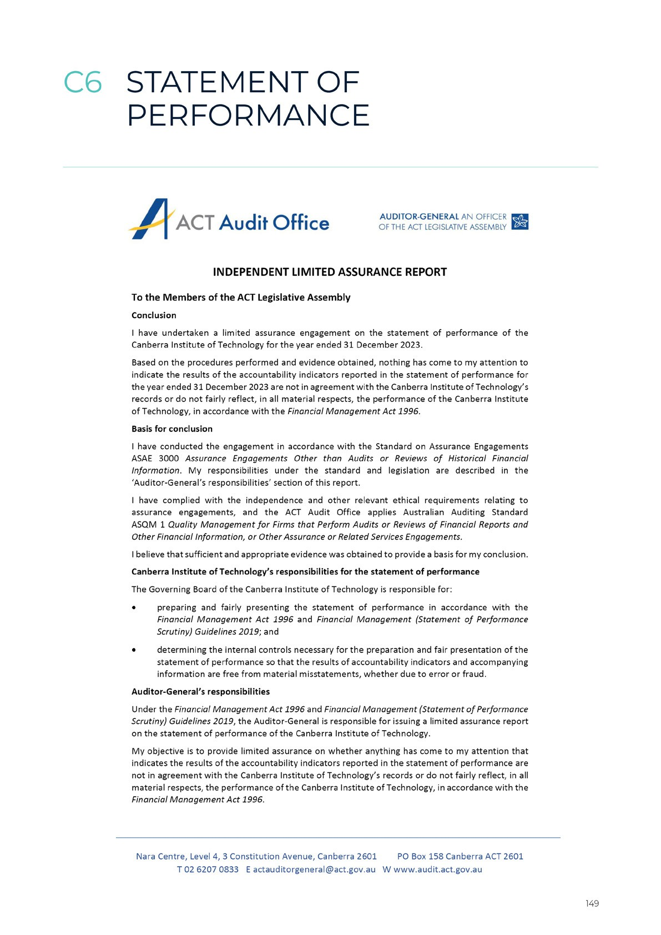

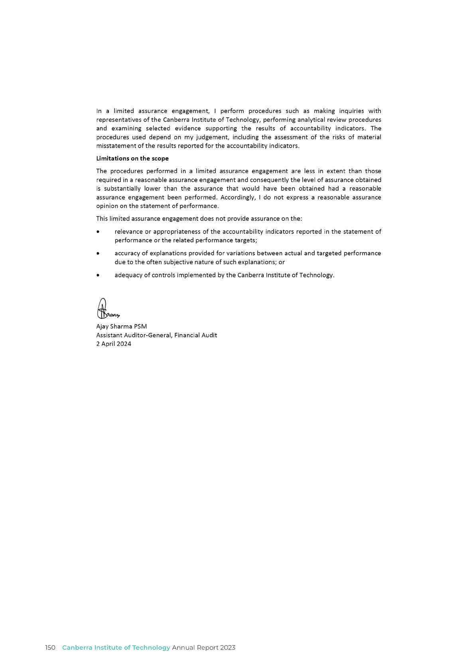

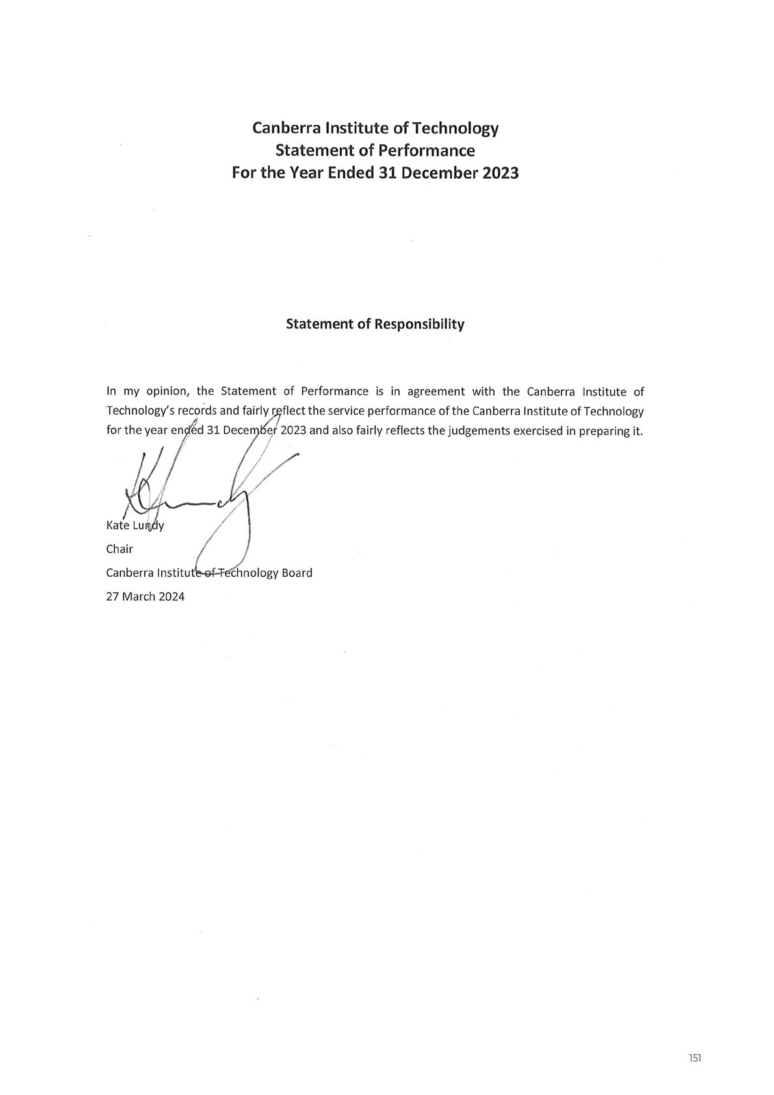

Output Class 1: Provision of Vocation Education and Training Services
For the year ended 1 January 2023 to 31 December 2023
 | 31 December  2023  Target | 31 December  2023  Actual | Variance  %*
Total Cost ($’000) | 134,926 | 139,176 | 3
Controlled Recurrent Payments ($’000) | 81,195 | 84,209 | 4
Accountability Indicators
a) Subject Enrolments¹ | 100,000 | 97,324 | (3)
b) Subject Pass Rate | 85% | 86% | 1
c) Achieve Key Output Targets
i) Learner Satisfaction Rate | 85% | 88% | 3
ii) Employer Satisfaction Rate² | 80% | 91% | 14

For the year ended 1 July 2022 to 30 June 2023
 | 30 June 2023  Target | 30 June 2023  Actual | Variance  %*
Total Cost ($’000)² | 128,093 | 126,484 | (1)
Controlled Recurrent Payments ($’000)² | 80,372 | 80,469 | 0
Accountability Indicators
a) Subject Enrolments¹ | 100,000 | 91,415 | (9)
b) Subject Pass Rate | 85% | 87% | 2
c) Achieve Key Output Targets
i) Learner Satisfaction Rate | 85% | 88% | 3
ii) Employer Satisfaction Rate² | 80% | 91% | 14

The above Accountability Indicators were examined by the ACT Audit Office in accordance with the Financial Management Act 1996. The Total Cost and Controlled Recurrent Payments measures were not examined by the ACT Audit Office as this is not required by the Financial Management (Statement of Performance Scrutiny) Guidelines 2019.

The above Statement of Performance should be read in conjunction with the accompanying notes.
*Variance from Target: The percentage variance is calculated by subtracting the target from the outcome and dividing this difference by the target.
Explanation of Material Variances:
- Subject enrolments forboth periods arebelow target due to a strong local employment market reducing the immediate demand for training. This result improved for the period ending 31 December 2023 following a positive response to the Fee Free TAFE initiative.
- The 2023 survey of employer satisfaction showed overall levels of satisfaction of 91%, reflecting the positive views of employers and students of their experience at CIT.
Accountability Indicator Definitions
- Subject Enrolments is the sum of the total student enrolments in each individual unit of competency for the reporting period, excludingany enrolments relating to students who withdrew without attendance (i.e. where a Withdrawal - Without Attendance/WW grade has been recorded). This measure includes all students enrolled at CIT during the reporting period.

- Subject Pass Rates reflect the proportion of subject enrolments issued with a grade indicating successful completion of the Unit of Competency during the reporting period, expressed as a percentage of total subject enrolments during the same period. This measure includes all students enrolled at CIT during the reporting period.
- Key Output targets are as specified below.
  - The learner satisfaction rates measure the proportion of current students who indicated that they were satisfied with the training they received at CIT. The learner survey has been designed by the Australian Council for Educational Research (ACER) to collect data relating to the Australian Quality Training Framework (AQTF) quality indicator (QI) ‘Learner Satisfaction’; and.
  - The employer satisfaction rates measure the proportion of employers indicating that they were satisfied with the training provided by CIT. The Employer Survey has been designed by ACER to collect data relating to the AQTF QI’s and Employer Satisfaction metrics.

ACRONYMS AND ABBREVIATIONS

AC Academic Council
ACE Adult and Community Education ACT Australian Capital Territory ACTIA ACT Insurance Authority
ACTPS ACT Public Service
ACU Australian Catholic University AIATSIS Australian Institute of Aboriginal and
Torres Strait Islander Studies
AIUE Academy of Interactive Entertainment ANMAC Australian Nursing and Midwives
Accreditation Council
ANU Australian National University
AQF Australian Qualifications Framework ASbA Australian School-based Apprenticeship ASNZS Australian/New Zealand Standard
ASQA Australian Skills Quality Authority ATSIPP Aboriginal and Torres Strait Islander
Procurement Policy
BCP Business Continuity Plan
BIF Better Infrastructure Fund
BSSS ACT Board of Senior Secondary Studies CBRIN Canberra Innovation Network
CEO Chief Executive Officer
CIT Canberra Institute of Technology CITSA CIT Student Association
CMT Crisis Management Team CMTEDD Chief Minister, Treasury, Economic
Development Directory
CPP Career Pathway Program
CRP Controlled Recurrent Payment CSU Charles Sturt University
DIRC Design Innovation Research Centre EA Enterprise Agreement
EAP Employee Assistance Program EMC Executive Management Committee ESS Employer Satisfaction Survey
ETD Education and Training Directorate FMA Financial Management Act 1996 FOI Freedom of Information
FOI Act Freedom of Information Act 2016 FTE Full-Time Equivalent
GWO Global Wind Organisation HR Human Resources
HSR Health and Safety Representative IAG Industry Advisory Group
IAHA Indigenous Allied Health Australia IAP Indigenous Apprenticeship Program IAGPD Indigenous Australian Government
Development Program
ICT Information and Communication Technology
IMICT Information Management/Information and Communication Technology
JSA Jobs and Skills Australia
LES Learner Engagement Survey
LLN Language, Literacy and Numeracy
LLND Language, Literacy, Numeracy and Digital LSA Learning Support Assistant
MCP Major Projects Canberra
MOU Memorandum of Understanding MPA Major Projects Canberra
NCVER National Centre for Vocational Education Research
NUHEP Non-University Higher Education Provider PIF Product Innovation Fund
RAP Reconciliation Action Plan RED Respect, Equity and Diversity
REDCO Respect, Equity and Diversity Contact Officer
RMP Records Management Program RTO Registered Training Organisation SERBIR Senior Executive Responsible for
Business Integrity Risk
SWATT Study Work Anywhere Any Time TAE Training and Education
TAFE Technical and Further Education TDA TAFE Directors Australia
TEQSA Tertiary Education Quality and Standards Agency
UC University of Canberra
UNEC United Ngunnawal Elders Council UNSW University of New South Wales VET Vocational Education and Training VETSES VET Student Experience Survey WHS Work Health and Safety
WHS Act Work Health and Safety Act 2011 YECC Yurauna Early Childhood Centre

COMPLIANCE INDEX 2023

The CIT 2023 Annual Report must comply with the Annual Report Directions (the Directions) made under section 8 of the Annual Reports Act. The Directions are found at the ACT Legislation Register: legislation.act.gov.au.
The Compliance Statement indicates the subsections, under Parts 1 to 5 of the Directions, that are applicable to CIT and the location of information that satisfies these requirements.

PART 1 DIRECTIONS OVERVIEW
The requirements under Part 1 of the Directions relate to the purpose, timing and distribution, and records keeping of annual reports. The CIT 2023 Annual Report complies with all subsections of Part 1 under the Directions. To meet Section 15 Feedback, Part 1 of the Directions, contact details for CIT are provided within the CIT 2023 Annual Report to provide readers with the opportunity to provide feedback.

PART 2 REPORTING ENTITY ANNUAL REPORT REQUIREMENTS
The requirements within Part 2 of the Directions are mandatory for all reporting entities and CIT complies with all subsections. The information that satisfies the requirements of Part 2 is found in the CIT 2023 Annual Report as follows:
- Transmittal Certificate, see page 7.
- Organisational Overview and Performance, inclusive of all subsections, see pages 12-80.
- Financial Management Reporting, inclusive of all subsections, see pages 82-153.

PART 3 REPORTING BY EXCEPTION
CIT has no information to report by exception under Part 3 of the Directions for the 2023 reporting year.

PART 4 DIRECTORATE AND PUBLIC SECTOR BODY SPECIFIC ANNUAL REPORT REQUIREMENTS
CIT is not required to report under Part 4 of the Directions.

PART 5 WHOLE OF GOVERNMENT ANNUAL REPORTING
Four of the five subsections of Part 5 of the Directions apply to CIT. Consistent with the Directions, the information satisfying these requirements is reported in the one place for all ACT Public Service directorates, as follows:
- Human Rights, see the annual report of the Justice and Community Safety Directorate
- Legal Services Directions, see the annual report of the Justice and Community Safety Directorate
- Public Sector Standards and Workforce Profile, see the annual State of the Service Report
- Territory Records, see the annual report of Chief Minister, Treasury and Economic Development Directorate.

CONTACT OFFICER

CIT Chief Executive Officer
Canberra Institute of Technology GPO Box 826
CANBERRA ACT 2601
Email: CITOfficeoftheChiefExecutive@cit.edu.au Telephone: (02) 6207 3103
Website Address
www.cit.edu.au

The CIT 2023 Annual Report can be found at:
Publications : Canberra Institute of Technology (cit.edu.au/about/publications)

