Dear General Practitioner,

Your patient presenting to you today has applied to study the Diploma of Nursing (Enrolled) HLT54115 at Canberra Institute of Technology (CIT).

We seek your help in addressing the following entry requirements for the course:
- CIT insurers require a letter from a General Practitioner attesting to the student’s fitness to undertake nursing duties at the time of course commencement. Any pre-existing injuries should also be included in this letter. The clearance letter must relate to any pre-existing injuries and the current health of the student. Please see over the page.
- Students with a current Workers Compensation claim or injury will be required to inform CIT and present a letter from their treating Medical Specialist.
- Students are also required to comply with the ACT Health “Student and Trainee Clinical Placement Policy” and the NSW Health Policy “Occupational Assessment, Screening and Vaccination against Specified Infectious Diseases”; and show documented evidence of their immunisation status.

Immunisation:
The following DOCUMENTED EVIDENCE (please provide batch numbers dates and/or serology results) are required for each student to ensure compliance with both ACT and NSW Health’s requirements for Clinical Placement:
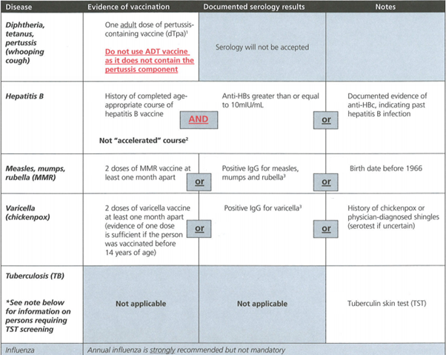

Your assistance in this enrolment process is appreciated.

Yours sincerely,
Linda Willington Charissa Hayward
Nursing Coordinator Clinical Placement Coordinator
Diploma of Nursing Diploma of Nursing
Doctor’s letter of fitness:

During the CIT Diploma of Nursing course, students are required to work in a simulated learning environment and complete 11 weeks of clinical placement in a variety of health care facilities across the ACT and NSW.

This requires the student to be both physically and psychologically fit to undertake nursing duties.
Examples of the duties students will be required to complete during the course include but are not limited to:

Manual handling techniques:
- Transferring a client from bed to chair and vice versa using manual handling equipment
- Assisting a client to ambulate – this may include wheelchairs, shower chairs, walking frames, crutches etc.
- Moving clients in the bed
- Positioning/active and passive exercises
- Bed making/sponging/showering
- Basic life support e.g. initiate CPR according to organisation procedures.

Please sign, date and stamp below verifying that the student is fit to perform nursing duties.

A separate letter is required listing any information regarding pre-existing conditions, and /or any workers compensation.

Student Name:

Doctor Signature:

Date:

Doctor Provider Number:

Stamp:

